Leftist Groups Continue To Launch Adventurist Aid Missions
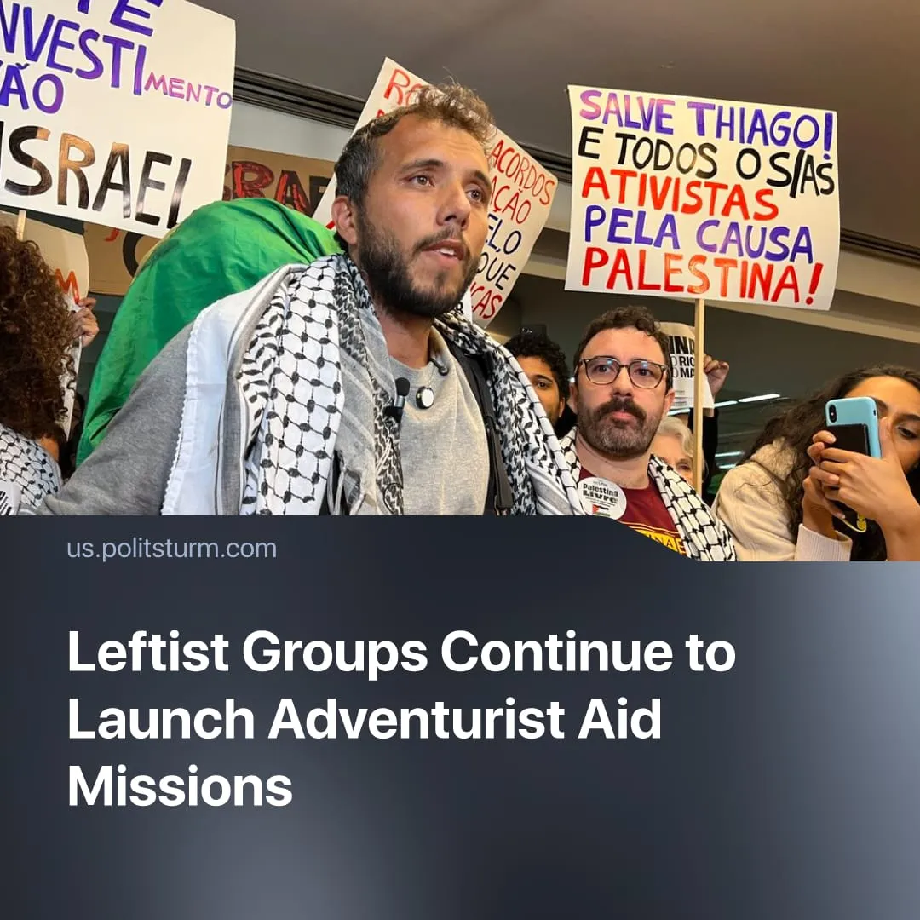

Original article
2026-02-23
1 min read

Leftist organizations are launching the 4th “freedom flotilla” in 6 months. These actions continue to produce mere spectacle whilst failing to deliver practical aid.
Details. The international “pro-Palestinian” initiative, Global Sumud Flotilla (GSF), intends to launch a new mission in March to deliver aid to Gaza. Key figures taking part in the flotilla include activists Susan Abdallah, Madla Mandela and Thiago Avila.
► The plan includes over 100 boats with 3,000+ participants of various professions from 100+ countries. Despite this flotilla’s larger scale, the volume of aid will still be far less than the amount already delivered to Gaza via UN trucks.
► Its stated goals include breaking the Israeli siege of Gaza, delivering aid, protective presence, reconstruction support, and catalysing global action. The mission is financed through donations, with nearly €200,000 raised.
► Amid Trump’s fuel embargo, Progressive International recently announced the formation of the “Nuestra América Flotilla”, sailing to Cuba in March to deliver voluntarily collected food and medicine to the island, aiming to soften the crisis, but not to overcome it. GSF’s Steering Committee member Thiago Avila will attend as a key organiser, along with opportunist US streamer Hasan Piker.
Context. In October 2025, the GSF, including Greta Thunberg, launched a similar mission involving ~50 boats and by their own admission only “symbolic” quantities of aid. The Israeli navy intercepted the flotilla. 442 out of 500 activists, including Thunberg, were detained. Like all previous flotillas, the mission ended in failure.
► The new Gaza aid mission differs from the previous one in both scale and goals, but not in strategy. The GSF aims to achieve a “proactive presence" by helping with reconstruction and education. However, it presents no clear strategy for breaking the siege or reducing suffering beyond appeals to international institutions for protection.
► In January, the European “RiseUp4Rojava” activist group had launched the “People’s Caravan” to Rojava, an autonomous territory of Syria. The land-based convoy, like a flotilla, transported humanitarian aid and activists to support the Kurdish-led SDF amid pro-Turkish invasions. The caravan was stopped in Turkey, and 28 participants were arrested.

Original article

