Activision Blizzard CEO on Unions
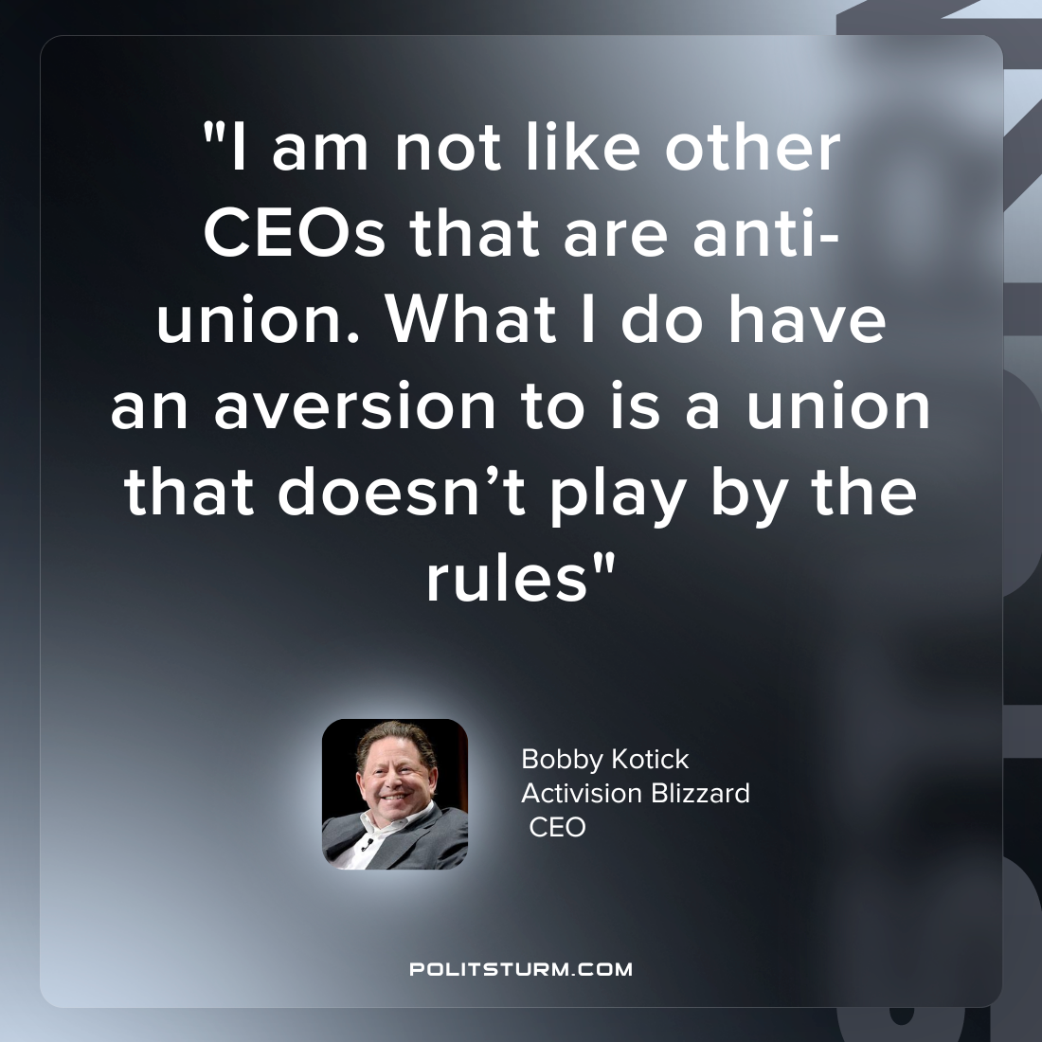

Original article
2023-06-07

"I am not like other CEOs that are anti-union. What I do have an aversion to is a union that doesn’t play by the rules"
Bobby Kotick
Activision Blizzard CEO

Original article

