About Putin's Speech
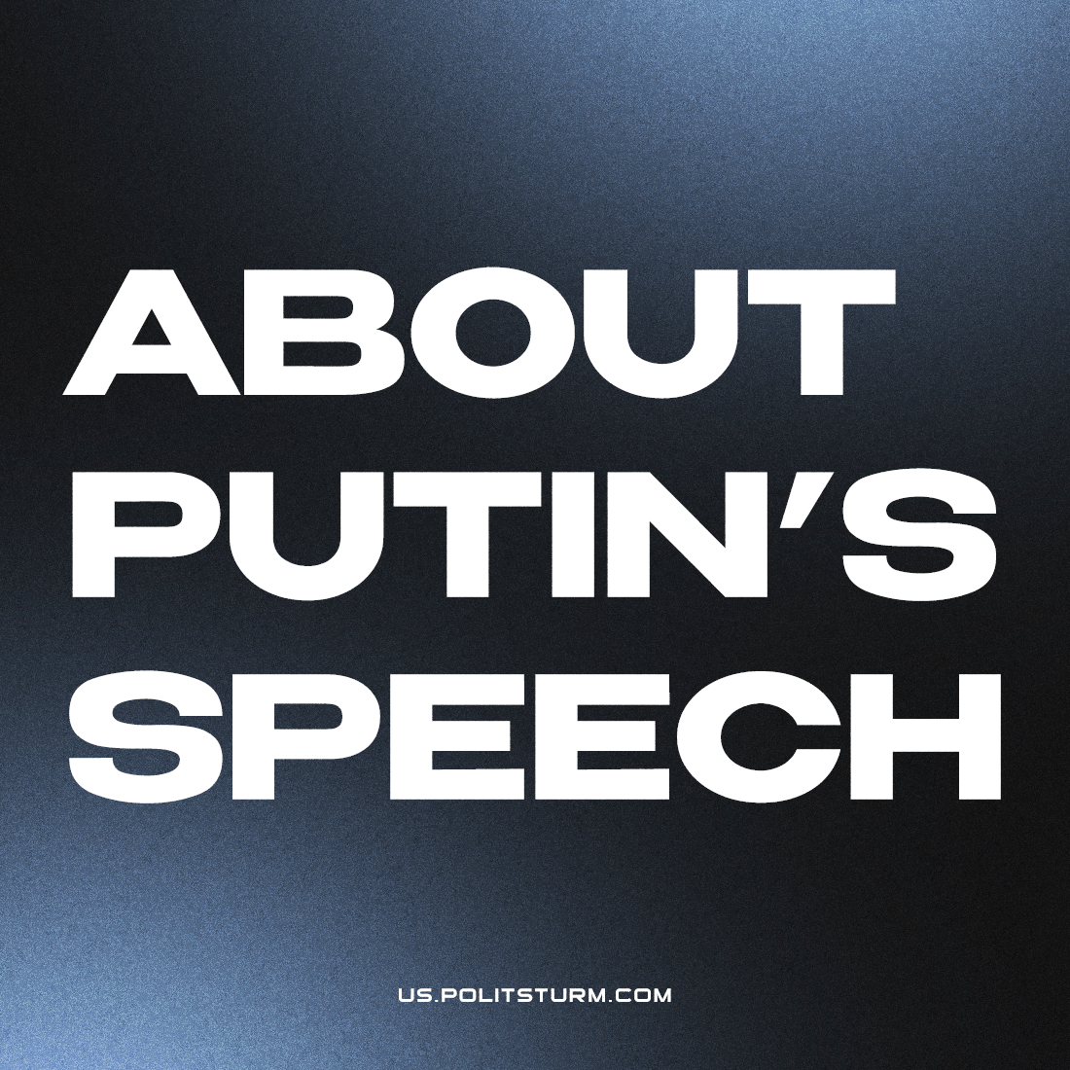

Original article
2022-09-30
3 min read

Today, the Kremlin hosted the ceremony of signing an agreement on the “accession” to the Russian Federation of the Donetsk and Luhansk “people’s republics”, as well as the Kherson and Zaporozhye regions, recognized as “independent” several hours before. The signing of the treaty was preceded by a long speech by Putin.
The president’s speech was not a revelation. The usual phrases were used about recognizing the “choice of millions”, about national unity, about the fight against the West, which is waging a “hybrid war” against Russia and seeking to turn other countries into its “vassals”.
Putin’s speech is replete with rhetoric aimed at the international level. He enumerated the crimes of Western imperialism at length: colonialism, the slave trade, plunder and destruction of peoples, and so on. The whole essence of the speech was reduced to one thought: the Western powers are oppressing the whole world, and Russia is resisting this.
Putin lashed out at Western capitalists, accusing them of stealing “Russia’s wealth“. However, he “forgot” to mention that he himself participated in the sale of former Soviet property as part of the St. Petersburg “Committee of the Mayor’s Office for External Relations”. He “forgot” that the wealth of Russia (and in fact the Soviet Union) was plundered primarily by Russian capitalists.
But, the President of the Russian Federation did not forget to once again expose the Communists as the culprits of current events: “[The Bolsheviks] cut the borders of the republics behind the scenes after the revolution”.
In other words, the Russian bourgeoisie, in whose interests economic and political expansion was carried out in the markets of the post-Soviet countries, intends to continue to fight to replace the hegemony of Western imperialism with its own. The “international part” of the speech, replete with references to traditionalism and historical memory, is designed to attract potential allies to the side of the Russian capitalism, including numerous far-right movements around the world.
At the end of his speech, Putin traditionally turned to quoting a white émigré who supported the Nazi regime of Hitler and the invasion of the USSR, Ivan Ilyin, a “true patriot” of Russia:
“If I consider Russia to be my homeland, then this means that I love in Russian, contemplate and think, sing and speak Russian; that I believe in the spiritual strength of the Russian people and accept its historical fate with my instinct and my will. Its spirit is my spirit; its fate is my fate; its suffering is my grief; its heyday is my joy” (I. Ilyin, “Russian Movement Manifesto”)
Let us recall, however, another quote from the same Ilyin:
“Fascism arose as a reaction to Bolshevism, as a concentration of state-protective forces to the right. During the onset of left-wing chaos and left-wing totalitarianism, that was a healthy, necessary and inevitable phenomenon… “ (I. Ilyin, “On Fascism”)
If one removes all the propaganda husk, the following can be stated:
I. A Call to Peace. Putin directly called on the Ukrainian authorities to stop the fighting and resume negotiations. Obviously, without experiencing difficulties at the front and being unsure of the successes, the bourgeoisie of the Russian Federation would not have so insistently demanded peace with Kyiv: “We call on the Kyiv regime to immediately cease fire and return to the negotiating table. We are ready for this.”
Faced with serious difficulties, causing retreats, the ruling class of Russia seeks to defend the gains and freeze the conflict at least for a while.
II. The Prospects of the Conflict. The events of recent weeks can be regarded as raising rates. After the announcement of mobilization, urgent referendums and the “admission” of new territories to the Russian Federation, behind-the-scenes negotiations on the cessation of hostilities may follow. In any case, there is no doubt that the Russian Federation is strongly interested in such negotiations.
Putin’s speech was followed by the first reaction: Ukraine is applying to join NATO. Prior to this, various information appeared that spoke of the strengthening of the NATO grouping on the borders of Belarus and Russia.
III. The Tasks of the Communists. While the degree of military hysteria around the world is increasing, the communist movement continues to be in a state of crisis. The communists are fragmented and do not pose a serious threat to the capitalists. In this regard, the tasks of the communists remain the same:
- exposing the bourgeoisie and the plans of the imperialists;
- combating all kinds of opportunism and revisionism, exposing social chauvinism;
- communist agitation and propaganda, the active introduction of class consciousness into the ranks of workers, the establishment of interaction with labor collectives;
- creation of a real communist organization in Russia, education and training of activists;
- establishing contacts with the communists of other countries, helping to create real communist organizations in these countries.

Original article

