A Large-Scale Strike Has Begun in Norway
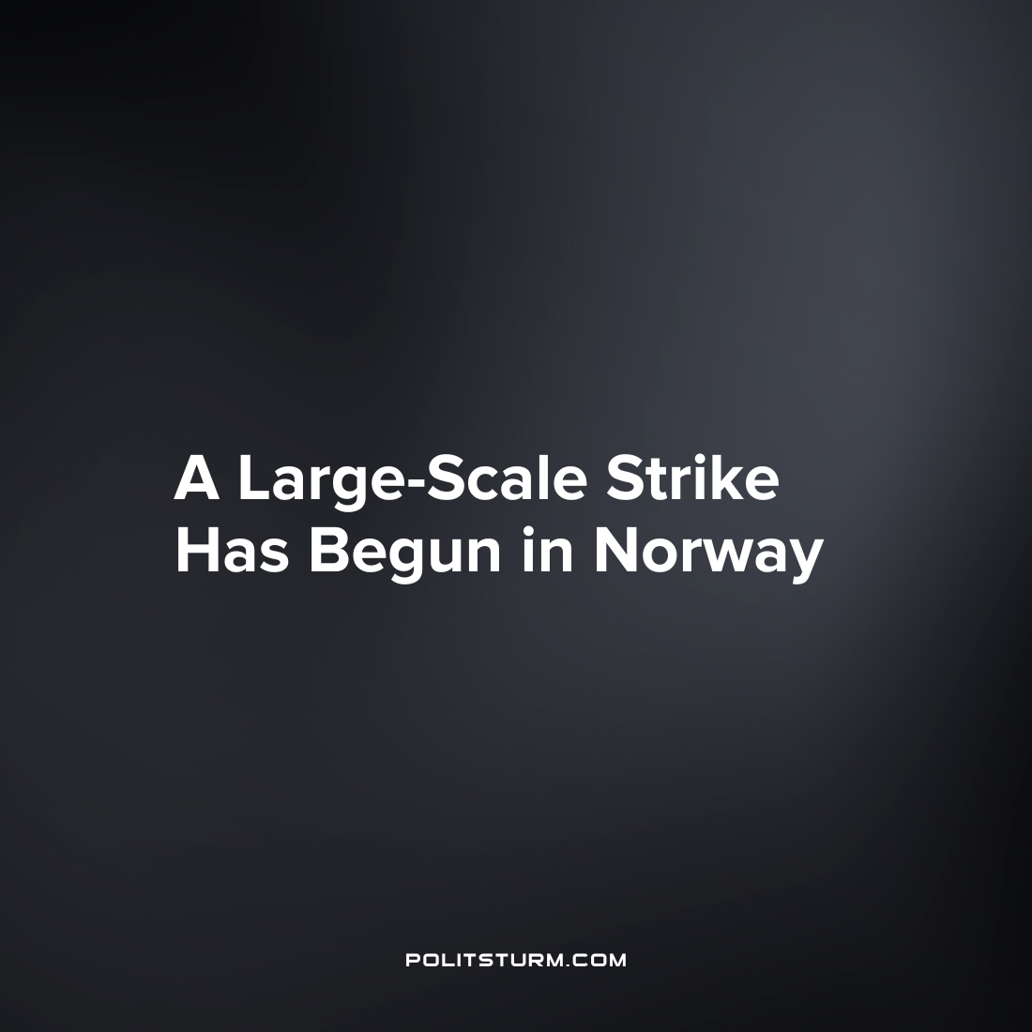

Original article
2023-05-07
2 min read

For the first time in almost a quarter of a century, the Norwegian Confederation of Labor (LO) announced a large-scale strike. The need for a strike was caused by unsuccessful negotiations with the government on raising wages for workers. Specifically, the Norwegian Confederation of Labor rejected the government's proposal to raise salaries by an average of 5.2% and insisted on linking salaries to the inflation rate, which currently stands at 6.5%. The last time the Norwegian Confederation of Labor organized a strike was in 2000.
On Monday, April 17th, about 25,000 workers from various industries went on strike, including builders, road workers, electricians, merchants, confectioners, brewers, and workers in the natural resources sector. The participation of thousands of employees of major oil companies Aibel and Aker Solutions, as well as the aluminum company Norsk Hydro, can create serious problems in these industries. In addition, the beer companies Ringnes, Hansa Borg and Mack announced the suspension of production processes and shipment of products, which is likely to lead to a shortage of beer in Norway in the near future.
The Norwegian Confederation of Labor, which is the largest and most influential trade union organization in Norway, unites almost a million people, but decided not to call all its members to strike at once. If the unions and the government have not yet reached an agreement by Friday, April 21st, another 16,000 workers of various LO unions will join the strike.
In addition to LO, the Confederation of Trade Unions (YS), which unites more than 225,000 workers, has promised to go on strike by the end of the week.
The decline in real wages in Norway, as in other European countries, has a negative impact on the living standards of the working class. With the deterioration of the economic situation, an increasing number of workers realize the incompatibility of their interests with the interests of the capitalist class and begin to take collective action.
This trend is reflected in the development of the strike movement throughout Europe.
However, making demands of an economic nature is not enough to achieve significant improvements in living conditions for workers. To do this, it is necessary to raise the level of class consciousness and unite the labor movement with a political party representing the interests of the working class and capable of bringing it to power.
Sources:
Dagens Nyheter – "Nästan 25 000 tas ut i strejk i Norge" from April 16, 2023
Dagens Nyheter – "Storstrejk drabbar oljeindustrin i Norge" from April 17, 2023
Dagens Nyheter – "Strejk hotar i Norge – kan bli ölbrist" from April 15, 2023
Expert – "A large-scale strike has begun in Norway" on April 17, 2023.

Original article

