9 in 10 Americans Report Cost-of-Living Crisis
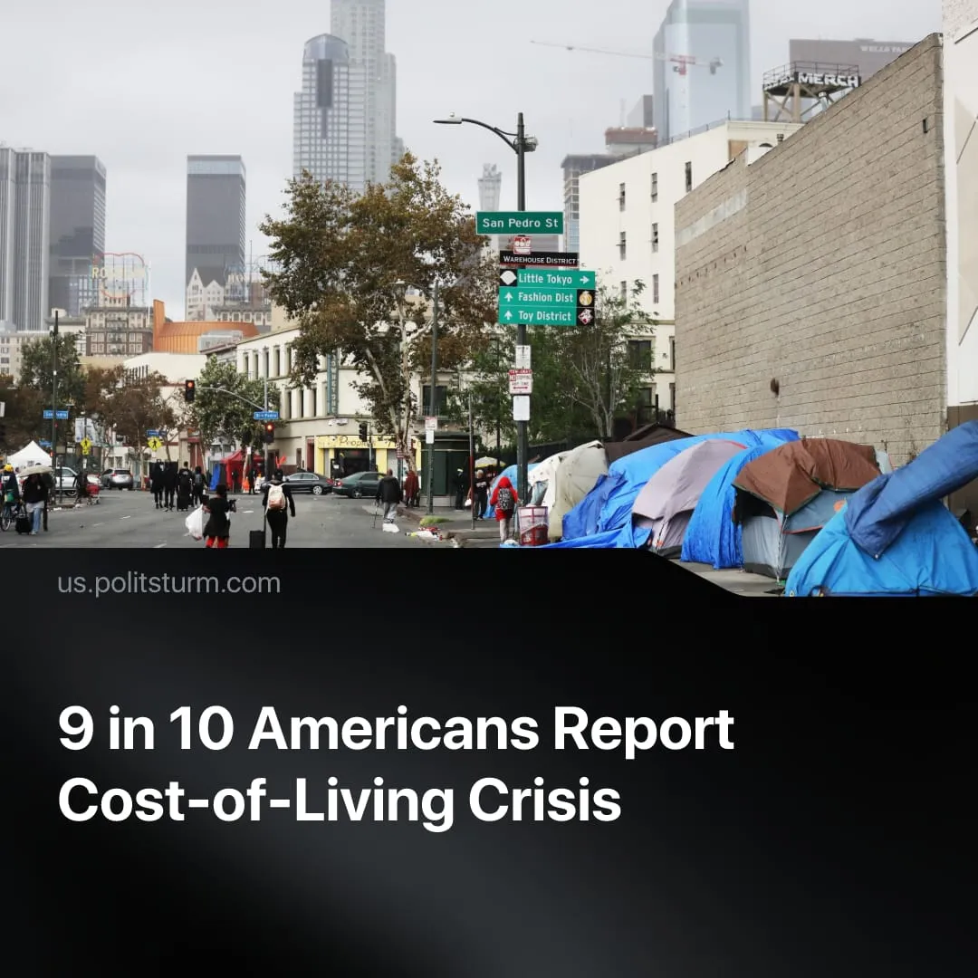

Original article
2026-02-19
1 min read

87% of Americans believe the country is in a cost-of-living crisis, whilst the Trump administration claims a booming economy and "defeated" inflation.
Details. A recent US survey of 5,000 people across all 50 states and age groups found that 9 in 10 Americans believe the country is in a cost-of-living crisis.
► The findings highlight the conditions of the American working class. 52% of respondents said they were struggling to pay basic bills such as rent and insurance, while 50% reported difficulty affording necessities like groceries.
► 78% believed that “everything” was more expensive in 2025, and 46% expected prices to rise even further in 2026. 73% said they could not cover expenses without a government tax refund.
Context. Trump continues to deny these conditions, claiming at the recent World Economic Forum that the economy is booming and inflation has been “defeated.” In reality, the economy remains strained despite his campaign and office promises: employment growth slowed in 2025 and is trending toward zero, consumer prices are still rising, and 83% of hourly workers have less than $500 in savings.
► Trump’s policies, like Biden’s before him, serve the ruling capitalist class, favouring corporate tax cuts and massive military spending outlined in the “Big Beautiful Bill.” The wealth gap between capitalists and the working class continues to widen; for example, the Trump family’s net worth has reportedly risen to $7 billion, a 70% increase since 2024.
► The administration has further increased burdens on ordinary people through cuts to welfare and public services, such as a $120 billion reduction in Medicaid funding. These cuts help finance accelerating fascisation and militarisation: $100 billion was added to the military budget, with Trump now pushing for an additional $500 billion, and $150 billion was allocated to ICE through 2029.

Original article

