9/11: What Have These 20 Years Been For?
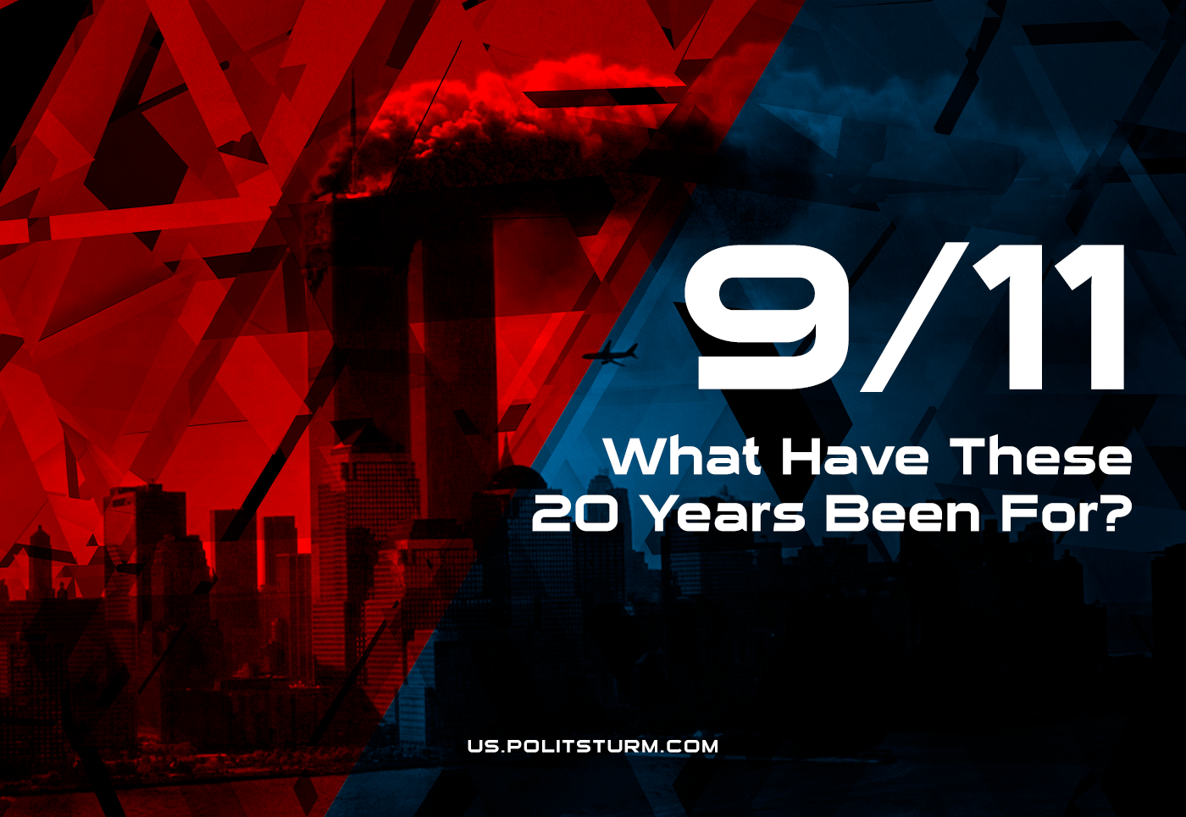

Original article
2021-09-11
5 min read

Twenty years have passed since the attacks on September 11th 2001 – events that have shaped US politics, both inside the state and out for decades. So, what have these 20 years been for?
Today, as bourgeois media centers on the anniversary from the perspective of the ruling class, let’s take a look at the true significance and consequences of these terrible events.
First and foremost are the attack’s use for the justifications of the state to vastly inflate military funding, in a time after the fall of the Soviet Union where such spending was on the downturn. Turned out that the world’s greatest military and intelligence power – a country which had assembled its vast capabilities with an enormous supply of world profits over the last 50 years – somehow amounted to nothing in the face of Islamists.
Whether these attacks were some conscious plan of the state, such as was outlined by the CIA in its rejected proposal for “Operation Northwoods”, is an impossible question to answer; what is only certain is that the attacks accomplished an effect that was desperately desired by the hawks of the Department of Defense and the military-industry corporations.
We’ve already written about the enormous $2 trillion cost of the U.S. Afghan campaign to confront the “Taliban” organization which state intelligence had alleged to hold central responsibility for the attacks. More and more campaigns continued; from the invasion of Iraq to interventions in Syria and Libya, and all of them required money. Military corporations reaped profits out of every bullet fired and every human corpse. While all these trillions are spent from the public treasury, while all these billions are kept in private accounts, the right-wing bobble-heads still tell us that the universal healthcare system is too expensive for the US budget.
Second in our consideration of the 9/11 attack is the significant impact it had on American society. Continuous footage of the events – most dramatically exhibitioning the live impact of an airliner into the South Tower – deeply shocked the people of the US, as well as other major capitalist countries around the world.
It is hard to imagine the circumstances required to institute such sweeping dissolutions of civil rights, as occurred in the United States between 2001 and 2021, without the trauma and spectacle of 9/11.
The children who watched these attacks on national TV, who took up the gauntlet of imperial chauvinism and joined its subsequent wars of vengeance, have today found themselves at the end of the inciting conflicts of the War on Terror with the U.S. military withdrawal from Iraq and Afghanistan.
Our third consideration is how particularly this event shaped the character of US foreign policy. New projects of the American imperialism continue to strike out across the world under the narrative shadow cast by 9/11; tenuous connections of Islamist militants to the legendary Al-Qaeda remain consistent in American press junkets behind deadly bombings and covert interventions.
Of course, as the results of such attacks should come as no surprise to us now; they came as no surprise to the American police apparatus and ruling class, as they saw such developments well ahead in the road. The attack’s perpetrators were already familiar to the FBI and US intelligence – public FBI records detail the depths of their informant network operating inside the hijacker’s own operation – while the State Department had fostered the rise of the well-funded Taliban reactionaries abroad.
But what about real threats of terror? Trillions of dollars were spent and thousands of lives were lost so that 9/11 would never happen again – but could their efforts have ever accomplished the end of terrorism that they claimed? Even without the evidence of the last 20 years, we must say no.
And the answer lies in the foundations of the world economic system.
Imperialism produces inequality and has turned the planet into a battlefield of the capitalist powers. Terrorism cannot be bombed out – history proves that it will rise again as long as social forces persist. Poor people of the dependent world, left without basic rights and without a real living are going to be attracted to the reactionary religion-based movements that are developing in their homeland.
Such an insurgency is a problem that reproduces itself – justifying ever-increasing spending for the ‘security’ budget. Today, the extensive police project cultivated by 9/11 continues to expand in scope as President Biden classifies further statutes for American ‘extremists’, naming leftists and ‘revolutionary socialists’ as an official target. Meanwhile, real terrorism runs rampant in U.S. cities, where fascist attacks, hate crimes and public shootings suspend Americans in a state of fear.
It is painfully clear now that the capitalist state is actually incapable or unwilling to prevent violent threats today. The problem of terrorism is tightly interwound with the problem of capitalism; only the workers, organized for social change in the vanguard party, can solve them.

Original article

