Half of Older Americans May Retire In Poverty
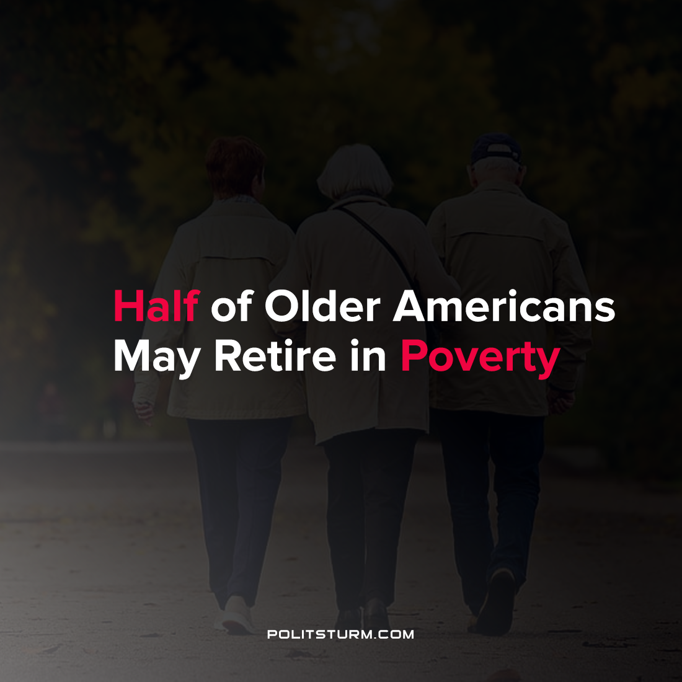

Original article
2021-08-14
1 min read

A harrowing report by economists at the New School for Social Research shows a dire situation for retirees in the United States. According to the research 2.9 million workers aged 55-70 dropped out of the labor force in March 2020. To put this figure into perspective, 1.9 million older workers left the labor force in the preceding recession in 2007.
A large percentage of the older workers who left the labor force are unlikely to return and are thus forced into early retirement.

“Several indicators show 2.9 million older workers who exited the labor force are unlikely to return. First, 42% of the 2.9 million older workers who left the labor force report retiring, compared to the 28% at the start of the Great Recession. It is unlikely that the rapid increase in self-reported retirements during the COVID-19 recession reflects an increase in planned retirements.” (Over Half of Unemployed Older Workers at Risk of Involuntary Retirement)
Early retirement can have dire consequences for retired workers who face reduced monthly Social Security payments and draw down their savings earlier and for a longer time frame. These factors contribute to increased poverty for early retirees who struggle to make ends meet with their limited incomes and their given expenses.
In the capitalist economic system periodic crises force older workers to retire early as they cannot find a buyer for their labor power after being involuntarily thrown out of work. Rather than providing for the retirement of workers, under capitalism workers are forced to rely on their own savings and any social programs available to them to fund their retirement with no guarantee that these sources will be sufficient to cover their living expenses.
Source: 1 , 2

Original article

