85,000 Kaiser Permanente Healthcare Workers Prepare for Strike Authorization Vote
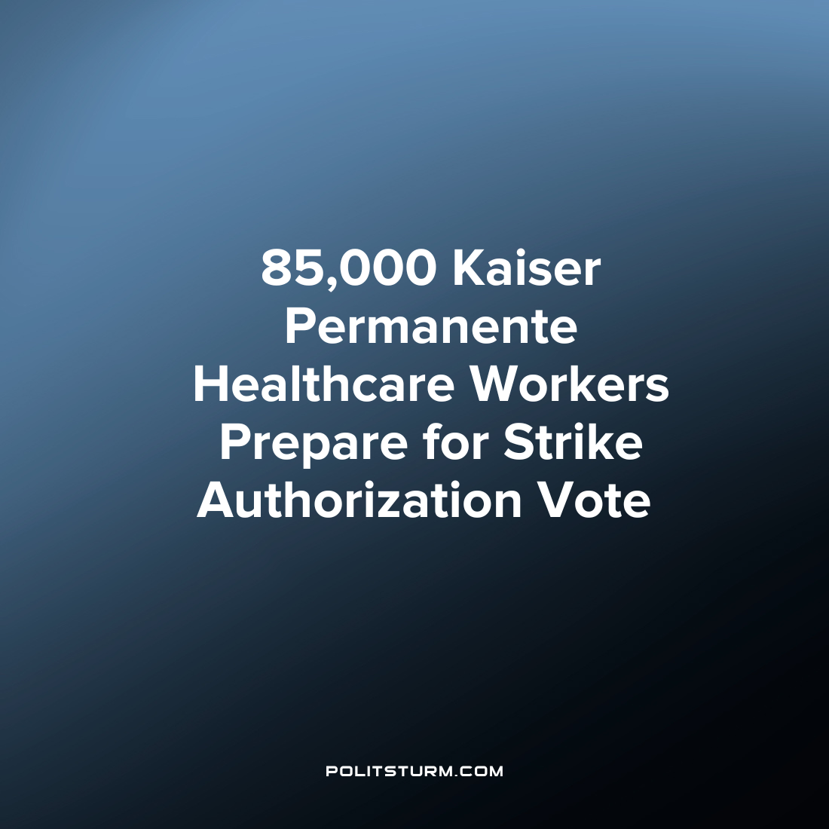

Original article
2023-09-02
1 min read

The coalition representing healthcare workers at Kaiser Permanente has warned of a strike beginning as early as October 1st if the national contract is not renewed by the end of September. The potential strike would affect millions of Kaiser members in states including California, Colorado, Oregon, Hawaii, Maryland, Virginia, and Washington, as well as Washington, D.C. The union accuses Kaiser of unfair labor practices, including a lack of good faith bargaining. The union leaders recently met with Kaiser for negotiations, but the company's representatives did not attend the meetings, leading to further frustration.
The coalition, which represents 85,000 healthcare workers, including lab scientists, therapists, nurses, and administrative staff, has filed numerous unfair labor practice charges against Kaiser. The union is pushing for a minimum wage of $25 per hour across all Kaiser jobs, compared to Kaiser's proposed $21 per hour in 2026. The coalition argues that despite being a non-profit organization, Kaiser has reported over $24 billion in profit over the past five years.
The class struggle between the workers and the capitalists has been intensifying as workers struggle with demanding work conditions and inflation deteriorating their real wages. The capitalists, by contrast, are resisting any attempts by the workers and their unions to concede and will not negotiate in good faith with the workers. The reason why there is no “good faith” negotiations on the part of the capitalists is that the interest of capitalists is diametrically opposed to the workers. Increased exploitation enriches the owners of capitalists and they have no interest in making any changes to the conditions of labor that reduce the profit rate. The workers will need to fight for every gain in the class struggle with the capitalist class and Marxist-Leninist theory provides the path towards achieving success to this end.
Source: 1

Original article

