DHS Authorizes DNA Collection For Immigration
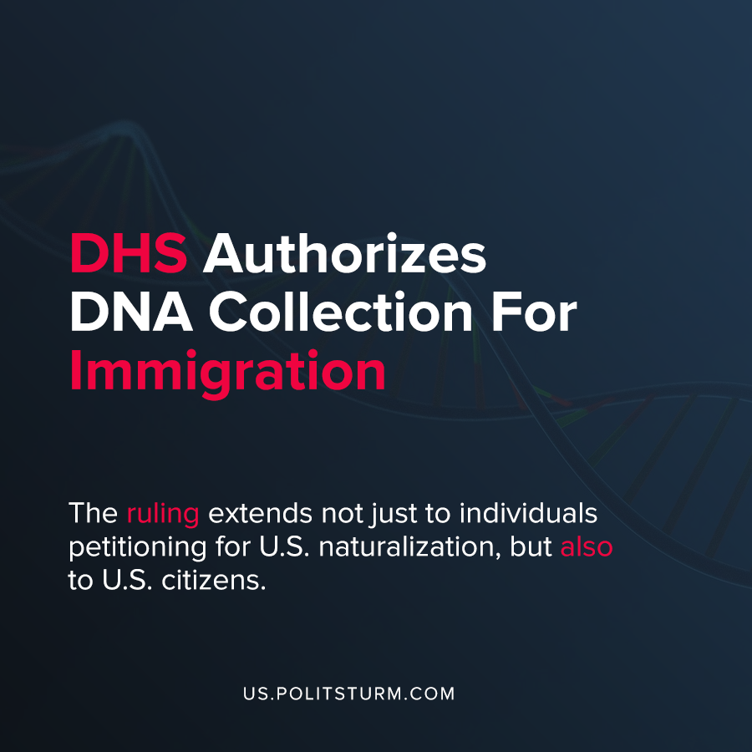

Original article
2020-09-15
1 min read

The Department of Homeland Security (DHS) released news on September 1st, 2020 that surrounded the collection of biometric data for immigration petitions. The proposed ruling would expand the types of information that can be collected by DHS.
Under the proposed ruling, the DHS can collect DNA and DNA test results in order to “provide sufficient documentary evidence to establish the claimed relationship”. In addition to DNA data collection, the proposed ruling would also allow for voice, iris, and facial recognition techniques.
Trump appointee and Senior Official Performing the Duties of the Deputy Secretary for the Department of Homeland Security Ken Cuccinelli lauded the proposed ruling.
“Leveraging readily available technology to verify the identity of an individual we are screening is responsible governing. The collection of biometric information also guards against identity theft and thwarts fraudsters who are not who they claim to be”, said Cuccinelli.
The ruling extends not just to individuals petitioning for U.S. naturalization, but also to U.S. citizens.
The Trump administration has taken repeated steps in limiting immigration to appease his nationalist political base. By collecting biometric data on U.S. citizens and immigrant applicants, the Trump administration is attempting to limit attempted immigration where there is no “verifiable genetic relationship”. The goal is to deflect the deficiencies of the capitalist economic system off the class of oligarchs and onto immigrants by limiting any form of immigration to the United States.
The root of the problems facing modern society are due to the capitalist economic system which exploits workers and causes immeasurable suffering in its highest form: imperialism. The crackdown on immigrants and the strengthening of nationalist rhetoric are tools of the ruling class to maintain the dominance of the capitalist class.
Sources: 1 , 2

Original article

