75% of Low-Wage Workers Cannot Meet Their Basic Needs
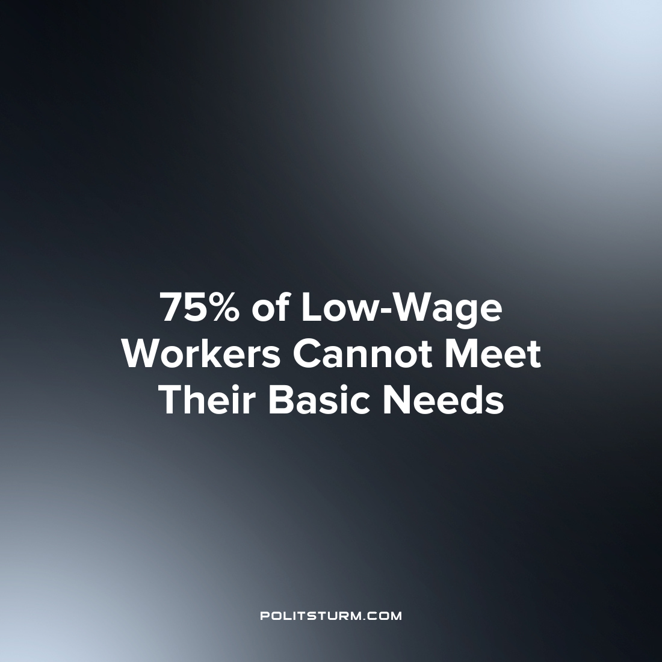

Original article
2022-09-09
1 min read

A study done by researchers at Brandeis University reveals that low-wage workers do not have the resources to adequately provide for families with children. More than one-third of families who work full-time do not have wages sufficient to provide for essentials like food, child care, housing, transportation, etic.
Low-income families in particular have the hardest time providing for basic expenses with 75% not being able to meet their basic needs. The data used by the study was from the period of 2015-2019 and therefore did not take into account the difficulties caused by job losses at the onset of the pandemic or the rising price level which followed.
The study calculated that low income families would need an additional $23,500 in annual earnings to be able to cover a basic budget.
Under the capitalist economic system the lowest wage workers are the most exploited and the study confirms the majority of which cannot even afford to provide for their families. The capitalist class, by contrast, is able to live off the wealth created by the working class without the need to work. Only the institution of the socialist mode of production under the control of the workers themselves will create the conditions necessary so that workers can live with dignity and provide for themselves and their families.
Source: 1

Original article

