70% of U.S. Small Housing Rentals Owned by Individual Landlords
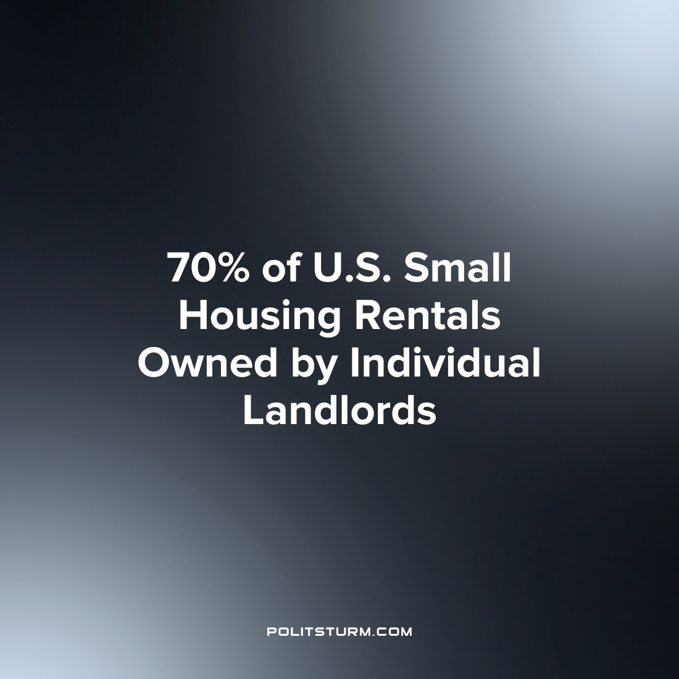

Original article
2022-12-05
1 min read

A new survey from the Census and the Department of Housing and Urban Development (HUD) gave some interesting statistics on housing in the U.S. There are 49.5 million rental units of housing in the U.S., of which 46% are small scale consisting of 1 to 4 units.
70% of these rental housing units are owned by individual investors. With larger scale properties consisting of 150 or more units, 67% are owned by limited liability corporations or partnerships.
The survey gives some interesting data with respect to housing in the United States. The data suggests that there is a large number of small-scale rental units through which landlords can extract rent from tenants. Also, unsurprisingly, as the scale of the rental operation increases the ownership is more likely to be that of an LLC or partnership whose owners profit from the rental revenue.
Under the capitalist economic system, the provision of housing necessitates the return of profit for the private owners. Small scale investors and corporations are able to extract rent from the working class to enrich themselves. Under the capitalist economic system, it is impossible to adequately provide housing for all as this is not compatible with the maximization of profit for the capitalists and landlords. The data clearly shows the scale to which rental-owned units exist within the country and these individual owners and corporate owners are exactly who benefit from the existing state of affairs. Only under a socialist organization of society is it possible to provide housing to the population without the need for profit maximization and the impoverishment of millions.
Source: 1

Original article

