66% of Americans Work While On Vacation
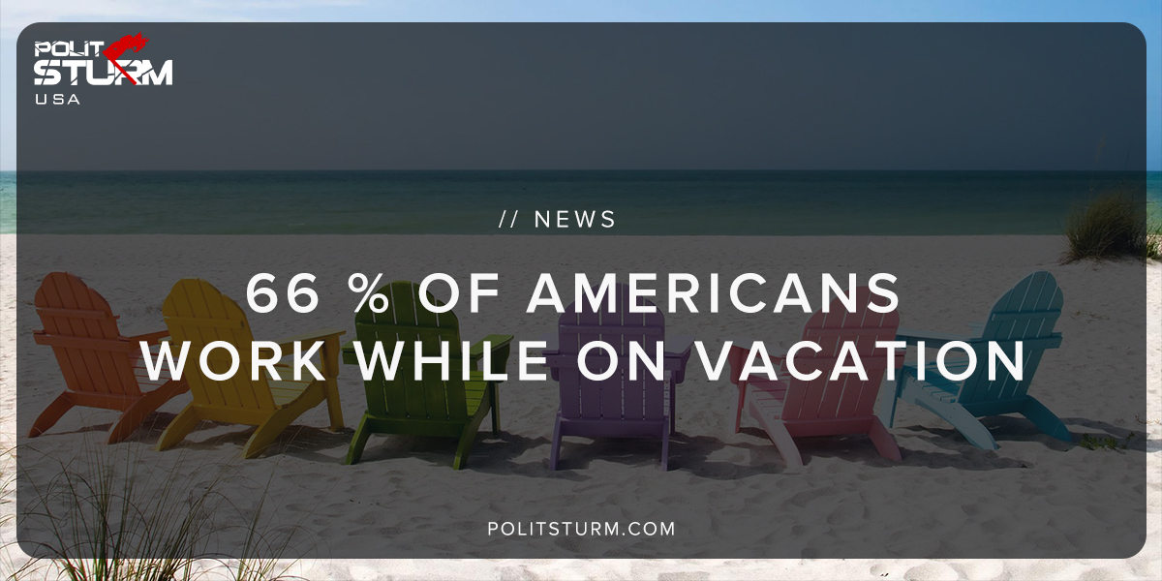

Original article
2018-11-25
1 min read

A recent Glassdoor study revealed that 66% of Americans work while they are on vacation. The study also shows that 54% of Americans who have paid time off do not use more than half of it. Americans are not using the time that they are given by choice or by submitting to “workplace norms”.
One quarter of the respondents claim that they are contacted by their boss while on vacation. Workers are performing additional labor for the capitalist class when they are supposed to be relaxing and socializing with friends and family.
The capitalist class in America and “workplace culture” have driven the workers into a completely submissive position. Workers are exploited in the workplace and even outside of the workplace. Technology allows workers to check their emails and perform work from a remote location.
Workers are afraid that if they do not perform additional labor, beyond the amount stipulated with their employer, that they will be replaced. Workers are pitted against one another to see who can produce the most profit for their employers and thus remain secure in their jobs.
As a result a large percentage of American workers are not taking all of their vacation time, which is beneficial to the employer who is getting more hours of concrete labor.
The American working class should not see itself as exploiting the employer when they utilize all their vacation time. It is quite the opposite. The capitalist class is exploiting workers by pressuring them into working longer hours for fewer benefits. The problem is not that the American worker is unwilling to “unplug” and enjoy leisure time.
The problem lies in the fact that the capitalist class is constantly exerting tremendous pressure on the workers to worker longer hours and take less vacation time. Currently the workers are capitulating to the capitalist class. This situation must change if the workers are to full enjoy their labor and leisure time.
Source

Original article

