62% of Americans Concerned They Cannot Pay Rent
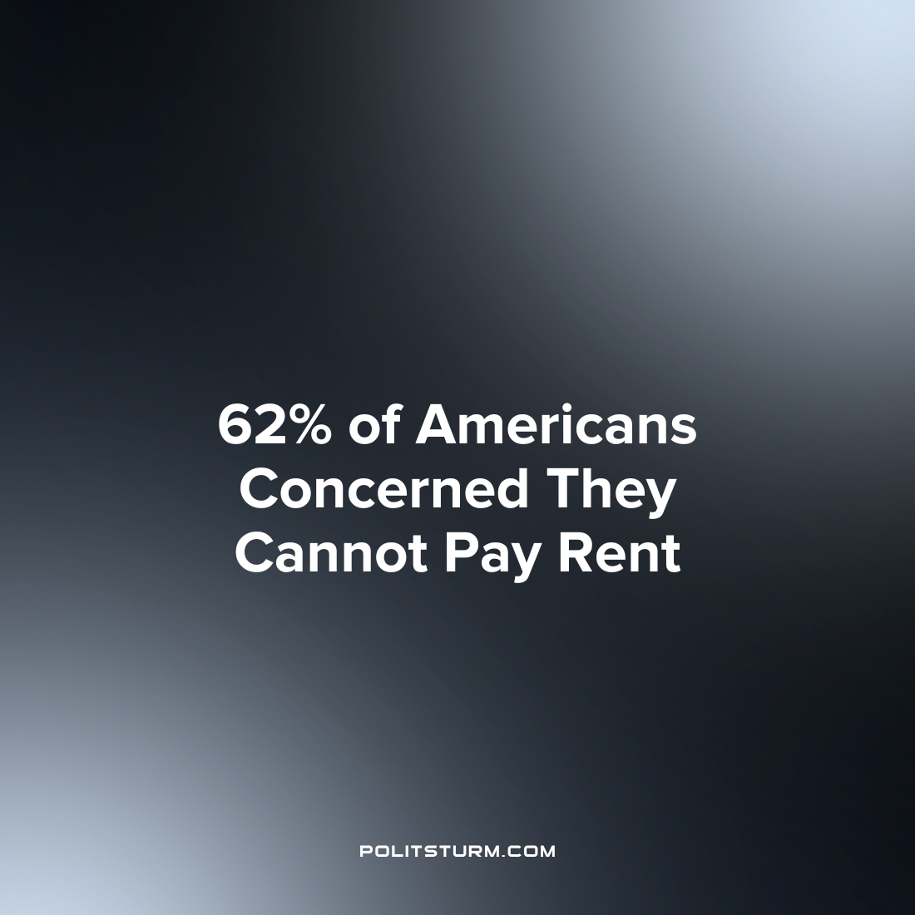

Original article
2022-08-17
1 min read

According to a survey conducted by Freddie Mac, Americans are becoming more burdened by rising rents and living expenses. Freddie Mac conducted a national survey of 2,000 Americans in order to gauge the effects of rising prices on personal finances and housing.
Of those surveyed, 62% were somewhat/very concerned that they would not have enough money to pay for housing within the next 12 months. 84% were concerned with the prospects of an impending economic recession while 77% were concerned with rising interest rates.
The survey also considered whether rents for respondents were increasing, staying the same, or decreasing. Within the last 12 months, 26% of renters had rent hikes of less than 10%. 15% of renters saw their rent increase by more than 10%. 11% of tenants saw their rent increase by more than 20% while 6% saw their rents increase by more than 30%.
As prices continue to rise across the country, workers are struggling to meet basic expenditures such as housing. Landlords, Investors, and Real Estate Investment Trusts can increase their rents while the renters struggle to survive on their limited incomes. The instability of the capitalist system subjects everyday workers to periodic crises of overproduction and precarity. Only the replacement of capitalism with socialism will end the class dictatorship of the capitalists and the landlords which causes great harm to the masses of workers.

Source: 1

Original article

