6.2 Million Lose Health Insurance During Pandemic
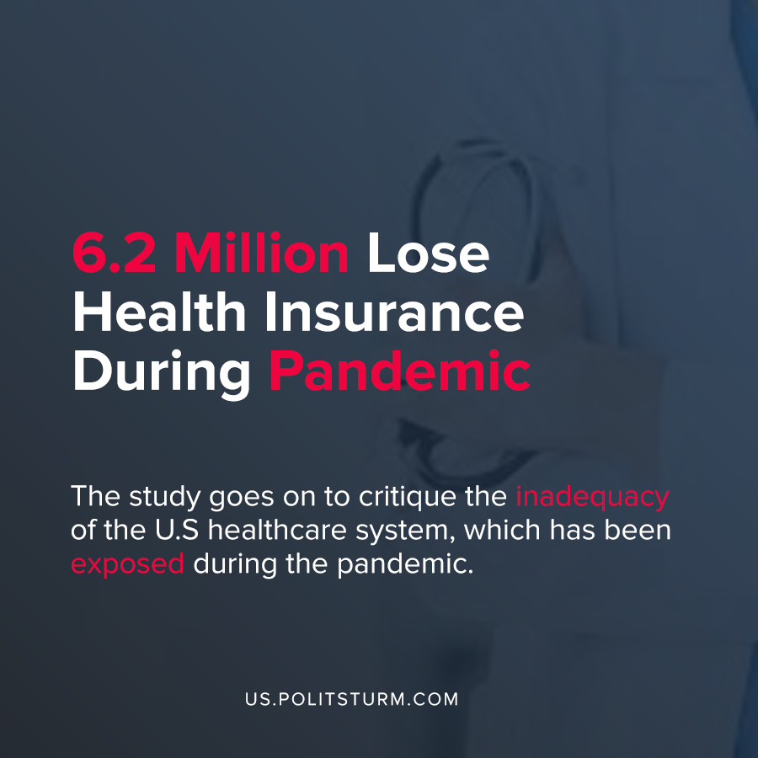

Original article
2020-09-02
1 min read

According to new research by the Economic Policy Institute (EPI) approximately 6.2 million workers will lose employer-sponsored health insurance during the pandemic. The estimation comes from the Bureau of Labor Statistics which showed that 9 million lost their jobs in March and April, with 2.9 million workers gaining employer-sponsored healthcare between April and July.
Not all workers that have lost employer-sponsored healthcare necessarily lose access to healthcare altogether. For example, the study cites the possibility of workers gaining insurance through a family member or Medicaid coverage, if available.
The study goes on to critique the inadequacy of the U.S healthcare system, which has been exposed during the pandemic.
“The COVID-19 shock has exposed just how incomplete and threadbare the U.S. safety net and social insurance system is. We should begin building a better set of systems that provide economic security to U.S. workers”, say the authors of the study.
However, the system of health insurance benefits the capitalist class as workers are dependent on their employers, families, or an inadequate system of government systems for healthcare. The laws and institutions of American society serve the interests of the dominant class, the capitalists. For as long as the capitalist economic system persists, when workers lose their jobs en masse, they will inevitably lose access to their employer-centered health care.
Source: 1

Original article

