55% Won’t Rehire Same Workers, One-Third Won’t Re-Open
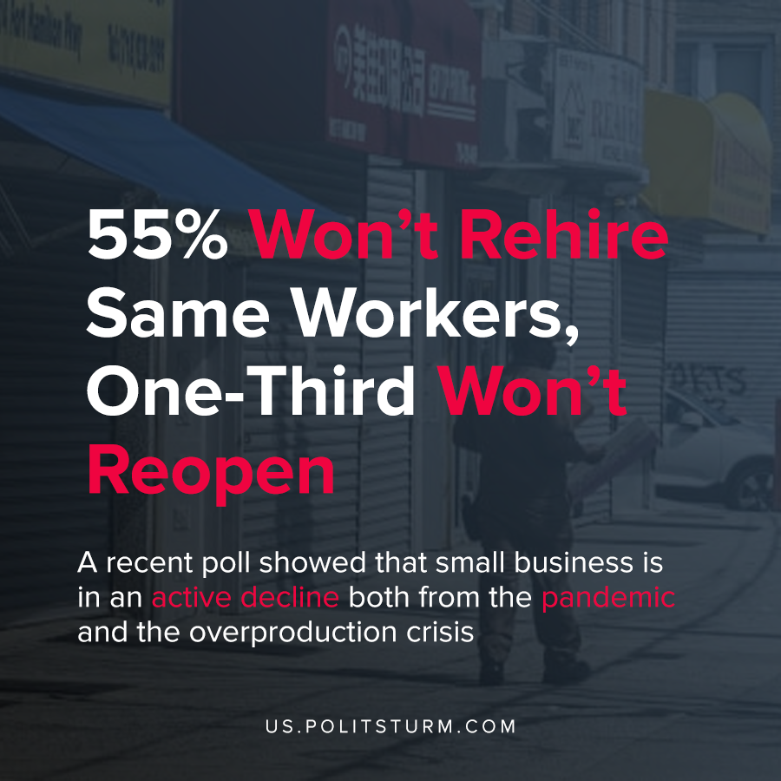

Original article
2020-05-25
1 min read

A recent poll showed that small business is in an active decline both from the pandemic and the overproduction crisis.
All over world news, we see the same fates similar to the American example above, while capitalist centres can provide some bailouts, countries that are centre dependent are not capable of doing that.
Small business in its entirety mostly remains to stay in the service sector and when people choose to rely on small business to help them earn some money and provide financial security in practice the contrary happens, and through the boom and bust cycles many people face ever greater issues in turn.
The government will never allocate a large sum of money to the small business sector as they apart from employment contribute little to the overall economy and hence even the route petite-bourgeoise dreams are doomed to fail.
“Tens of thousands of huge enterprises are everything; millions of small ones are nothing.”
V. I. Lenin
Imperialism, the Highest Stage of Capitalism,
A POPULAR OUTLINE,
I. CONCENTRATION OF PRODUCTION AND MONOPOLIES
Once more socialism is the only solution that will not force people to take risks that will cost their lives and to their families and their skills can be placed to better use in worker competition where you are properly awarded what you are worth. No idealistic statements will ever survive in the real world and hence the sooner we let go of it and move the empirically proven works of Marx and Lenin the closer we will achieve prosperity for the working class.

Original article

