55% of Americans Disapprove of Trump’s Handling of Crisis
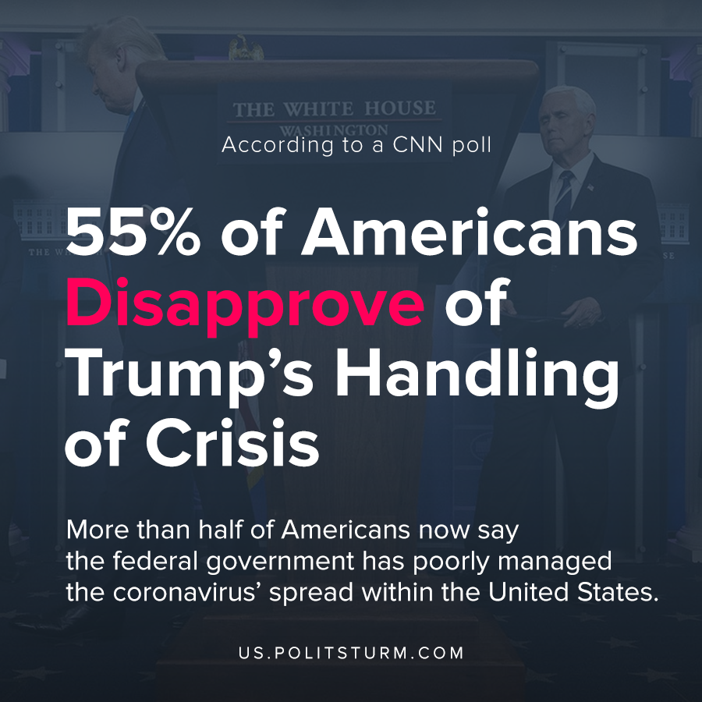

Original article
2020-04-08

More than half of Americans now say the federal government has poorly managed the coronavirus’ spread within the United States, and a majority also disapprove of President Donald Trump’s handling of the public health crisis.
Source: https://www.politico.com/news/2020/04/08/poll-majority-of-americans-now-disapprove-of-federal-coronavirus-efforts-trumps-handling-of-crisis-174643

Original article

