54.3 Million Americans Projected to Experience Food Insecurity
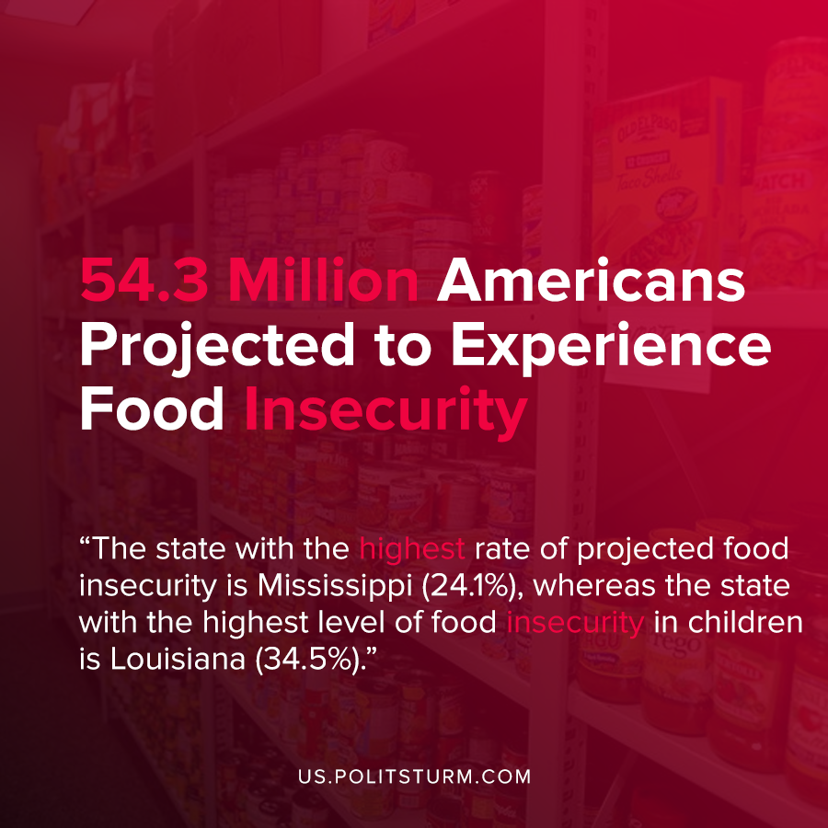

Original article
2020-07-28
1 min read

A study released by Feeding America examined what the increase in food insecurity would be in America in the aftermath of the coronavirus pandemic and the most recent economic crisis of overproduction.
In the most pessimistic scenario which is comparable to the current official unemployment rate in the U.S (11.5% vs 11.1%), it is estimated that 54.3 million Americans would experience food insecurity. Food insecurity entails that Americans would have insufficient access to food in order to live a healthy, active life.
The state with the highest rate of projected food insecurity is Mississippi (24.1%), whereas the state with the highest level of food insecurity in children is Louisiana (34.5%).
At the same time when millions of Americans are experiencing great food insecurity, milk is being needlessly dumped and crops are destroyed in order to maintain profitability. Millions of American children and adults who cannot afford to buy food are forced to suffer while a small number of oligarchs accumulate massive fortunes.
The capitalist economic system is oriented around the profit motive, not meeting the needs of the working people. If the producers of commodities cannot realize a profit, they will let their crops spoil or destroy them. For example, in the USDA announcement about direct payments to farmers, they even mention that they will subsidize farmers whose crops became “spoiled due to loss of marketing channels”.
One clear example of the absurdity of the capitalist mode of production is the undernourishment of a large portion of the population alongside waste and destruction of produced food. Only a socialist economy which is geared towards the needs of the working people and not the capitalist class will fundamentally resolve this contradiction.
Sources: 1 , 2, 3 , 4 , 5 , 6

Original article

