500,000 Americans Have Died from COVID-19
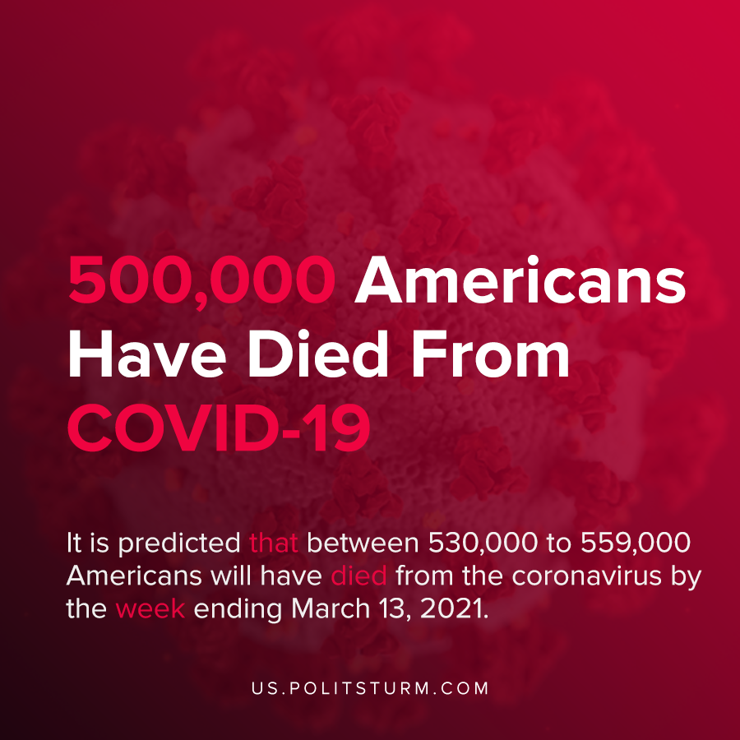

Original article
2021-02-24
1 min read

The United States passed another grim milestone as more than 500,000 Americans have died from the coronavirus. More Americans have died from the coronavirus than in World War 1, World War 2, and the Vietnam War combined.
Forecasting models by the CDC predict that the death toll will continue to grow over the coming weeks. It is predicted that between 530,000 to 559,000 Americans will have died from the coronavirus by the week ending March 13, 2021.
At this point in the pandemic, the practical effects are quite apparent. Hundreds of thousands have lost their lives and millions have lost their jobs. At the same time, the capitalist class continues to amass profits and enrich themselves.
“On this solemn occasion, we reflect on their loss and on their loved ones left behind. We, as a Nation, must remember them so we can begin to heal, to unite, and find purpose as one Nation to defeat this pandemic”, said President Biden while declaring the U.S. flag is to be flown at half-staff in remembrance of lives lost.
The number of Americans who have died of coronavirus is tragic and heartbreaking. However, it must be remembered how the capitalist fought against restrictions at the onset of the pandemic that would threaten their profits, and against public healthcare for decades.
Calls to “unite” on the basis of national identity to overcome the crisis are simply hollow rhetoric aimed to diffuse the inherent contradiction between the capitalists and workers. The capitalist class will continue to make profits through the crisis, while hundreds of thousands of Americans die only to be the recipients of the crocodile-tears from bourgeois politicians.
Sources: 1 , 2 , 3

Original article

