Happy Victory in Europe Day!
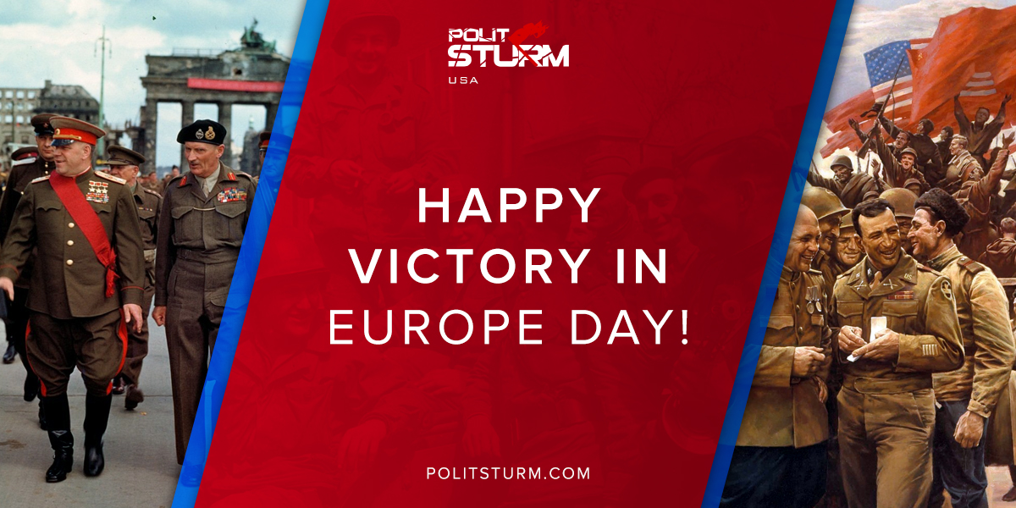

Original article
2018-05-08
5 min read

Today America celebrates Victory in Europe Day. Victory in the most terrible and most destructive war in the history of mankind – the Second World War. All the nations of Anti-Hitler Coalition made their contribution into common victory over fascism and nazism, especially the Soviet Union, which lost more than 25 million people struggling against Nazi Germany and its allies.
But today much of this history has been lost to Hollywood films, computer games and state propaganda that glorify the Allied Western front and marginalize the Eastern Front, as well as Cold War propaganda. Vision of Western front as «good guys bringing peace and freedom» and Eastern front as «evil comissars sending thousands of unarmed men on german machineguns» firmly established in the minds of western people. Of course, this is not true.
On May 9th, every Russian and other people of the ex-Soviet Bloc come together to celebrate Victory day (Dyen Pobedy). Why do they celebrate it tomorrow? This is because Nazi Germany capitulated twice – an earlier version of «German Instrument of Surrender» had been signed in a ceremony in Reims on 7 May 1945 and then in Berlin on the next day. In the West, 8 May is known as Victory in Europe Day, whereas in post-Soviet states the Victory Day is celebrated on 9 May.
Unlike in the United States, where May 9th is an average working day for Americans, Victory Day holds special significance for ex-Soviet Countries specifically because of the immense struggle that took place between Nazi Germany and its allies against the Soviet Union.
Despite what most Americans and Britons would say, the Soviet Union was responsible for contributing to the victory over Nazi Germany in ways that the Allies were not; making enormous sacrifices that the Americans and Britons did not have to suffer. In the struggle against fascism, the USSR took the brunt of the German attack by themselves for over three years. Belarus lost 25% of its population, whereas Armenia, Azerbaijan, Kazakhstan, Latvia, Lithuania, Russia, and Ukraine lost at least 10% or more. All in all, the Soviet Union lost an unfathomable 27 million people during the war, 10 million of which were military personnel, compared to 350,000 British and 300,000 American losses.
At the same time, the war triggered immense changes for the entire population as the entire citizenry was mobilized to defeat the Nazis. In the 1920s and 30s, the Soviet Union was rapidly industrialized at a speed unmatched in history, so as to prevent invasion from outside powers. Whole villages, factories, kolkhozes were transported to the East to keep them from harm’s way. The Soviet people themselves took up arms against the occupying Soviet territory; called the partisans, these fighters took it upon themselves to set traps, launch raids, and sabotage Nazi supply routes.
While the struggle in the West was one of liberation, on the East, it was one for survival. Deeming them to be “Untermenschen” or sub-humans, the Nazi’s ideological belief in the inferiority of the people of Slavic descent brought about the infamous policy of exterminating 100 Slavic people for every 1 German killed by resistance fighters. Millions of Jews, Belorussians, Ukrainians, and Russians met their death in concentration costs. Jews in the East were murdered and left in mass graves or sent to the concentration camps with other ethnic groups. To add to the suffering was the fact that some people chose not only to collaborate with the Germans but also actively participate in the rounding-up and shooting of Jews and Communists by Ukrainian, Lithuanian, Latvian and Estonian Nationalists. During the Second World War, the Soviet Union lost more than 32% of its Jewish population.
Much of this, however, has been forgotten, mainly as an effect of political realities. The efforts of the Soviet people were instrumental in contributing to the fall of the Third Reich but instead of attributing this victory to all of the Allied countries, today, it is widely believed that the United States and the United Kingdom “won” the war against Fascism. Capitalists of all countries are trying to split us. “We won the war!” – cry western mass-media. “No, stupid americans did nothing good!” – say russian purchasable mass-media and add – “War was won by russians, not Soviets! Evil Stalin and communists only wanted to kill everybody!”
While the allied effort in the war cannot be denied, despite what many Russian nationalists would say today, the idea that the Americans or British somehow “won” the war all alone, contributing more than the Soviet Union did, is a gross exaggeration and a pseudo-historical account of history that is used by those with a nationalist agenda in the capitalistic world today to denigrate those who chose the path contrary to the forces of capital.
That’s why during these 2 days we will post several articles on common myths about World War 2 and especially Soviet part – «The Great Patriotic War».
On V.E. Day we at Politsturm remember the millions of lives lost and forever altered to free us from the tyranny of fascism! Let’s keep memory about them and never forget, that international brotherhood of arms crushed the Nazis and their military machine.

Original article

