410,000 U.S. COVID Deaths Projected By 2021
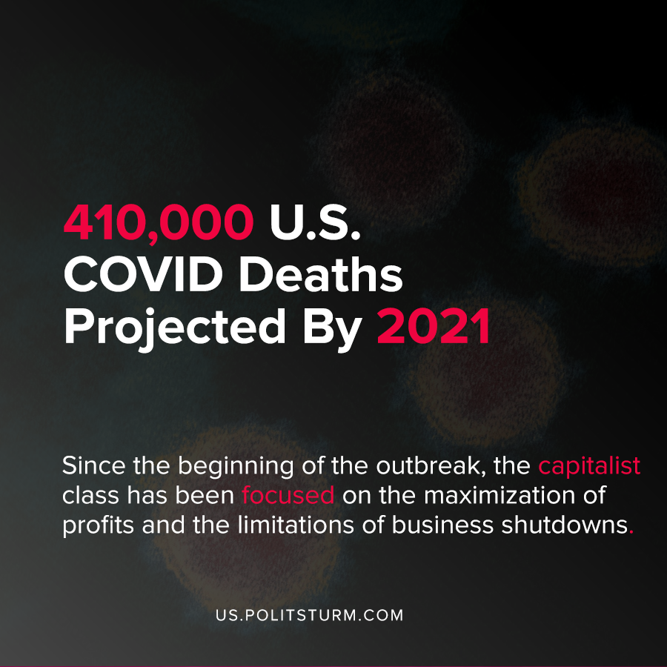

Original article
2020-09-05
1 min read

According to projections by the Institute for Health Metrics and Evaluation at the University of Washington’s School of Medicine, 410,000 Americans are projected to die from the coronavirus by January 1st, 2021. The projections assume that current trends of coronavirus mortality will continue into the future, with a higher projected death toll of over 620,000 if mask mandates are lifted.
The United States has the highest number of reported deaths due to the coronavirus, and has handled the crisis worse than every other country.
In the midst of the crisis the president, Donald Trump, has promoted baseless conspiracy theories that the “deep state” is intentionally making vaccine testing difficult until the election to hurt him politically.
“The deep state, or whoever, over at the FDA is making it very difficult for drug companies to get people in order to test the vaccines and therapeutics. Obviously, they are hoping to delay the answer until after November 3rd”, said Trump in a tweet.
Since the beginning of the outbreak, the capitalist class has been focused on the maximization of profits and the limitations of business shutdowns. The concern for the welfare of the working class is always secondary to the profit motive under capitalism, and as the data suggests the death toll will continue to climb as the year comes to a close.
The coronavirus and the concurrent capitalist overproduction crisis has clearly exposed the inadequacy of the capitalist mode of production, the U.S public health system which is organized on the basis of profit, and the corrupt, shameless politicians of the capitalist class.
Sources : 1 , 2

Original article

