400 Wealthiest American Families Pay 8.2% Tax Rate
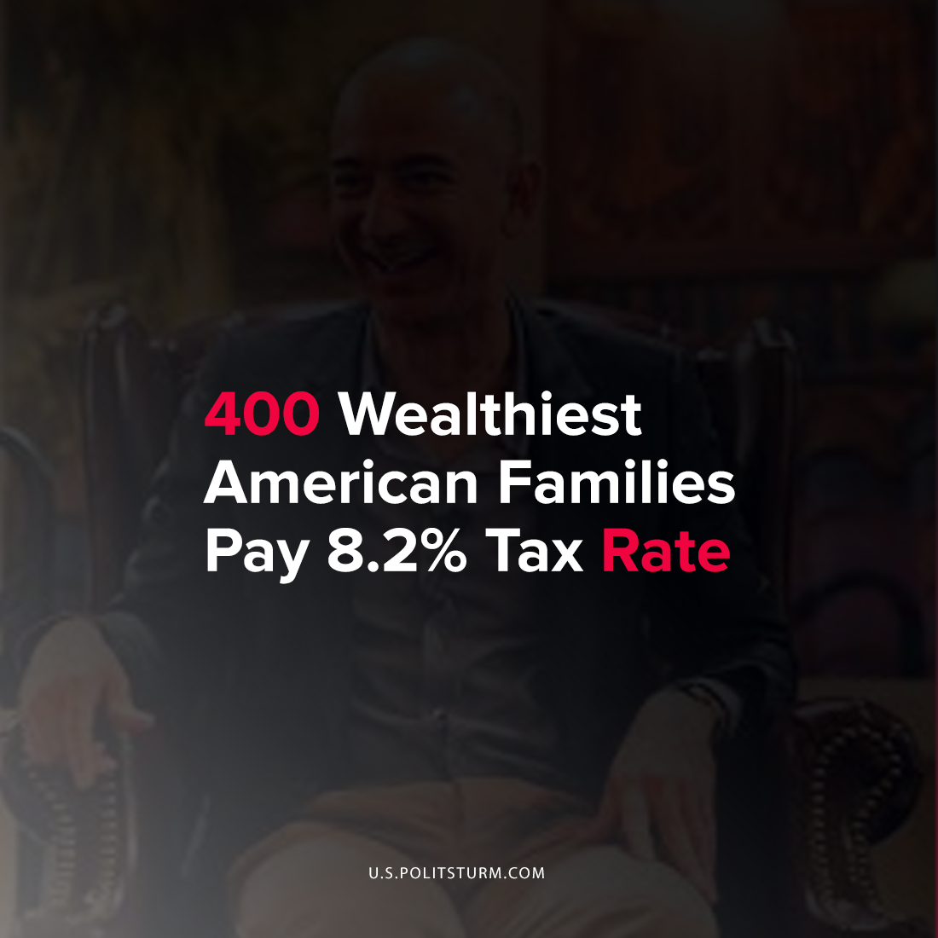

Original article
2021-09-24
1 min read

Using publicly available statistics from the IRS Statistics of Income Division, the Survey of Consumer Finances, and Forbes magazine, economists estimated the tax rate for the 400 wealthiest American households. The results of the analysis concluded that the average income tax rate was 8.2% in the period of 2010-2018.
There were two main factors that contributed to the low effective tax rate for the wealthiest Americans, preferential tax rates on capital gains and dividend income and stepped up cost basis.
Since the wealthy derive income from investments they benefit from paying lower taxes on investment holdings, particularly those held for a long-term period. Also, there is another favorable provision for the capitalists in the tax law that allows for the “step-up” in cost basis which serves to reduce the taxes paid on appreciated investments. On the death of an account holder, regulations allow the cost basis (used to determine investment gains) to be raised to a recent market value which eliminates capital gains on appreciated investments.
It comes as no surprise that the U.S. tax law favors the capitalist class and allows them to pay a lower rate than working Americans. This is a result of the U.S. political system serving the class interests of the capitalists and landlords who reap unearned income in the form of profits, interest, dividends, rents, capital gains, etc. Their “income” is merely surplus value, or unpaid labor of the working class, which they derive through their private ownership over the means of production.
Source: 1

Original article

