31,000 Stop & Shop Workers Walk Off Job
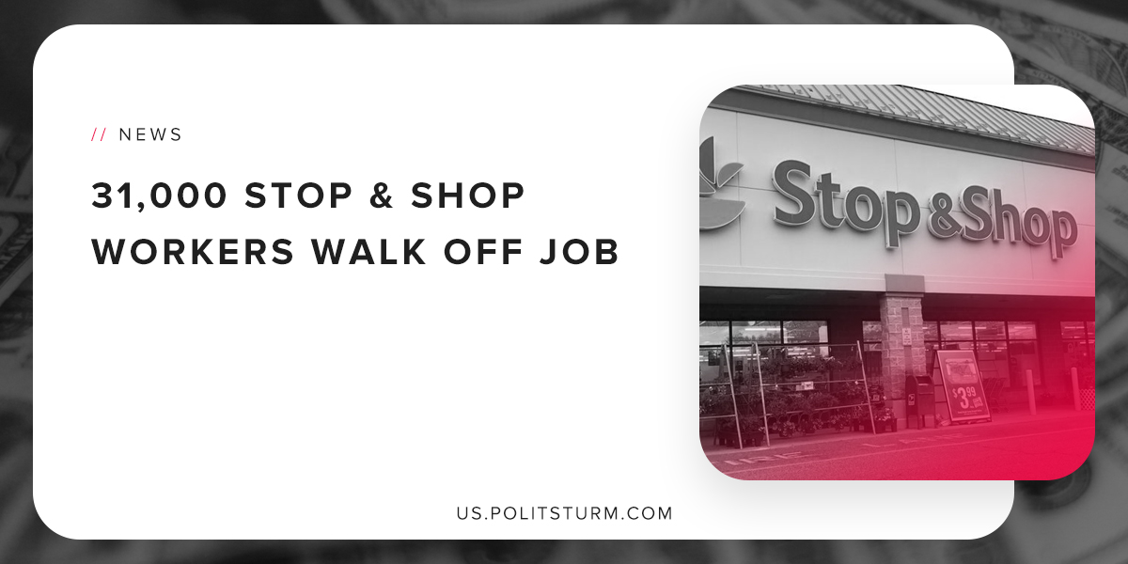

Original article
2019-04-21
1 min read

31,000 workers who are part of the United Food & Commercial Workers (UFCW) union who work for grocery retailer Stop & Shop are walking off the job. The workers are protesting cuts to health care, take home pay, customer service and unlawful conduct.
The union workers did not accept the terms of the latest proposal make by Stop & Shop which entailed massive cuts. Specifically, the company would require full-time employees to pay $893 more in health care premiums over the next three years. The average part-time worker would pay $603 more in weekly health care premiums over the next 3 years.
Pension benefits were also targeted to be cut by the proposed contract. Newly hired full-time employees would have their monthly pension benefit reduced by 32%.
In terms of wage increases, many part employees would receive a wage increase that is less than 2% on average. This increase would not even keep pace with the inflation of prices, so workers would not even see any increase in their real wages. The union noted that there was an 11.1% increase in dividends last year and profits were over $2 billion.
The union and workers can see that the capitalist class are making tremendous profits while the wages of the workers are stagnant. The dividends, capital gains, interest, etc. are flowing to the capitalist class, while the workers are working diligently but not seeing any tangible benefits.
The capitalist economic system is a system that benefits the class interests of the capitalists. Only the institution of a socialist planned economy and dictatorship of the proletariat will end the exploitation of the working class.
https://fred.stlouisfed.org/series/FPCPITOTLZGUSA
http://www.ufcw.org/press/

Original article

