3 Million Worldwide Deaths From COVID-19
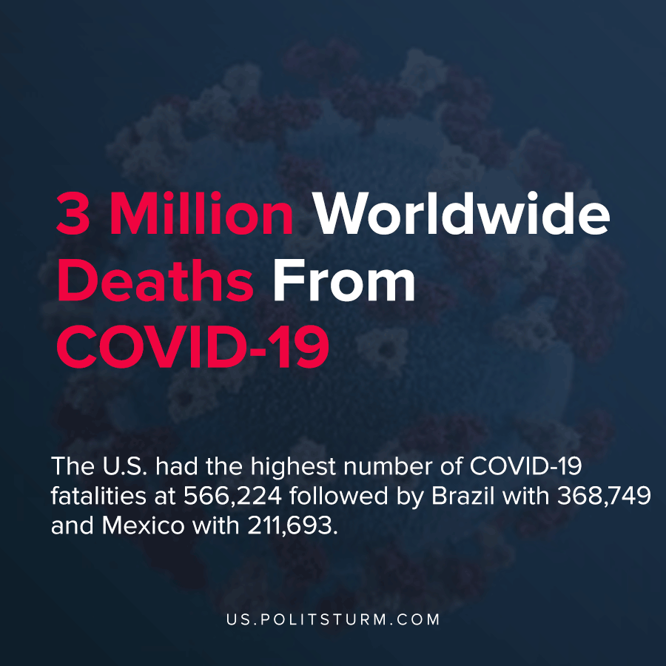

Original article
2021-04-17
1 min read

According to John Hopkins University COVID-19 tracker, more than 3 million people have died since the onset of the pandemic. The U.S. had the highest number of COVID-19 fatalities at 566,224 followed Brazil with 368,749 and Mexico with 211,693.
The United States has also had the highest number of reported cases at 31,567,744 which is almost 10% of the population of the country.
While vaccination figures have increased, the pandemic does not appear to be slowing down with 21 U.S. states reporting at least a 10% increase in cases.
Michigan saw the most rapid increase in cases per capita over the past week and also led the country in per capita hospitalizations.

“The answer to that is to really close things down, to go back to our basics, to go back to where we were last spring, last summer, and to shut things down”, said U.S. Centers for Disease Control and Prevention Director Rochelle Walensky.
The U.S. has failed to contain the pandemic and over half a million Americans have died as a result. The largely uncoordinated federal, state, and local response to the pandemic has been ineffective, and guidance from expert health officials often contradicts the profit motive of business owners.
Source: 1 , 2 , 3 , 4

Original article

