3.7 Million Children Fall Into Poverty
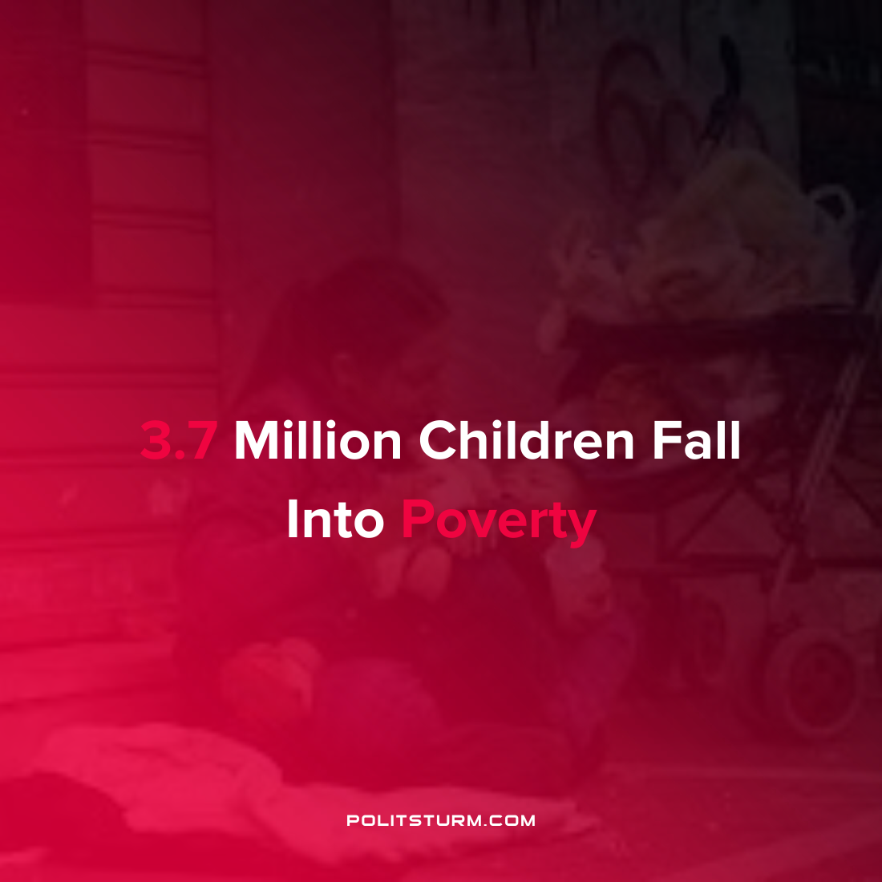

Original article
2022-04-15
1 min read

Millions of children have fallen into poverty in 2022 following the expiration of the Child Tax Credit, according to Columbia University’s Center on Poverty & Social Policy. The Child Tax Credit was created in 1997 and reduced taxes for families with children by reducing federal taxes.
During the coronavirus pandemic through the ‘American Rescue Plan’, monthly payments of $250 to $300 per child were made to families with children. At the end of 2021 the monthly payments expired which has had a measurable impact on child poverty in the country.
The monthly child poverty rate increased from 12.1% in December 2021 to 17% in January of 2022, an increase of 41%. This represents 3.7 million more American children living in poverty due to inaction of the bourgeois government.
Under the capitalist economic system, millions of vulnerable children live in poverty while the American oligarchs continue to extract massive profits. The entire economic and legislative edifice serves the interests of the rich, while problems of hunger, poverty, and unemployment (which only afflict the working class) are treated as unsolvable problems whose worst repercussions can only be slightly mitigated, at best. The hardships of the capitalist economic system are pushed onto the working class, particularly the most vulnerable proletarians. Marxism-Leninism, not the legislative acts of the congressional millionaires, is the only path through which the affliction of child poverty can be eliminated.
Sources: 1 2 3 4

Original article

