263 Million More People Pushed into Extreme Poverty in 2022
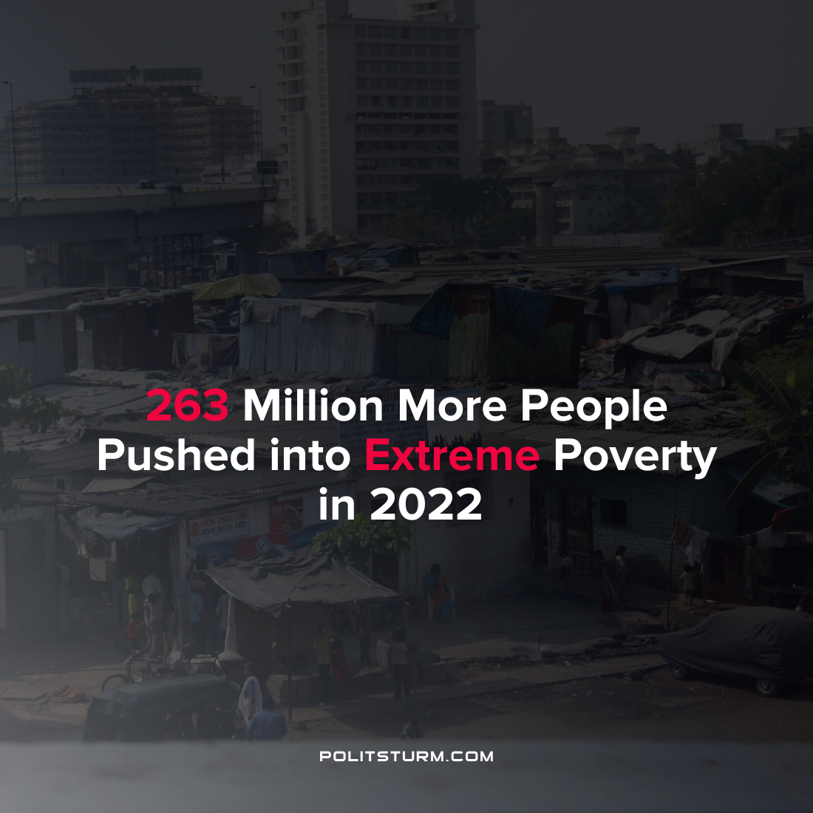

Original article
2022-04-21
1 min read

A brief by Oxfam predicts that a quarter billion people could fall into extreme poverty this year due to rising food prices, rising inequality and the ongoing “special operations” in Ukraine. Highly indebted countries ravaged by imperialism face looming debt crises, while corporate profits and the wealth of the oligarchs continue to rise.
“The combined impact of COVID-19, inequality and food price hikes could result in 263 million more people living in extreme poverty this year, resulting in a total of 860 million people living below the $1.90 a day extreme poverty line”, the brief states.
While food prices are rising at an extremely high rate pushing millions into poverty, large companies are reaping the benefit of rising prices as it boosts profits. By contrast, real wages are decreasing as wage gains remain stagnant while prices continue to rise and erode the purchasing power of workers.
Even prior to the pandemic, it was predicted that 593 million people would be pushed into poverty in 2022. However, due to a confluence of negative events, 263 million additional people could be living in extreme poverty this year.
As the capitalist economic system creates tremendous wealth for the private owners of the means of production, it relegates the majority of the world population to poverty. While the bourgeois class can only envision the mitigation of the worst excesses of capitalism, it is necessary to study the works of Marxism-Leninism in order to end the senseless cruelty of the capitalist economic system and end the exploitation of man by man.
Source: 1

Original article

