22,000 Tech Layoffs in 2022
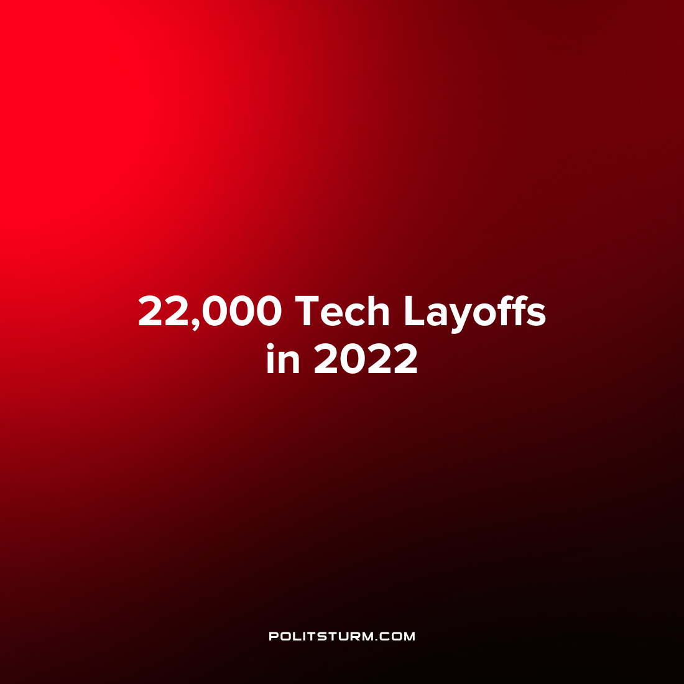

Original article
2022-06-07
1 min read

Crunchbase, a company that tracks data surrounding public and private companies, reported that 2022 is a banner year for tech layoffs. There have been 22,000 layoffs year to date so far in the U.S. technology sector.
Some of the prominent companies that have laid off staff this year include Netflix, Robinhood, Glossier, and Better. Companies have cited the COVID-19 pandemic and overhiring the previous periods as a rationale to explain the layoffs.
The article indicates that the effects of inflation, rising interest rates, and geopolitical uncertainty have affected publicly traded companies and this impact is now starting to be felt by smaller start-up companies.
Under the capitalist economic system the employment of the working class is always precarious. The capitalists can at any time stop purchasing the labor power of the workers who are left to fend for themselves. The laid off workers join the ranks of the army of the unemployed which puts downward pressure on the bargaining power of workers against the capitalists and benefits the class of oligarchs. Only under the socialist economic system has the ability to end the scourge of unemployment which is only a pipedream under capitalism.
Source: 1

Original article

