21st Century Famines? Capitalism To Take More Lives Again
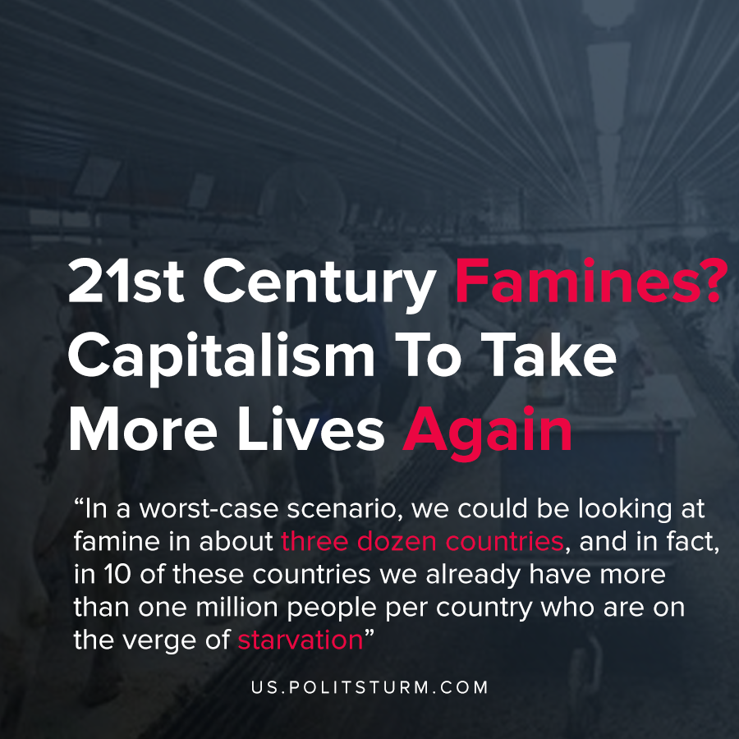

Original article
2020-04-27
1 min read

The UN agency chief had announced that we are to face one of the biggest starvations we had.
Beasley said today 821 million people go to bed hungry every night all over the world, a further 135 million people are facing “crisis levels of hunger or worse,” and a new World Food Program analysis shows that as a result of COVID-19 an additional 130 million people “could be pushed to the brink of starvation by the end of 2020.”
“In a worst-case scenario, we could be looking at famine in about three dozen countries, and in fact, in 10 of these countries we already have more than one million people per country who are on the verge of starvation,” he said.
In a crisis of overproduction, the capitalists do not see it being profitable to sell food under the market price since no profit can be generated. This once more proves that capitalism does not care about human being but only about profits. Historically similar events would occur in Imperial Russia which under Ivan Vyshnegradsky who was the minister of finance that became well known for his quote translated from Russian to “undernourished but exported”. Similar fates most of the world is experiencing where home countries produce more than enough food while there are still people starving.
The capitalist system allows for the starvation of millions while being able to produce enough to feed everyone. With the emergence of the next great depression, we can expect this starvation to spread to the developed world, similar to what America had to fight through during the great depression where people would also perish from the lack of nourishment. Only socialism can fix these contradictions of capitalism, as seen before every socialist country had fixed their malnourishment problems once and for all even though they only a few years ago under capitalism would have severe famines.
https://abcnews.go.com/US/wireStory/food-agency-chief-world-brink-hunger-pandemic-70269400

Original article

