2026 Starts Off with War Hysteria
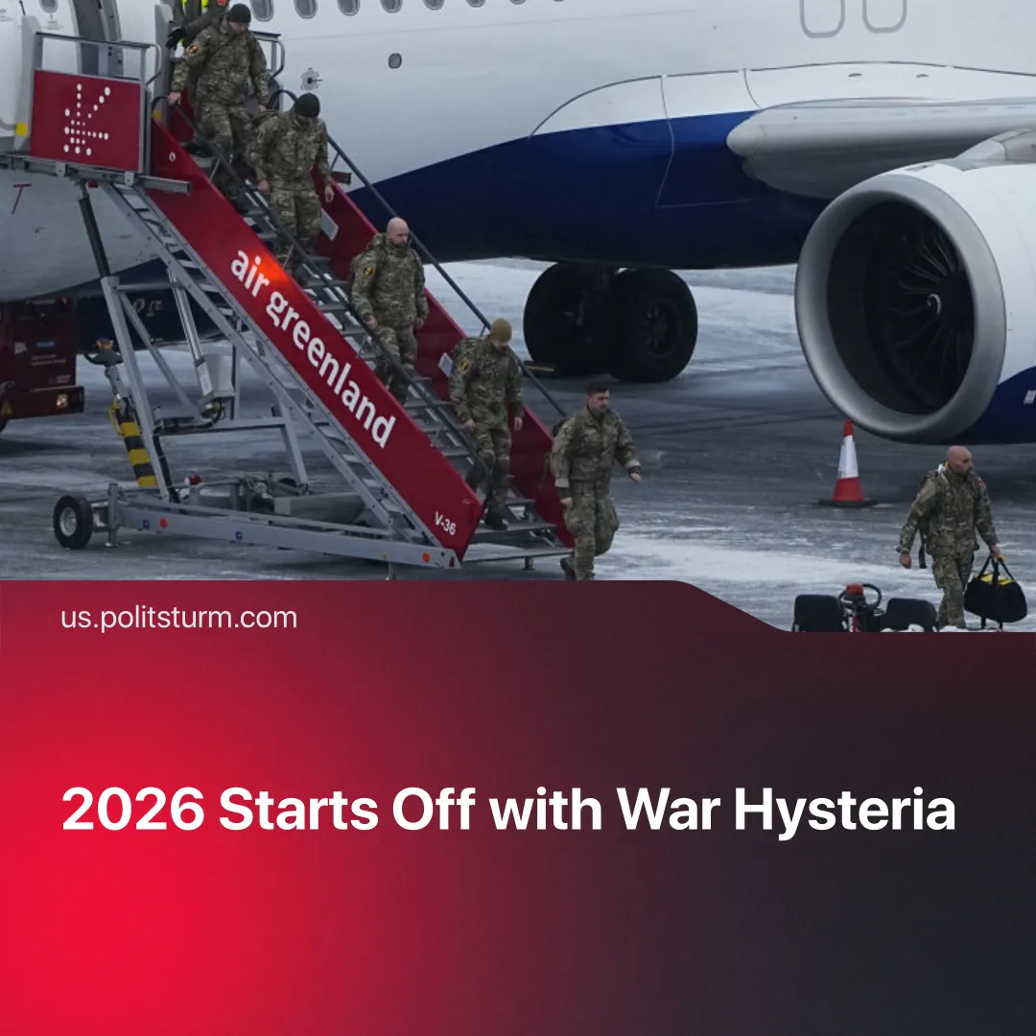

Original article
2026-01-24
2 min read

2026 started off with general war hysteria, mirroring historical world war preparations.
Details. In January, major escalations began across multiple fronts of the global inter-imperialist conflict, as capitalists increased the urgency of their drive to world war.
► In South America, the USA brazenly attacked Venezuela, breaking international law and capturing another nation’s president, with threats of similar actions elsewhere. This operation displaced Russo-Chinese capitalists from the strategically valuable oil fields.
► In the Atlantic, NATO captured foreign oil tankers, including a Russian-flagged one. This implements the latest US war strategy: clearly demarcating territory and sending warning signals to rivals. Following this, the BRICS alliance ramped up China-led naval exercises around the Cape.
► In Europe, the UK and France agreed to deploy thousands of troops to Ukraine after the SMO. The Russian military launched new Oreshnik missile strikes to threaten the West. Europe temporarily sent soldiers to Greenland to signal its ability to defend the island, whilst Trump floated a possible invasion.
► In the Pacific, the US and China intensified preparations. At the end of 2025, China had concluded its largest military drills yet around Taiwan, simulating a blockade of the US dependency.
► In the Middle East, lightning offensives in Syria and Yemen broke through frontlines that had been static for years. This followed heightened tensions between the new Saudi-led axis of Sunni powers and the Israeli-UAE partnership. In the process, the US abandoned its Kurdish proxies, despite decades of collaboration, instead endorsing Turkey’s efforts to secure its southern flank via the Syrian Transitional Government.
► In the Gulf, the US accelerated its offensive against Iran’s capitalist regime through “maximum pressure” sanctions. Israel and the US prepared renewed military strikes on Iran, although they were delayed for now.
► In Africa, local border disputes were drawn into wider conflict: Israel pursued an alliance with Ethiopia, whilst neighboring enemy Somalia joined the Sunni pact; similar divisions followed in Sudan and Libya.
Context. Today’s rapid rearmament mirrors the arms race in the years preceding WW1 and WW2. Capitalist propaganda whipped up war scares and militaristic hysteria to justify massive defense spending at the expense of workers, all while boosting profits.
► Similarly to today, imperialists clashed to consolidate their blocs. Great power annexations of neighboring territories, like Bosnia and Czechoslovakia, preceded the two world wars. In the 1911 Agadir Crisis, Germany used gunboat diplomacy to pressure France into exchanging African colonies.
► In the 1930s, leading up to WW2, fascist powers invaded Manchuria and Ethiopia. The League of Nations was impotent, merely sending "Commissions of Enquiry” to issue meaningless reports and condemnations. In the 2020s, the UN is equally powerless, its resolutions on Ukraine and Palestine ignored. Unilateral attacks and invasions have now become normalised.
Important to Know. Every major player is preparing for an open clash, be it an ever increasing number of proxy wars or a full-on imperialist world war. All blocs are clearing their rear, consolidating their territory, and getting rid of unnecessary distractions.
► Strategic resources are being secured, and capitalist war economies streamlined. Alliances are being rebalanced as imperialist interests diverge. Old agreements are revised, whilst new ones are formed.
► The US Secretary of War declared America is preparing for open conflict; President Trump recently announced a further 50% rise in defense spending to a record $1.5 trillion. NATO’s head urged readiness for world war, with Germany’s defense minister warning it could erupt in 2026. European states moved to reintroduce conscription, while increased surveillance and fascisation at home prepare societies for war by enforcing labour discipline and suppressing dissent.

Original article

