U.S. Elections: Everything You Need to Know
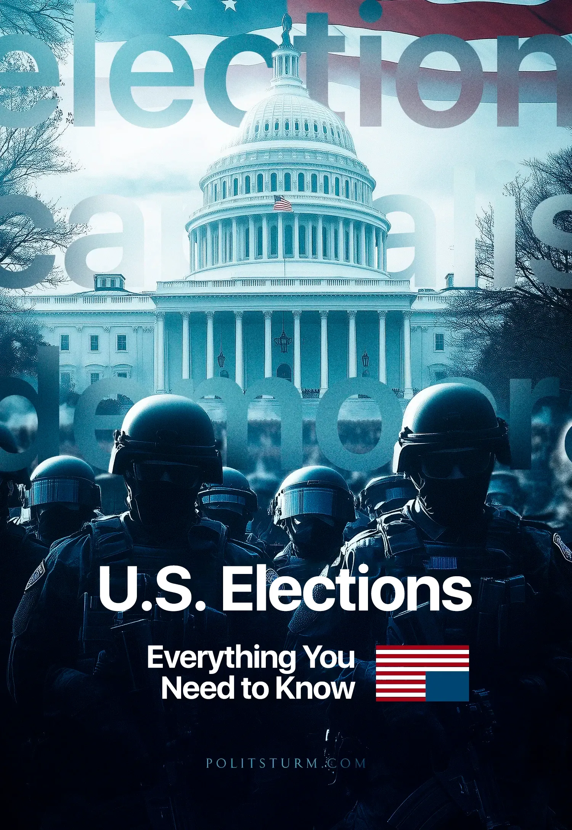

Original article
2024-11-03
93 min read

On November 5th this year, the presidential election were held in the United States. The political struggle in America has not subsided over the past months and has taken particularly acute forms instead.
What role does the President of the United States play? How is the American election system organized? What are the differences between the Democratic and Republican parties? Which representatives of big business support the main candidates and how will U.S. policy change after these elections?

I. What is the Role of the President of the United States?
The office of President of the United States has its origins in the early days of the formation of the American state. Following the conclusion of the War for Independence of the Thirteen Colonies, the Constitutional Convention adopted the U.S. Constitution in 1787. By setting out the general structure of the polity and the separation of powers, the Constitution would establish the role of the president as the head of the executive branch.
However, the real political weight and role of the office of the president in subsequent U.S. history would go far beyond the brief wording of the Articles of the Constitution. The president would become one of the most important officeholders in the entire U.S. political system. This process of expanding the role and powers of the president will be closely tied to the changing role of the United States itself in the international arena, especially in the twentieth century.
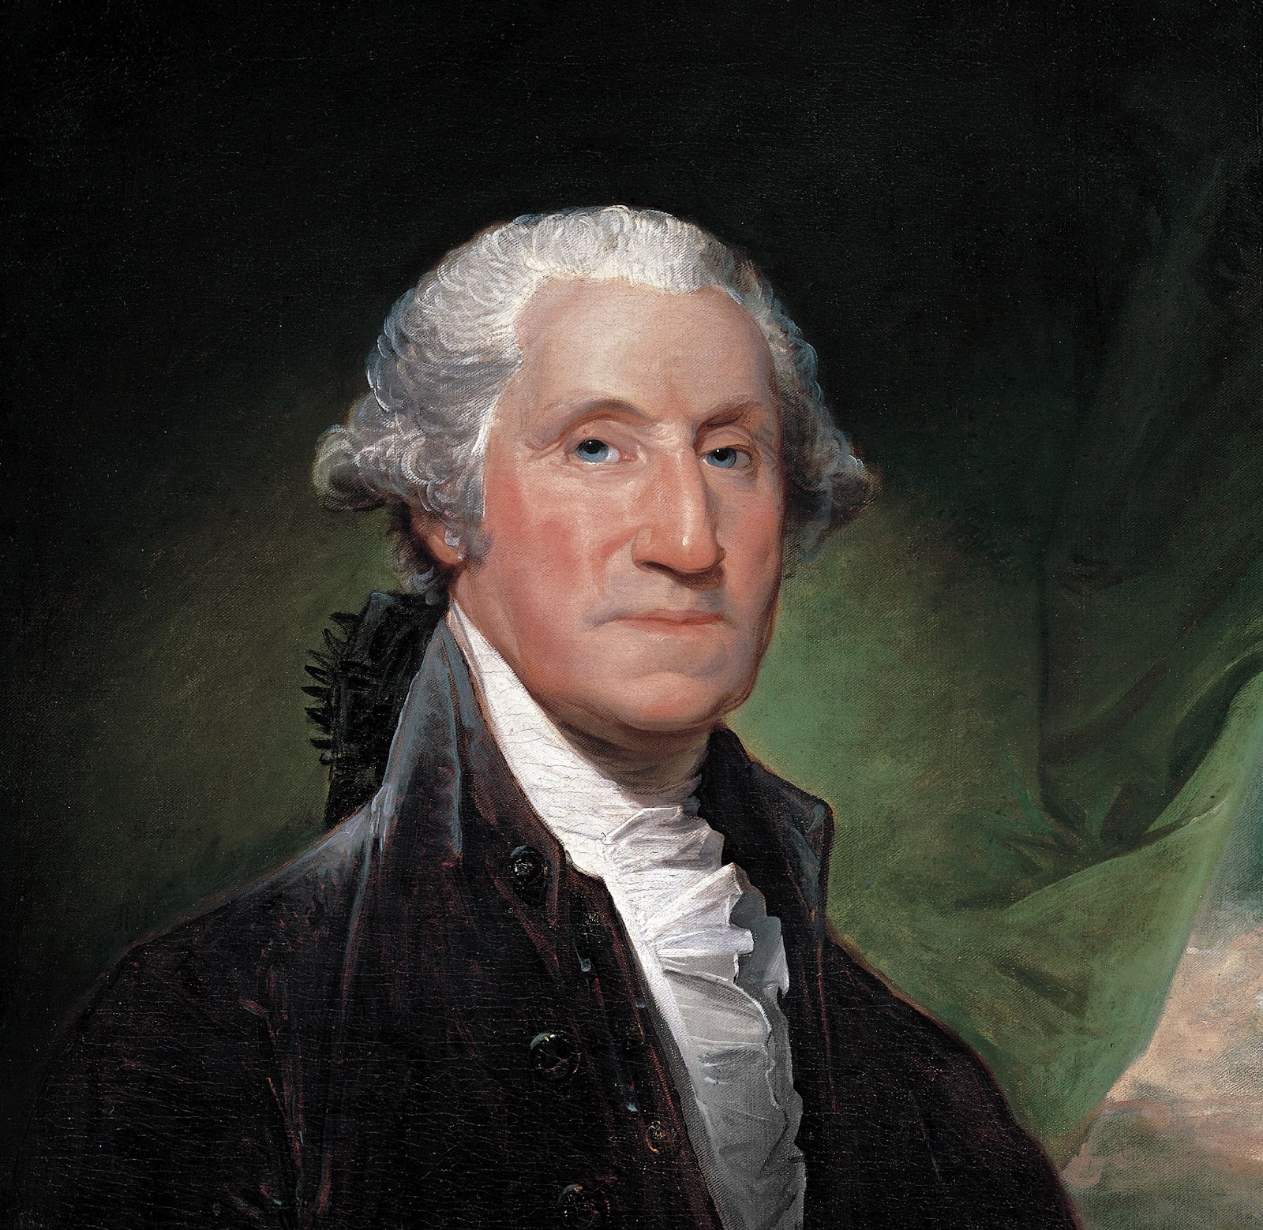
George Washington, the first president of the United States
Karl Marx called a state an executive committee of the ruling class. The president in the United States, as in any other bourgeois presidential republic, is the chairman of such a committee. He is the political leader of the entire American capitalist system, or to put it simply, the “general manager”. He approves or rejects laws passed by Congress, and appoints key officials: ministers, ambassadors, heads of various departments, and key services, as well as nominates Supreme Court justices. The president can also dismiss or remove these individuals from their positions (except the Supreme Court justices).
In terms of domestic policy and government, the powers of the U.S. president are limited. In particular, unlike in Russia or other post-Soviet republics with strong presidential power, he has no direct legislative initiative and cannot introduce laws directly to Congress. He can only promote new laws indirectly through individual members of Congress or his party. The most he can do is to send a message to Congress calling for the passage of a particular law.
This system of presidential involvement in legislative change has repeatedly led to episodes of confrontation between the American president and the legislative and judicial branches of government. It took especially acute forms in periods of long-overdue and profound reforms.
Franklin Roosevelt once had to fight with Congress and the Supreme Court when implementing economic reforms to overcome the Great Depression in the 1930s. At times, the confrontation reached the point where the Supreme Court tried to overturn Roosevelt's laws, and some officials accused the president of tyranny. In response to the Supreme Court's resistance, Roosevelt even attempted to "expand" the Supreme Court to appoint more loyal justices, but this initiative met with stiff resistance in Congress.
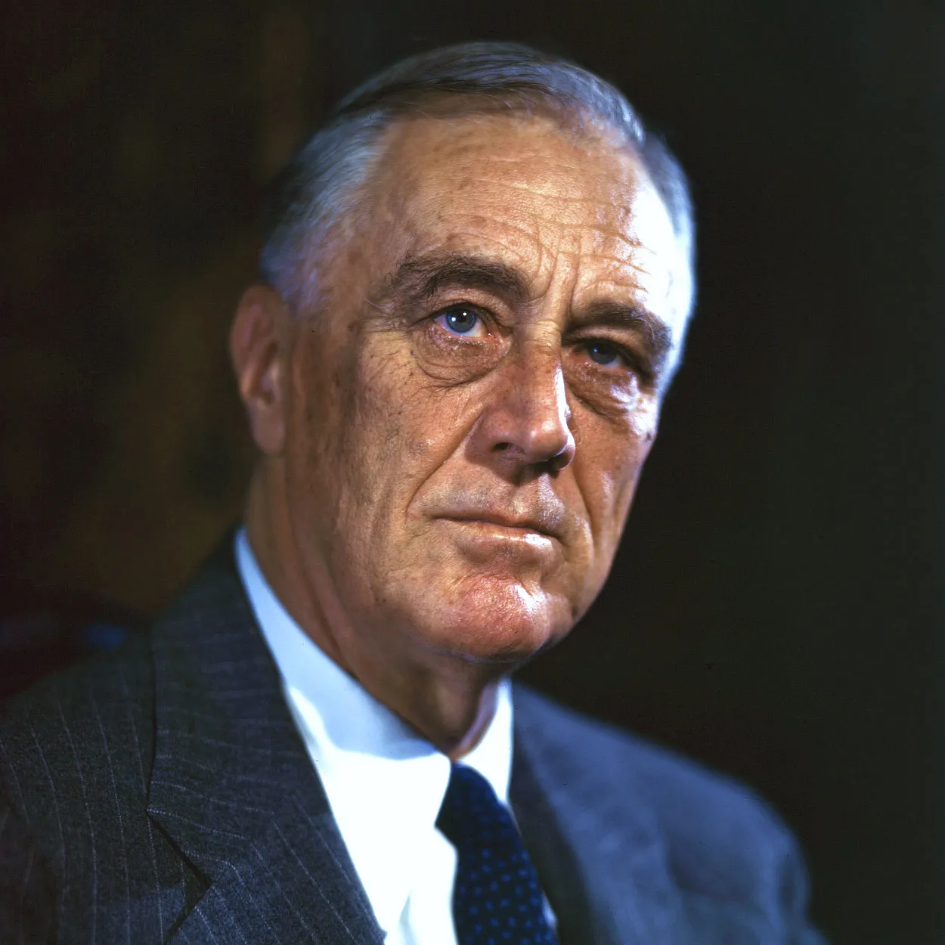
Franklin Roosevelt, 32nd president of the United States.
Bill Clinton in 1993 faced opposition from Republicans in Congress to federal tax reform, which was designed to cover the budget deficit. Clinton was able to overcome congressional opposition and pass the reform. But a year later, he failed in his attempt to change the healthcare system: the reform, which would have provided health insurance to all U.S. citizens and shifted the cost of that insurance to businesses, was scrapped after a fierce fight by big business and its lobby in Congress.
A few decades later, Barack Obama would return to the Affordable Care Act, again facing opposition in Congress and the media. But unlike Clinton, Obama would succeed in passing what is now known as “Obamacare”.
In recent times, the greatest resistance of the legislature to the reformist aspirations of the president has been seen under the presidency of Donald Trump. One of Trump's key campaign promises was tax reform: during the election, he promised to drastically cut taxes, especially for businesses and large corporations. Although the Republican Party, from which Trump won the election, controlled both houses of Congress, his initiative drew a barrage of criticism from Democrats. To pass the bill, Trump and the Republican Party had to engage in lengthy negotiations with the Democratic Party. The reform, which included a reduction in the corporate tax rate from 35% to 21%, was signed into law by Trump in 2017.
Any domestic reform or change affecting one or another area of the inner workings of the American economy, social sphere, or politics goes through a complex system of review and approval. At every stage of the development of a bill or initiative, big business-controlled lobbying groups in Congress, the media, the Supreme Court, and a host of other organizations conduct campaigns to promote or oppose the reform. This system reflects the conflicting views of different dominant groups of the American business and political elite on domestic issues. The entire mechanism for passing domestic reforms is designed to give no one group a decisive advantage.
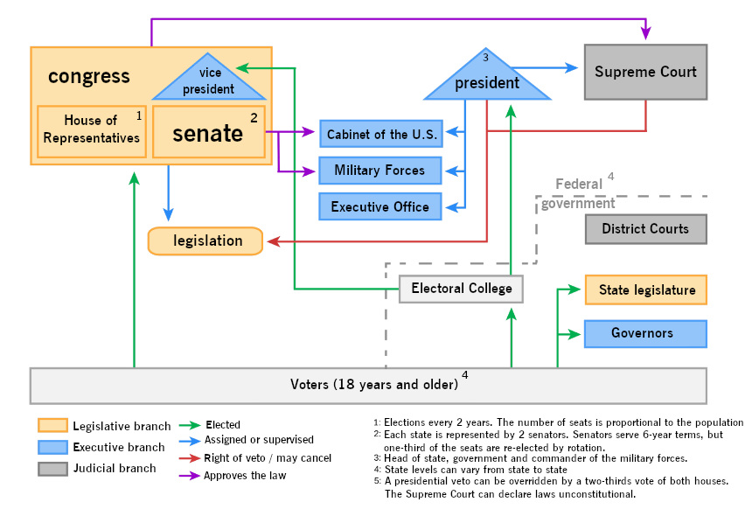
However, there is an area in which the vast majority of U.S. business and corporate elites share a collective class interest. They may argue about taxes, health care, or social policy, but they all converge on the desire to maintain and strengthen U.S. dominance in the global marketplace and international arena. This leads to the U.S. president having far more power over foreign policy.
The U.S. President has the full right to direct the entire foreign policy of the state, and his capabilities far exceed those of Congress. In some aspects, this influence acquires truly autocratic features. It is the president who acts as a key figure in determining the direction of foreign policy and setting goals and objectives for such departments as the State Department (i.e. the Ministry of Foreign Affairs). For this purpose, the president has a full set of necessary tools.
The President acts as commander-in-chief of the U.S. armed forces, makes international treaties with Senate approval, and serves as the chief diplomatic representative and negotiator. But far more important is the president's military power. He can single-handedly initiate military operations without the need for a declaration of war by Congress. The War Powers Resolution passed in 1973, gives the president the right to use the military at his discretion for a period of 60 to 90 days. All the president has to do is notify Congress of his decision and give them a report on the reasons and circumstances for using the U.S. armed forces. At the end of the specified period, the President either recalls the troops or obtains special authorization from Congress to continue using the military.
Although the law was presented as restrictive, it in fact legally formalized the exclusive right of the U.S. President to use the armed forces within designated boundaries.
The 1973 law made it much easier for the U.S. ruling class to conduct military operations and incursions into its areas of interest. It simply eliminated from the process all the bureaucratic procedures of coordinating actions with the legislature, where conflicting political interests often clash and delay the decision-making process. The U.S. foreign policy war machine acts quickly.
The law's provisions were used by President Reagan for Operation “Urgent Fury”: the invasion of Grenada in 1983 to overthrow the pro-Soviet and pro-Cuban leftist government. Three years later, in 1986, he would order air strikes on Libya as part of Operation Eldorado Canyon.
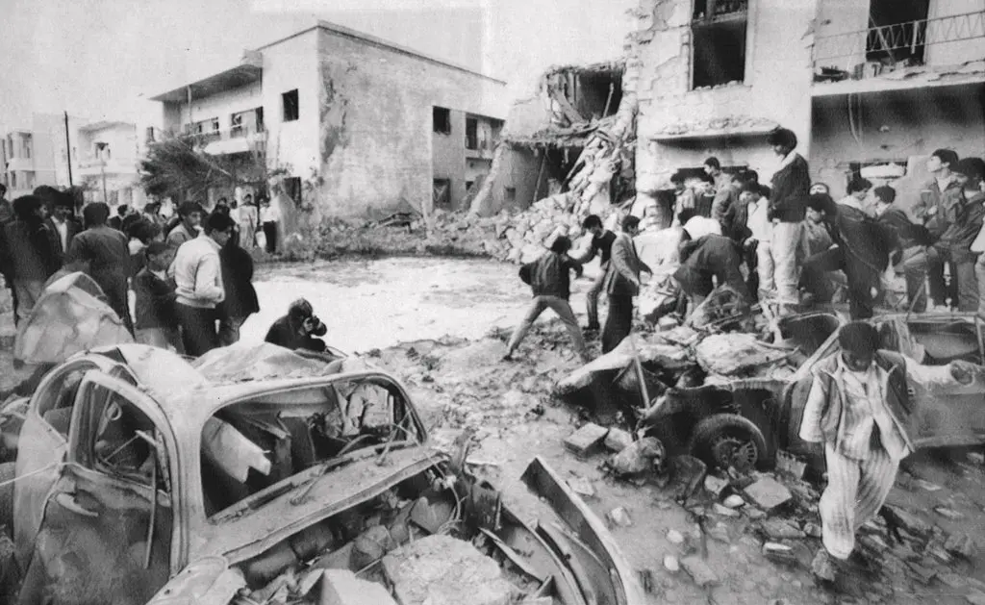
Libyans observe the damage in Tripoli, after U.S. warplane strikes in 1986. Source: Associated Press
George Bush Sr. would invoke the provisions of the War Powers Act to send U.S. troops to the Persian Gulf in 1990-1991 for the “Gulf War” against Saddam Hussein's government in Iraq. Bill Clinton used the law to send troops to Somalia in 1993-1994, in 1994 to invade Haiti, and in 1995 to bomb Bosnian Serbs during the 1991-1995 war in Bosnia and Herzegovina. Finally, in 1999 the bombing of Belgrade and other cities in Yugoslavia.
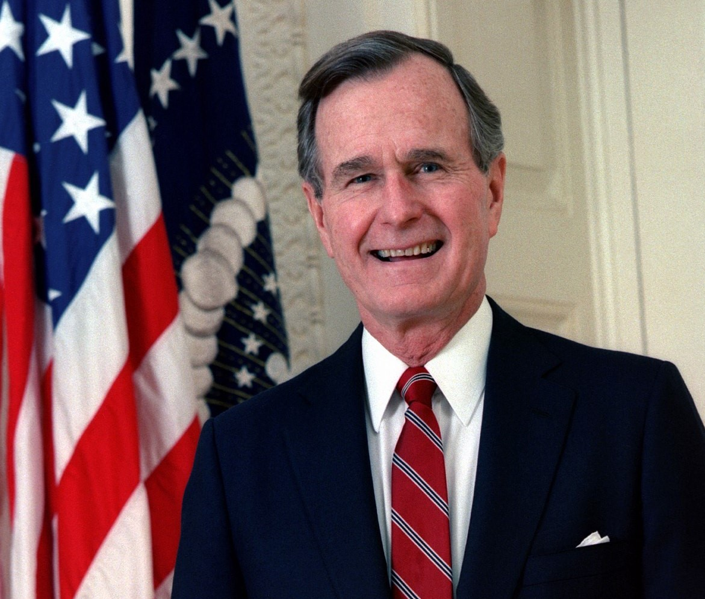
George Bush Sr., 41st President of the United States.
The same legal mechanism will apply to all subsequent U.S. military operations around the globe, from Syria to Afghanistan.
In total, from 1973 to 2017, U.S. presidents notified Congress of the use of armed forces outside the United States 168 times. At the same time, they "forgot" to do so 18 times between 1973 and 1998. If during all this time the institution of the presidency in America was criticized for its exclusive powers in the sphere of foreign policy, after the events of September 11, 2011, such criticism has practically disappeared. On the contrary, critical voices against such presidential powers have been drowned out by militaristic propaganda and have given way to demands for a "strong president".
It is worth mentioning here that American political scientists and legal scholars themselves noticed the president’s special role in foreign policy and call it “imperial presidency”. In the area of foreign policy and the use of armed force, the US president finds himself free from most elements of the checks and balances imposed on him by the Constitution and the laws. In his almost autocratic hands is the second, after finance and credit, the key tool of American diplomacy — military force.
But even before the 1973 law, the president had very few constraints on the use of military force abroad. The law merely formalized and simplified what existed in practice: the president's special authority to send U.S. troops into areas of U.S. interest without seeking separate congressional authorization.
Thus, the imbalance that exists between the powers of the U.S. president in the domestic and foreign policy spheres is clearly visible.
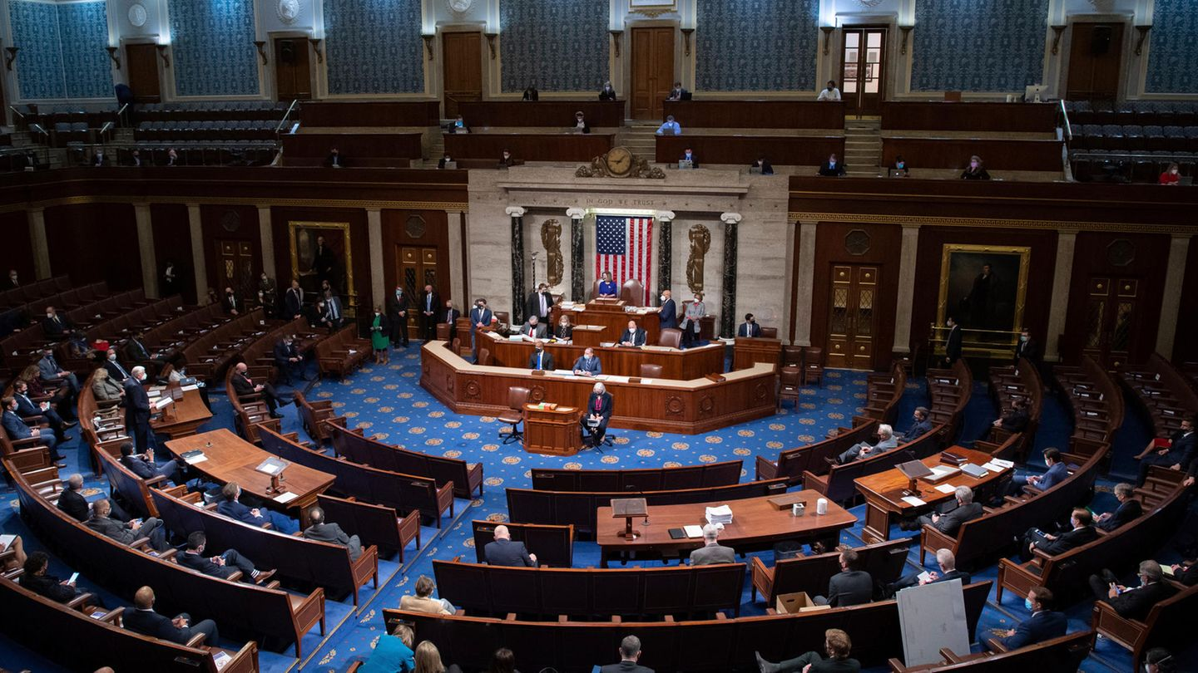
Congress session
What is the reason for this? Why, when in domestic policy the president has to coordinate every decision with countless legislative and judicial institutions, and every step is constrained by a multitude of constitutional limitations, in foreign policy he has almost complete freedom of action? After all, the Constitution does not provide for such presidential powers.
It's about the role and position of the United States in the world. It has not always been as it is today: from the adoption of the text of the Constitution in 1787 to the present, the influence of the United States on international politics in general, and of American capital on the world market in particular, has markedly changed.
In the 19th century, American industry was still weak and American capitalists had little influence in the world market. They were squeezed from all sides by the European “great powers”, and the dominant attitude of American politicians was “isolationism”: focusing on domestic affairs.
Everything changed after the two world wars. During the First World War, American financial circles enriched themselves by lending to Europe. By the end of the war, the domestic market had grown and the industry of American companies had strengthened. Given the general economic decline of Europe, this led to the active expansion of American capital into the European market. Following American credit, American goods began to flow more aggressively into Western Europe: machinery, automobiles, food, materials, and other products. The U.S. began to invest heavily in European companies, and American banks began to lend. Where faltering European capital lost ground, American capital immediately stepped in.
The growing economic weight of the United States in the European market, and thus in the world market, inevitably led to an increase in the political influence of the American state. American President Woodrow Wilson, although he entered World War I later than other participants, was one of the key persons during the Paris Peace Conference. The so-called Five Power Treaty, the first attempt to limit the naval arms race after World War I, was signed in Washington.
However, the strengthening of the U.S. position on the world stage gained the greatest momentum after World War II. Weakened after the most destructive war in the history of mankind, Western Europe fell at the feet of the new hegemon of the capitalist world. American financial capital, even more enriched by military supplies and loans, simply could not compete in the European markets. A special role was played by the Marshall Plan, which provided European countries with economic aid for reconstruction in exchange for the expulsion of communists from official politics. The creation of the NATO bloc and other international organizations in which the United States played a key role, such as the International Monetary Fund, completed the job.
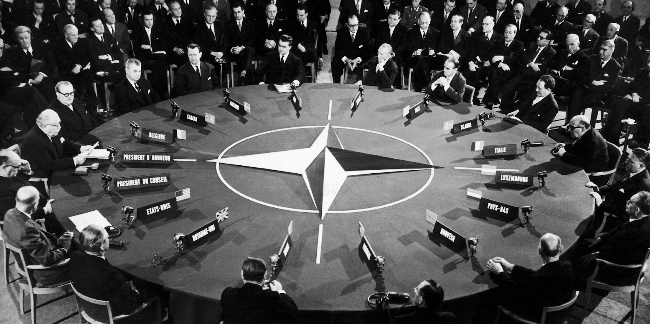
NATO Council after the end of World War II
In the period from the end of World War II until the end of the 20th century, America's position became even stronger. The U.S. became the largest economic and political actor in the capitalist world. The collapse of the USSR and the defeat of the socialist system in 1991 meant that for a while the USA was the only hegemon on the planet and the only country that could truly be called a "superpower". This will only change with the rise of China.
In line with the new role of the American state as the “world leader” and the strongest “great power,” the role of the U.S. head of state has also changed. The American president has become a key world leader - a “world policeman” guarding the U.S.-centric “world order”.
Thus, as the weight of the United States in world processes increased, the powers of the president in directing and determining foreign policy expanded. They reached a scale and significance that the "founding fathers" of the American state could not have imagined.
This process is natural. The American ruling class, which had become the most influential force in the capitalist world, faced many challenges. Not only did it have to strengthen and expand its position in the world, but it also had to resist attempts to change the prevailing world order in at least one particular region. National liberation movements in European colonies, communist revolutions in Asia, Latin America, and Africa, as well as the struggle of certain bourgeois regimes for influence in their regions. Finally, the Cold War confrontation with the Soviet Union. All this directly affected the interests of American capital and threatened its position and sphere of influence.
American soldiers and American weapons have taken part in countless hot and cold conflicts from Korea and Vietnam to the Middle East and Cuba. U.S. intelligence agencies, political advisors, and agents have created a vast network of influence and agency around the world. The main motive behind the aggressive policy of the USA was the confrontation with the USSR and the international communist movement. The American state went through a series of complex stages and periods, separate crises such as the one in Cuba, as well as the space and nuclear races. Each of them threatened the existence of the American-centered world system. But even after the elimination of the socialist system, the number of challenges to the position of the United States did not decrease. They include endless interventions in Africa and the Middle East, confrontation with Russia in the regions of the former Soviet Union, especially in Ukraine, and a new cold war with China.
With such a broad foreign policy front, the American ruling class needed an effective apparatus for decision-making and implementation — an instrument whose work would not be slowed down by endless parliamentary hearings and debates. The office of the president became such an instrument.
By concentrating the broad powers of foreign policy and the use of military force in one office, by surrounding the president with specialized agencies and services of varying degrees of secrecy, the American ruling class got an official who would carry out its will.
The president of the United States is completely subordinated to the interests of the ruling class. He shapes and directs international policy following his economic interests through countless agencies and services: the State Department, the Secret Service, the Department of Defense, the CIA, etc. In this case, the president acts as a convenient instrument of foreign policy — a conductor of the will of big capital.
At the same time, American presidents themselves are connected to the ruling class and elite circles by countless threads, often coming from their backgrounds and networks. For example, political elites such as Howard Taft, John F. Kennedy, Bill Clinton, or Joe Biden; capitalists such as Herbert Hoover, Gerald Ford, Jimmy Carter, or Donald Trump. An overwhelming number of American presidents have risen through the ranks of the dominant elites in one way or another: they have had distinguished political careers in the Senate or at the state level, attended elite Ivy League educational institutions, come from elite families, or owned large corporations.
A special place in American politics is occupied by entire political dynasties that have been formed over centuries: the Roosevelts, Kennedys, Fords, and Bushes. In the case of the Roosevelts and the Bushes, different members of these families came to power several times, and the Clinton family is still considered one of the most influential political forces in America.
This close class kinship between American presidents and the ruling elites makes them an organic part of the entire capitalist system. The interests of American business and elites are understandable and close to them in class terms. In this sense, every American president embodies the collective capitalist of America.

II. Who elects the president and how?

2.1 Who can become the president?
According to the Constitution, any natural-born citizen of the United States who is at least 35 years old and a resident of the United States for at least 14 years may be elected President. There is no formal monetary or political qualification. In theory, any adult American citizen can become president. This is what politicians try to convince the American society and the whole world.
In reality, not everyone in the United States can become president. Moreover, not everyone can afford to even participate in elections.
Money is the main barrier that excludes the majority of potential participants in the presidential race. Campaigning requires an enormous amount of money. Presidential candidates need hundreds of millions of dollars just for campaigning, advertising, and public appearances.
Cumulative spending by all presidential candidates from 1984 to 2024 was $3 trillion. At the same time, the cost of campaigning has been rising steadily all this time. If in the 2000 election. The Democratic Party spent about 176 million dollars, in 2008 this amount was already 1 billion and 100 million, increasing to 3 billion by 2020.
Obviously, a candidate, even if he is a big businessman himself, can never pay for his campaign alone. But it is not required, because at this point the sponsors or, as they are called in the United States — donors of presidential campaigns - come into play. It is American millionaires and billionaires, owners of large corporations and financial conglomerates who pay for the entire campaign with their contributions to the candidate's campaign accounts.
At the national convention of the Republican Party in July of this year, vice-presidential candidate J.D. Vance said:
“We don't need a leader in the pocket of big business, but someone who is accountable to common workers.”
Vance, whom Trump chose as his vice presidential running mate for the upcoming election, repeated the same narrative his boss used in the 2016 election. Back then, Trump presented himself as a fighter against the elites, a defender of the common American worker, and an opponent of the establishment. One of his famous promises was to “drain the Washington swamp.”
In fact, Trump is just as much in a pocket of big business as his opponents. This is especially evident in the financial reports of his campaign headquarters. As of the summer of 2024, 26 American billionaires with a combined fortune of about $143 billion have endorsed him. And while the exact amount Trump has raised for the election is currently unknown, the figure is in the hundreds of millions of dollars.
But we know much better how much he managed to raise in past elections. In 2016, his staff spent almost $4 billion dollars on the campaign, and in 2020. - A whopping $6 billion. But that's not the limit either - his opponent in that election, current President Joe Biden, raised 9.5 billion.
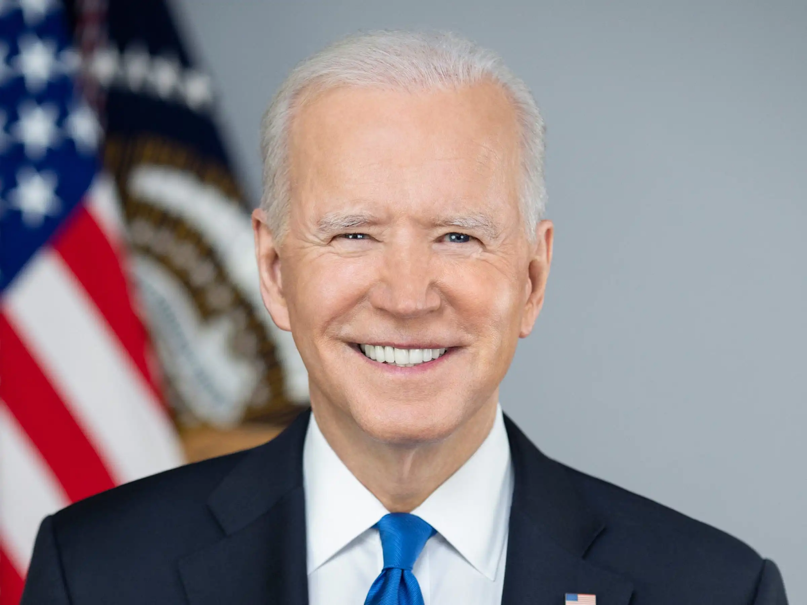
Joseph “Joe” Biden, 46th President of the United States
These are all sums that the average American cannot even imagine. At the same time, it is the amount of money available in the campaign account that largely determines the outcome of the campaign.
It turns out that no matter how much American politicians deny their ties to big business and the wealthiest Americans, it is their support that ultimately determines their victory in elections. Thus, it is safe to say that presidential elections do indeed have an informal barrier of entry in the form of money that is not reflected in any statute or article of the Constitution. No senator or politician will say anything about this limitation, but it exists, and it greatly impacts the outcome of the election.
At the same time, however, the open participation of multi-million sums of big capital in the election procedure means that each participant in the presidential race is not an independent figure but a pawn subordinated to capitalists and representing their interests.

2.2 Republicans and Democrats
The money limit is not the only obstacle on the road to the White House. Sponsors must be attracted, and this can only be done if the candidate has the necessary political support from a major U.S. party. If a candidate seriously expects to advance their candidacy, they must represent one of the major U.S. parties: the Republicans or the Democrats. Only if one of these parties selects this candidate for the next presidential election will they have a real chance of winning.
As we know, there is a two-party system in the United States: while there are dozens of registered parties, there are only 2 major and influential ones that control Congress and can exert a decisive influence on state’s policy.
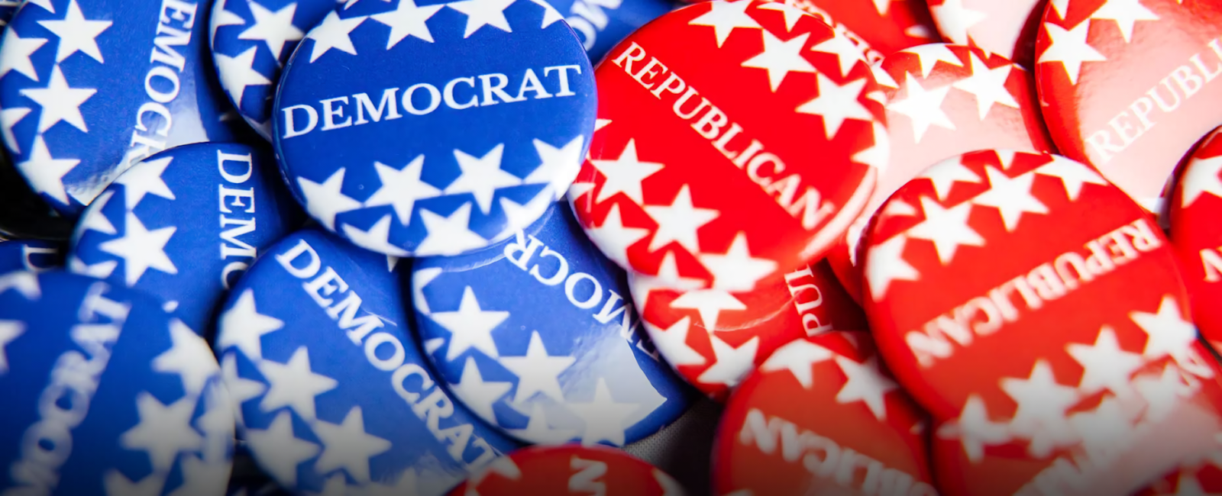
The modern two-party system with the choice between Democrats and Republicans did not always exist. In the early decades of U.S. history, the country alternated between several party systems, but the dominance of the two parties remained constant. Parties split and changed, new parties emerged, and old parties disappeared. The modern division of the United States into Democratic and Republican parties has existed since the mid-19th century.
Neither Republicans nor Democrats have ever been monolithic political entities with once and for all established value systems. On the contrary, they have often shifted their ideological positions to the point of conflict. During the Civil War, the Republican Party, led by President Abraham Lincoln, acted as a progressive force and fought for the abolition of slavery, while the Democratic Party mainly represented the interests of reactionary Southern slaveholders and opposed the abolition of slavery in every way possible.
By the middle of the 20th century, the parties had switched places. The Democratic Party was the one that supported Roosevelt's New Deal, which provided for a significant increase in government regulation and the development of social welfare during the Great Depression. Meanwhile, Roosevelt's opponents in the Republican Party criticized his actions in every way possible, advocating a free market with minimal government intervention.
The ideological labels of both parties would change many times in subsequent American history. But by the middle of the 20th century, both parties would take on ideological colors familiar to a modern person. In public policy, the Democrats would assume the role of a party with a “leftist” bias, while the Republicans would demonstrate a commitment to a “rightist” course.
In the 1980 election, the Republican candidate, Ronald Reagan, advocated reducing government regulation of the economy, lowering taxes, and slowing the pace of social reform. These policies came to be called “Reaganomics” after his victory. And the Democratic candidate, Jimmy Carter, proposed exactly the opposite: to continue the policy of government regulation of the economy and to increase spending on social programs. At that time, the Democratic Party's agenda included messages about environmental protection and a “liberal” approach to social issues.
In the 2008 election, Democrat Barack Obama advocated for a massive health care reform and stimulating the economy by increasing government spending. He promised to cut taxes for workers and raise them for the rich. His Republican opponent, John McCain, ran on exactly the opposite platform: cut government spending, preserve the old tax system of Republican President George W. Bush, and increase oil and gas production.
In all these cases, the ideological orientation of each party is clearly visible. At the moment, the situation has not changed but only intensified: since the beginning of 2010, the image of both parties has been definitively established.
The Democratic Party creates the illusion of a “left force” in American society. It appeals to poor and partially middle-class American workers. Its main messages are government regulation, promises to protect the working class, environmentalism, and minority interests. It is the values that the Democratic Party usually promotes that are commonly called “left-liberal” in the West.
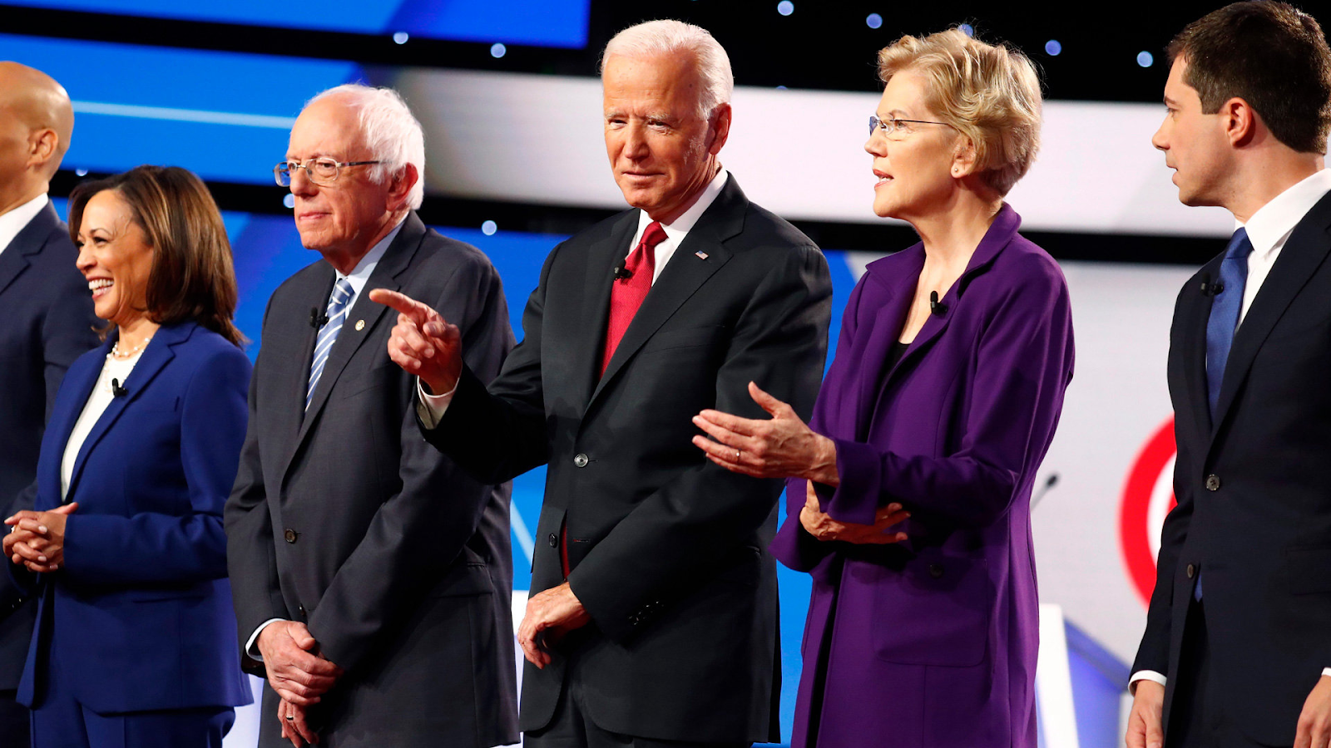
Representatives of the U.S. Democratic Party. From left to right: Kamala Harris, Bernie Sanders, Joe Biden, and Elizabeth Warren.
For example, the so-called “left-wing Democrats” is a faction that acts as a “radical” wing within the Democratic Party with maximalist demands on social policy, from universal health care and high taxes on corporations to comprehensive support for minorities and criminal justice reform. The Democrats are joined by politician Bernie Sanders, who calls himself a “socialist”, criticizes Donald Trump, and fights against corporations. But that didn't stop him from supporting legislation favorable to big sugar producers after receiving about $20,000 from the sugar lobby.
All the bourgeois organizations and figures that make a show of “progressive rhetoric” are also oriented toward the Democratic Party: environmentalists, all bourgeois feminist organizations, minority groups, pseudo-socialists, and social democrats. Often, even Trotskyists maintain ties to this party. In particular, the Trotskyist “Reform and Revolution” faction within the Democratic Socialists of America organization regularly supports Democratic Party initiatives and Democratic Party candidates.
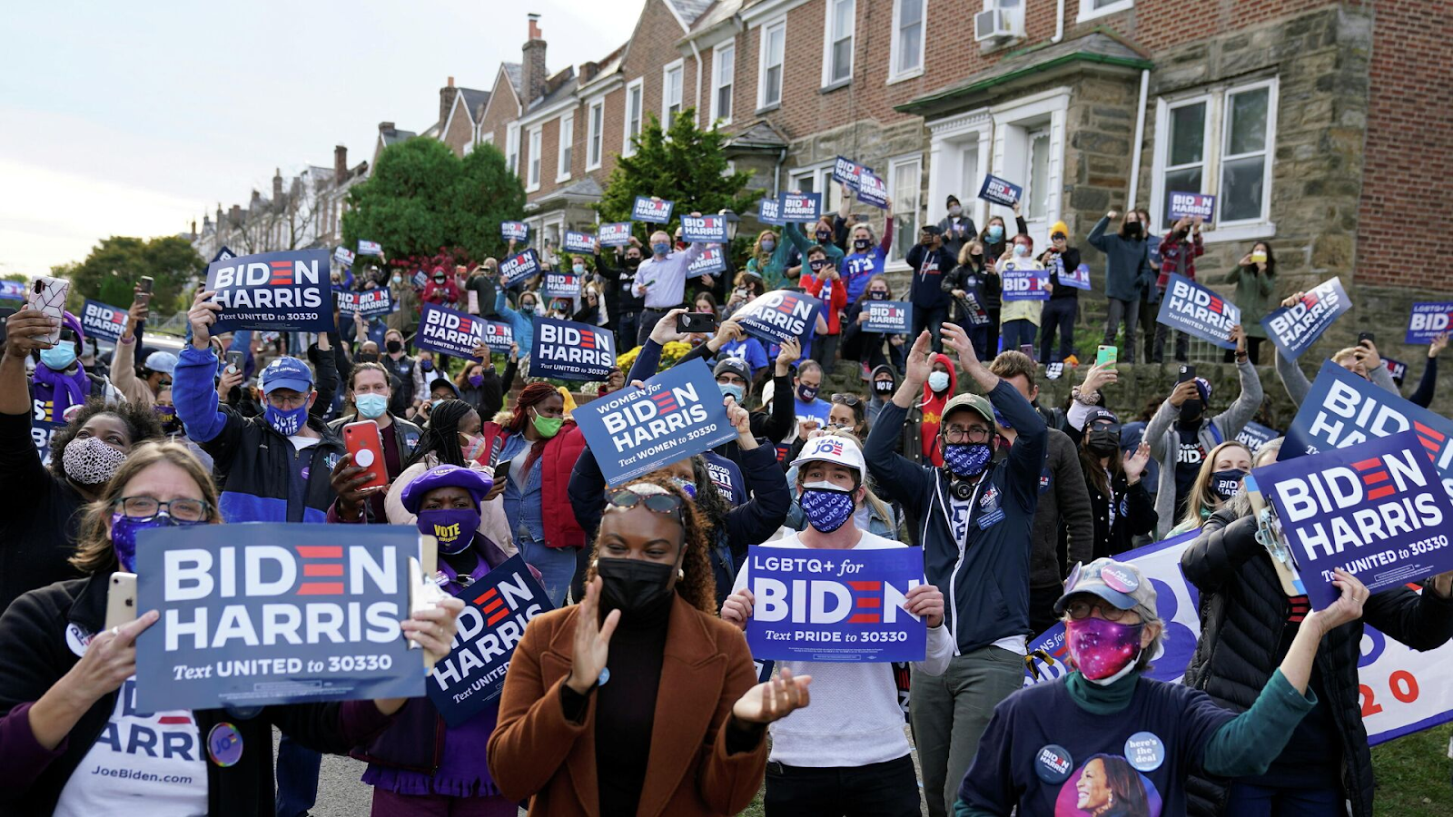
A rally of the US Democratic Party supporters. Source: Reuters / Kevin Lamarque
The Republican Party, on the other hand, positions itself as the main “right-wing” force in America, relying on the middle and wealthy classes of Americans, including large farmers and landowners. This party espouses slogans of “conservative” and “traditional” values and flirts with messages of “good old-fashioned” America. Republicans vehemently criticize the Democrats' environmental, gender, and social agendas. On the economic front, the party portrays itself as the defender of business, advocating less government regulation and lower taxes.
This is why all radical right and far-right elements in the United States are aligned with it.
In particular, there is a faction of the Christian Right within the party that dates back to the 1970s. During Trump's first term, his vice president, Mike Pence, was a member of the Christian Right. The faction is currently represented by the Speaker of the House, Mike Johnson. The Christian Right demands a conservative and religious-nationalist course in domestic policy, fighting against the gender agenda and the granting of rights to sexual minorities. One of the main points for the Christian Right is the restriction of abortion.
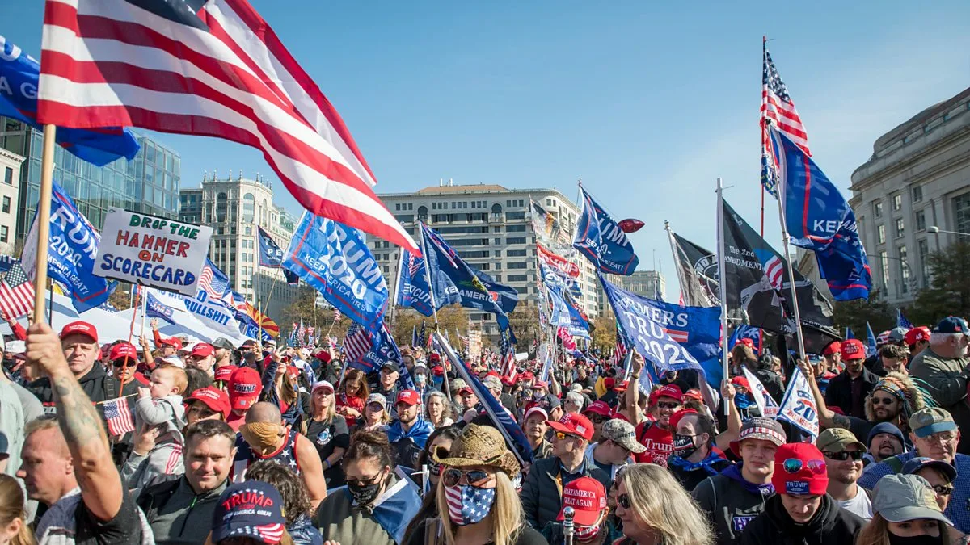
Gathering of Donald Trump’s and the US Republican Party’s supporters.
A special place both within the Republican Party itself and among its voters is occupied by the Trumpist movement, most often referred to as the MAGA movement (abbr. Make America Great Again) or America First. These are groups and organizations characterized by strong support for Donald Trump.
In most cases, the Trumpist trend absorbs broad right-wing elements, from populists to the open far right, including near-fascist organizations. These include neo-fascist organizations such as the Proud Boys, a group that preaches nationalist, anti-Semitic, and Islamophobic ideas. Members of this organization participated in the storming of the Capitol on January 6, 2021.
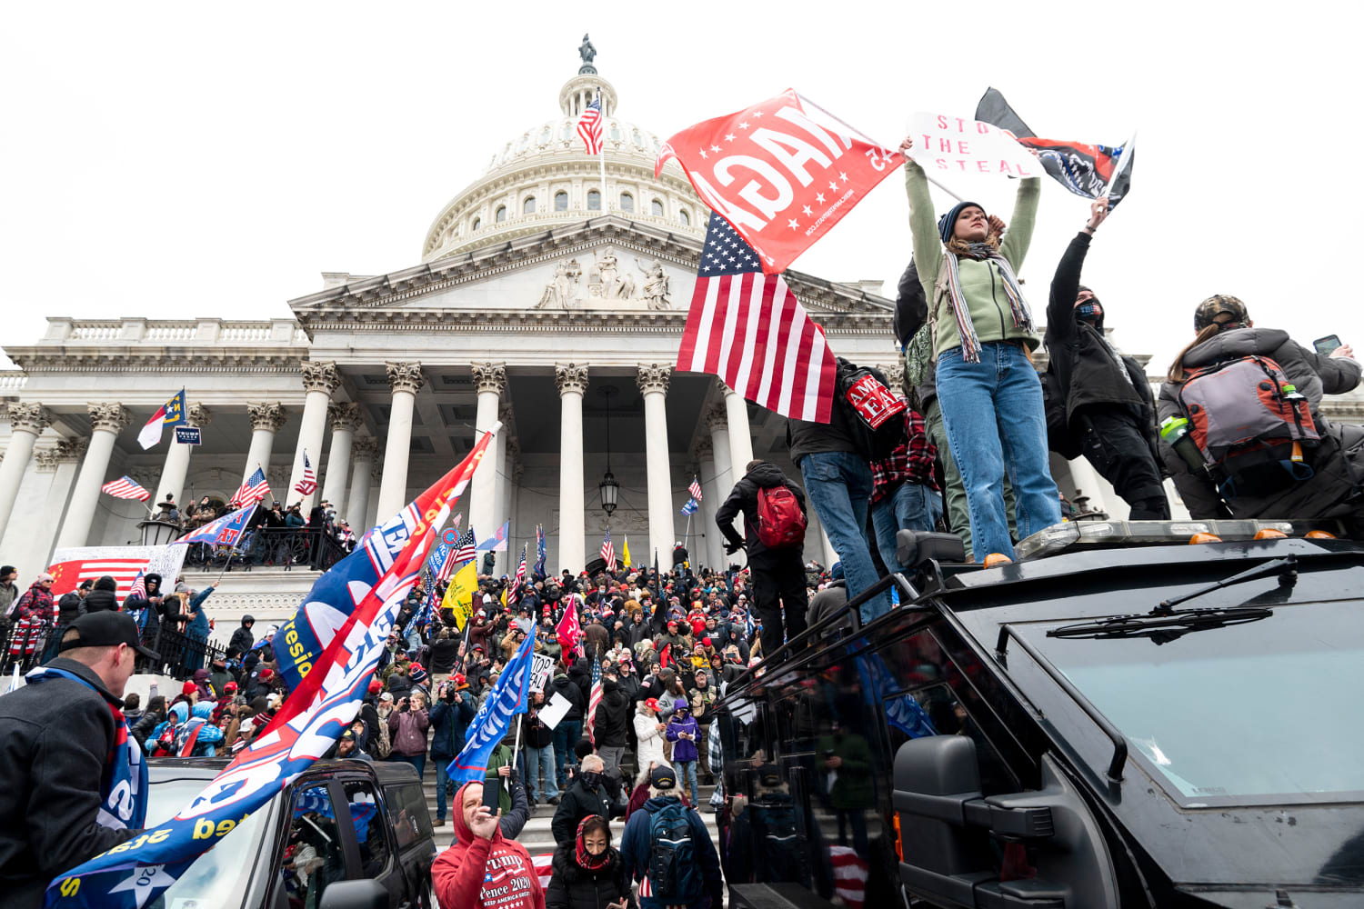
Hundreds of rioters outside the Capitol on January 6, 2021, including supporters of Donald Trump and the U.S. Republican Party. Source: Getty Images
The Patriot Front openly describes itself as a white supremacist and American nationalist movement. The Three Percenters are a far-right paramilitarist association of gun owners and anti-government activists. The far-right group Oath Keepers had members used by Trump in the provocation of January 6, 2021. We can also mention the informal conspiracy movement QAnon — its members believe that there is a secret global network of satanic pedophiles who are involved in child trafficking and whom Donald Trump is supposedly opposing.
Since the beginning of 2024, the Trumpist faction has been the dominant force in the Republican Party.
Republicans are also targeted by big business lobbying structures usually associated with “traditional” American values. They are primarily supported by the National Rifle Association, the NRA, whose interests Republicans have traditionally supported by opposing restrictions on the trade and carrying of guns. In return, the association generously subsidizes Republican candidates.
Trump is well aware of the power of the gun lobby, which is why he frequently appeals to it. In May 2024, for example, he addressed the NRA convention, urging support for his candidacy and threatening that if the Democrats win, “they will come for the guns” of Americans. He also called himself “the best friend of gun owners”.
Thus, the entire political system of the United States is constructed, for the average American, into a clear and understandable picture of the confrontation between two irreconcilable antagonistic forces: the “left-liberal” Democratic Party and the “conservative” Republican Party.
It is the battle between Democrats and Republicans for the minds and feelings of Americans that has been presented for many decades as the central political conflict of all American society. The battle between elephants and donkeys — democrats versus republicans — divides American society along this artificial line of political confrontation, which is presented as a confrontation of different values.
In reality, all the differences between the parties are secondary issues that are brought to the fore by the media and politicians under the control of big capital. Behind the tinsel of ideological confrontation lies the main point: both the Democrats and the Republicans are the parties of big business. They are the two flanks of the ruling class. Both parties are pro-big business, promote their interests, defend the institution of private property, try to ideologically disarm the working class, and hate communism.
By dividing American workers along party lines, the corporations distract them from the central conflict of all modern society: the conflict between labor and capital. The whole dichotomy of the two-party system, with its division between the “left” Democratic Party and the “right” Republican Party, is designed to obscure the fundamental contradiction of capitalism, to hide the capitalist exploitation of labor and the oppression of man by man.
The conflict between Republicans and Democrats essentially boils down to whether the labor is exploited under “progressive” or “conservative” labels. Both forces agree on the main thing: preserving the capitalist system and promoting the interests of U.S. capital on the world stage.

2.3 The election system
The American system for the presidential elections is very archaic and has been largely unchanged since the adoption of the Constitution.
Elections have a two-stage structure: first, there is a popular vote in all states, in which the people of each state vote for a candidate, and then the Electoral College votes. In such a system, the electors have the final say and ultimately determine the outcome of the election.
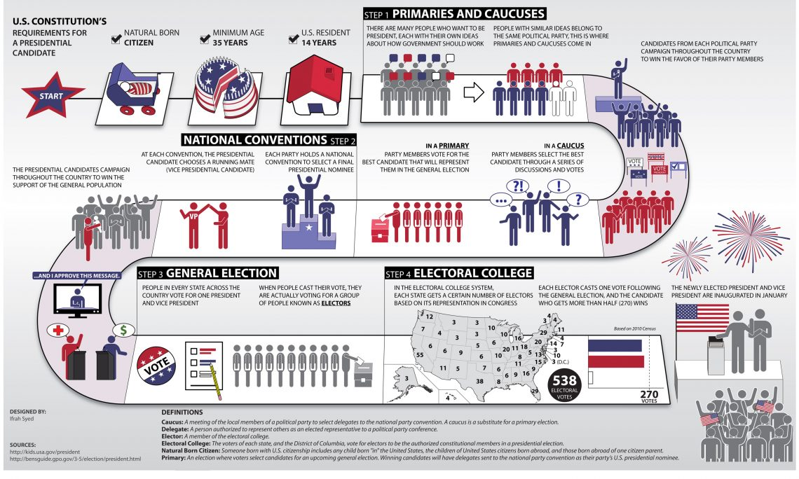
Each state appoints its own electors to the Electoral College, which is equal to the number of representatives the state has in Congress. This is usually two Senators and members of the House of Representatives, the number of which depends on the quantity of electoral votes in the state. Ultimately, the number of representatives is determined by population. Wyoming and the federal District of Columbia, where the capital of the United States is located, have the fewest representatives — 3 representatives each. California (55), Texas (38), Florida, and New York (29 each) have the most electors. The total number of electors in the Electoral College is currently 538.
The elections themselves are organized as follows: prior to the national popular vote, Republican and Democratic party conventions are held in each state. These conventions select slates of electors for each party in the state. The electors are usually state senators and congressmen, popular politicians, public figures, etc.
After each party has determined its statewide slate of electors, the popular vote begins.
The people of each state vote for a party's candidate as if the president were elected directly. Americans go to the polls and vote for one of the candidates on the ballot. In some cases, the ballot also includes a list of electors for the candidate. The candidate who wins a simple majority is declared the winner — and then, in accordance with the “winner takes all” principle, only electors from the winning candidate's party are sent to the Electoral College. On the 41st day after the popular vote, state-by-state elections for the Electoral College take place.
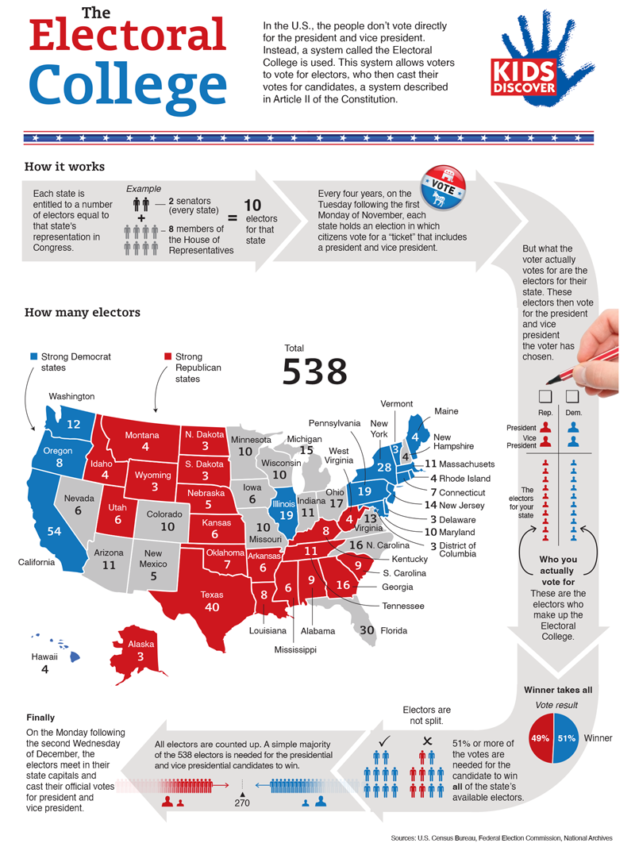
It is important to say something about how electors vote. There is no federal law that requires an elector to vote according to the will of the voters - that is, for the candidate whose party got him into the Electoral College. Formally, the elector is not bound by anything and can vote as he or she wishes, regardless of party affiliation. The elector may not vote at all.
However, unspoken rules require electors to follow party discipline and vote for their party's candidate. Those who violate this rule are called “faithless electors” in the United States. At the same time, there are laws at the state level that provide for the punishment of such electors: usually in the form of a fine. Not all states have such laws: 16 of them have no laws on the subject at all.
For a long time, this practice had no official status and was just another “unspoken rule”. But in 2020. The Supreme Court legalized the right of states to punish those of their electors who vote for the candidate that the majority of people in their state did not vote for.
The phenomenon of “faithless electors” is as old as the American electoral system itself. In the very first presidential election, won by George Washington, 3 electors did not vote. In the next election in 1792, 3 electors also refused to vote. In the election of 1796, there were 19 “faithless electors”.
The most massive emergence of “faithless electors” occurred in 1872. At that time, Democrat Horace Greeley and Republican Ulysses Grant were competing in the election, but Greeley died just before the Electoral College vote. At that point, 66 electors were supposed to vote for him, but since one of the leading candidates died, they voted for the other participating candidates. Three of them cast their votes for the now-deceased candidate. While this had no effect on the outcome of the election, and the case itself is not usually put into the “faithless electors” category, the will of the nearly 3 million Americans who did cast their votes for the Democrat Greeley was simply ignored.
In the history of American elections as of 2016, a total of 23,548 electors have voted in the Electoral College, only 157 of which voted incorrectly. This suggests that “rogue” electors have almost never had a decisive impact on presidential elections.
But in addition to the “faithless” members of the Electoral College, the U.S. system has another, more serious problem: the “winner takes all” principle — it means that the candidate who wins a simple majority of the popular vote gets all of a state's electors. This often results in the person being elected president not being the one supported by the majority of the population.
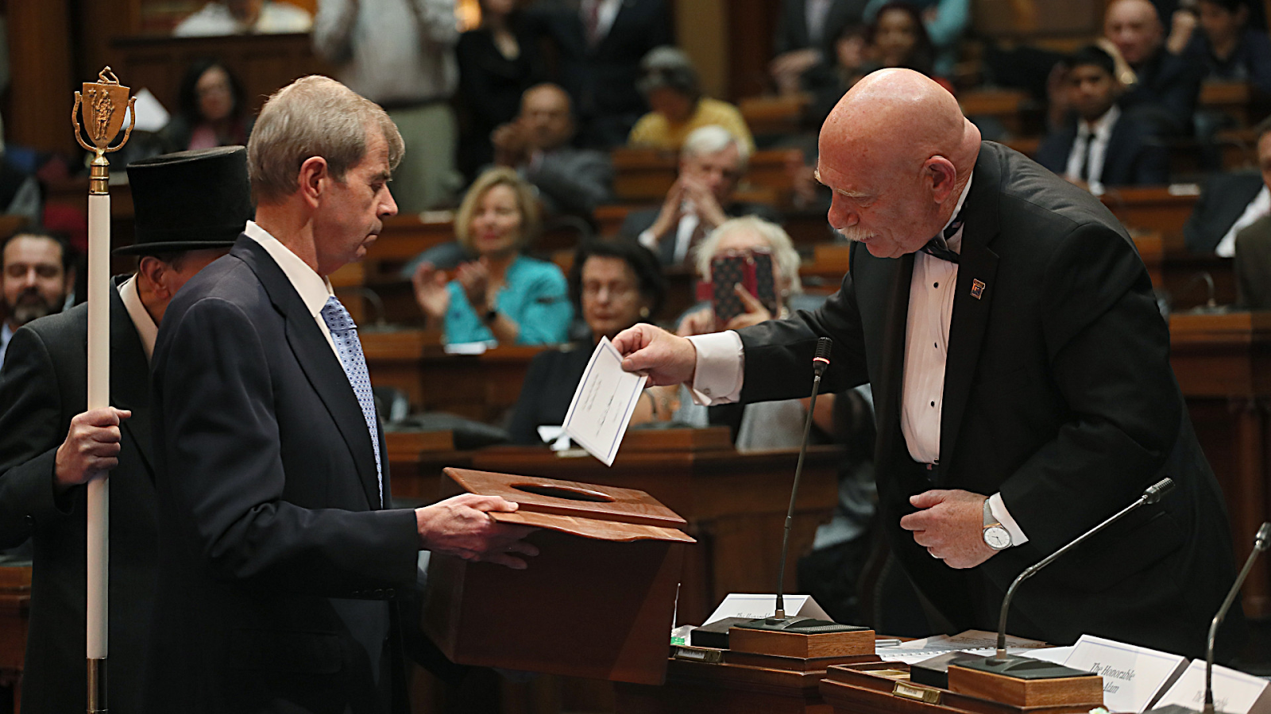
Secretary of the Commonwealth William Galvin (on the left), holds the ballot box as Paul G. Yorkey casts his ballot in the Massachusetts House of Representatives on December 19, 2016. Source: Suzanne KreiterGlobe staff
In the election of 2000, the Republican candidate George W. Bush, Jr. won. In the Electoral College, he beat his opponent, Democrat Albert Gore, by 5 votes: Bush received 271 votes to Gore's 266. However, if we look at the national popular vote data, it turns out that it was Gore who won. A total of 50,999,897 U.S. citizens voted for him, while Bush received 50,456,0
The situation was repeated in the 2016 election when Donald Trump and Hillary Clinton competed for the presidency. In the Electoral College, Trump received 304 votes and Clinton 227. In the national popular vote, the difference is even more impressive than in the case of Bush and Gore. There were 62,984,828 popular votes for Trump and 65,853,514 for Clinton. That's a difference of at least 3 million.
There have been two other similar cases in the history of the United States. It turns out that the American electoral system contains mechanisms that can ignore the will of hundreds of thousands and even millions of voters. The unfairness of such elections begins at the state level.
In the 2016 election, when Trump won in Florida with 4.6 million votes, beating Clinton with her 4.5 million votes and winning all 29 of the state's electors, it is unlikely that the remaining half of Florida's population was happy to know that their state would cast all of its votes for Trump. Exactly the same feelings might have been felt by residents of Pennsylvania, where Trump beat Clinton by only half a million votes, or by residents of Michigan, where the Republican's margin of victory was only 0.2 per cent.
In Wisconsin, the margin in favor of Trump was 0.8%. In all cases, however, this margin was enough for the Republican Party, represented by Trump, to win all of these states' electors. And it was those states that were considered key in the 2016 election, giving Trump 75 electoral votes and ensuring his victory.
The same can be said for all the other states where Hillary Clinton already beat Trump by only a few per cent points, taking all the electors of those states in her favor.
So the American electoral system is discriminatory. It doesn't matter how many millions of people in a state vote for a particular candidate. If one candidate is ahead of his opponent by a small fraction of votes, the opinion of half of the state's residents is simply ignored. Their ability to influence the outcome of the election ends there.
In summary of what has been said about the process of election of a president in the United States, the following must be stated:
1. Material Census. Despite all statements about the democracy of the electoral process and the possibility for every American to lead the state, in reality, only a person supported by big business can afford to participate in elections. Spending on advertising and campaigning, fighting for the votes of Americans, and lobbying for their candidacy costs tens of millions of dollars.
Only people who are either connected to the ruling class or are themselves representatives of the ruling class can afford such expenditures. As a result, there is an unspoken material barrier in America that only the most influential politicians and wealthy capitalists can overcome.
2. Every candidate is a puppet of business. Capital will never spend a cent unless it benefits from it. At the same time, politicians who accept large donations from capitalists are inevitably influenced by them.
Thus, the election of the president is just another form of lobbying — the legalized purchase by capitalists of the politicians, who in turn will promote laws and initiatives favorable to them. Senators or congressmen who have taken money to promote corporate interests vote in the interests of those corporations, just as the president of the United States pursues policies in the interests of his sponsors, in exchange for donations to his presidential campaign.
3. There is no alternative. The population chooses, both during primaries and during the election itself, only among the candidates presented by the two parties.
Despite the presence of independent candidates or candidates from other parties, the political system is organized in such a way that Republican and Democratic candidates have the most political weight and influence in society. Because there are only two powerful parties in the U.S., which also have a monopoly on control of Congress, there are only two types of dominant voters: Republicans and Democrats.
More than a century of the two-party system has made Americans accustomed to relying only on these two parties. They are simply accustomed to the fact that there is no worthy alternative to the dominant parties in the United States and bothering to learn about the others isn't worth the effort. The concentration of media and political PR attention only on the donkeys and elephants makes it much more difficult for other parties, right or left, to have any impact on American politics.
4. The population cannot really influence elections. The two-stage electoral system, in which the Electoral College, rather than the citizens, has the final say, as well as the manner in which electors are chosen, actually limits the voting rights of Americans.
Not only does the electoral system make the election itself more predictable and controllable, but it also eliminates any possibility of an independent candidate winning by nullifying the majority of their votes. Since the total number of votes for candidates decides nothing, independent candidates have no “cumulative” vote total that could affect the election. In statewide elections, a candidate from one of the two parties always leads, and the voters — also from only two parties — decide the outcome.

III. Elections 2024

3.1 Pre-election Environment
This time around, former US President Donald Trump and current Vice President Kamala Harris will face off in a battle for the Oval Office. Before we talk about who the candidates are and what policies they might start to pursue if elected, it is worth saying a few words about the general political environment in which the elections are taking place.
Since the end of last year, the American media and politicians have been actively inflaming the situation around the elections. The candidates are also happy to take part in the hysteria. Democrats and associated news outlets have repeatedly called Trump a fascist, directly or indirectly. In particular, Kamala Harris said that Trump is a fascist. Trump responded by accusing the Democratic Party and its candidates of being “communists,” calling Harris a “Marxist.” At a pro-Trump rally at Madison Square Garden on Oct. 27, David Rehm, introduced as a “friend of Trump,” called Harris a “devil” and “anti-Christ” while waving a crucifix.
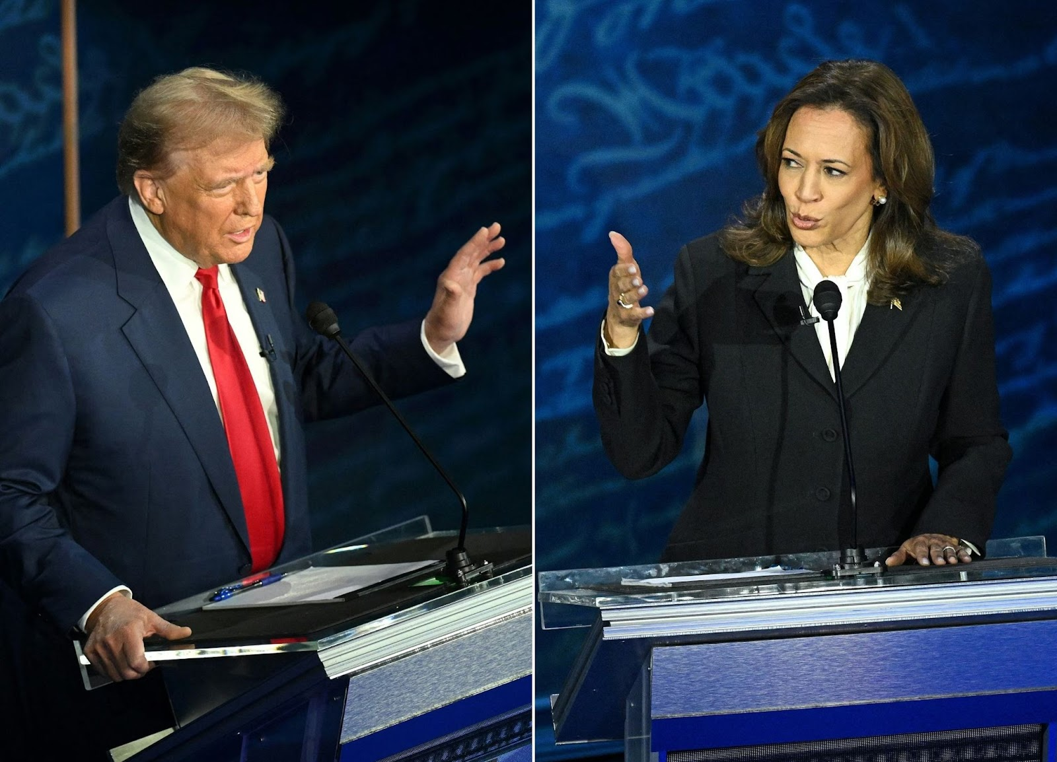
Debate between Donald Trump and Kamala Harris on Sept. 10, 2024 Source: ABC News
The elections were particularly tense because of the general political context in which the elections took place. In the first half of 2024, there were trials against Trump, who was accused of forgery of financial documents and improper handling of classified documents. Despite the fact that the classified documents case was closed by a judge's ruling, Trump's opponents actively used the opportunity to discredit the former president. Soon, as early as late August, a new indictment was filed against him in a U.S. court – this time for the 2020 election.
The struggle reached its peak at the time of the assassination attempt on Trump. During a July 13 campaign rally in Pennsylvania, 20-year-old Thomas Matthew Crooks fired an AR-15 rifle from the roof of a nearby building. The bullet passed within millimeters of Trump's head, wounding his ear. In addition to Trump, 4 other rally attendees were injured, including 1 fatality.
Trump and Republicans immediately used the incident for political PR. The failed assassination attempt further strengthened Trump's position in the Republican Party and among Trumpist and undecided voters and energized Trump's campaign. All Democrat propaganda based on accusations of fascist views and accusations in court was temporarily disarmed.
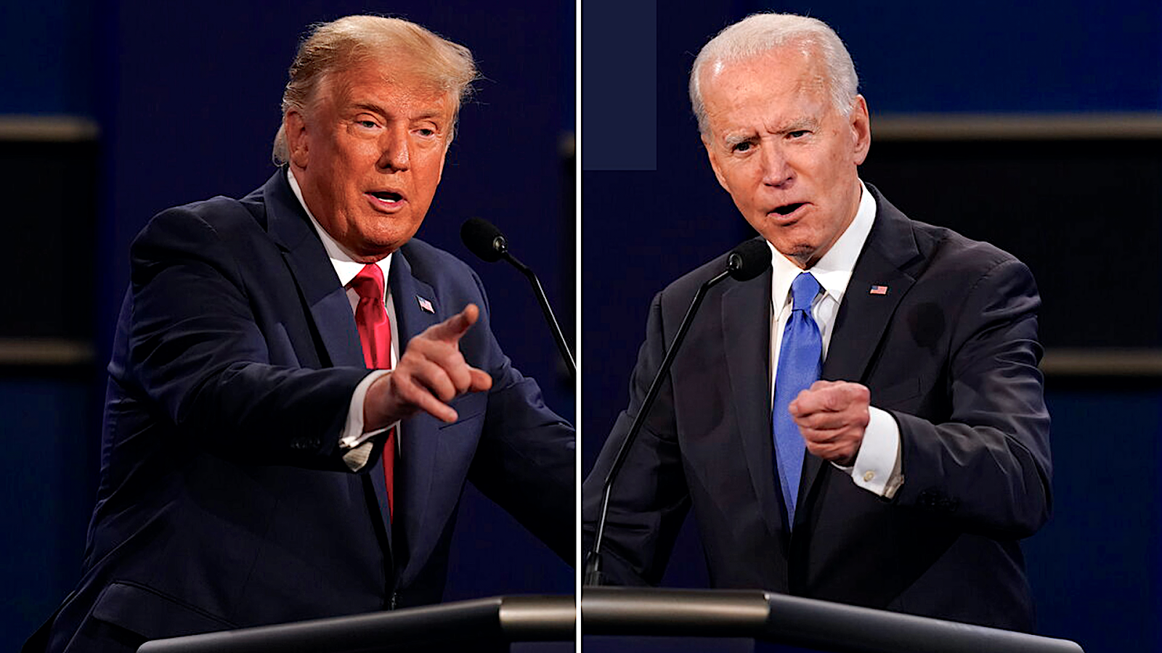
Donald Trump and Joe Biden debate
In turn, this has intensified the crisis in the Democratic Party. Despite the fact that the age difference between Trump and Biden is only three years, Trump has actively used the topic of the sitting president's age, health issues, and inappropriate public behavior in his campaign. Over time, criticism of the incumbent, who was considering a run for the presidency, began to echo among Democrats. After a significant drop in Biden's approval rating and reports that the Democratic Party's largest donors had frozen 90 million of their contributions, the Democrats nominated incumbent Vice President Kamala Harris as their running mate. The Democratic National Convention in August endorsed Harris.
The change of candidate had a positive impact on the ratings of the Democratic Party. In a short period of time, Harris was able to regain the support of the Democratic electorate, major donors and politicians, and win back some of the undecided voters. All of this has largely negated the media boost that Trump received, and it has also robbed him of one of his main trump cards - the accusation that his opponent is incapable of governing for health reasons.
The elections are also influenced by the global political situation. The Russian-Ukrainian conflict, now in its third year, is reaching a new level of escalation and tension due to the recent actions of the AFU and the Russian Armed Forces. In turn, tensions continue to rise in the Asia-Pacific region between mainland China and Taiwan. In the Middle East, the military actions of the Israeli army continue in the Gaza Strip and neighboring Muslim countries. Overall global tensions continue to rise, forcing U.S. NATO allies in Europe to follow the outcome of the U.S. presidential election with special attention.

3.2 Trump The Businessman
Donald Trump was born on June 14, 1946, to Fred Trump, a major New York real estate magnate. Trump's father, whose ancestors emigrated to the United States from Germany in the late 19th century, made a fortune in the construction business. The Brooklyn Daily Eagle in 1938 called Trump Sr. “the Henry Ford of the housing industry.” However, Fred Trump's main capital was earned from the post-war real estate boom in the 1950s.
Having received an economic education with a major in finance, Donald Trump became president of his father's company in the 1970s. That's when it got its current name: The Trump Organization.
Under the new leadership, the Trump family business continued to grow: Manhattan was gradually being built up, and in 1980 the old Commodore Hotel was rebuilt into the modern Grand Hyatt New York.
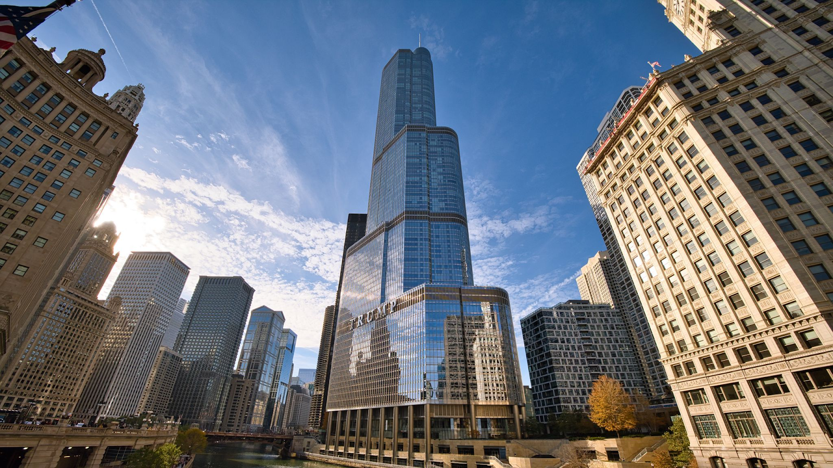
Trump Tower on 5th Avenue
The most famous object of Trump's construction empire was the famous 68-story Trump Tower on 5th Avenue. The tower has become a recognizable New York City landmark that has been referenced in movies many times: it was featured in such films as The Dark Knight and Transformers. Trump later turned the tower into his own speaking platform: it was there that he first announced his intention to run in the 2016 presidential race and where he also announced his victory.
As his business grew, Trump gave his name to various buildings and structures. It became a kind of business strategy for him. Apart from the tower, there are also Trump Palace and Trump World Tower in New York City. Buildings that have in their name the surname of the businessman can be seen in multiple cities in America and beyond. Thus, Trump's name can even be found in the Philippines or Mumbai.
Like many businessmen, Trump has always sought to diversify his business and venture into new areas of the market like the gambling business. The most famous object from this category was a casino hotel in Atlantic City, located in New Jersey.
As part of the 2015-2016 presidential campaign, Donald Trump filed a financial report with the federal government about his wealth. The report declared nearly $1.5 billion in assets and approximately $78 million in stocks, mutual funds, and hedge funds, as well as numerous properties valued at $50 million or more.
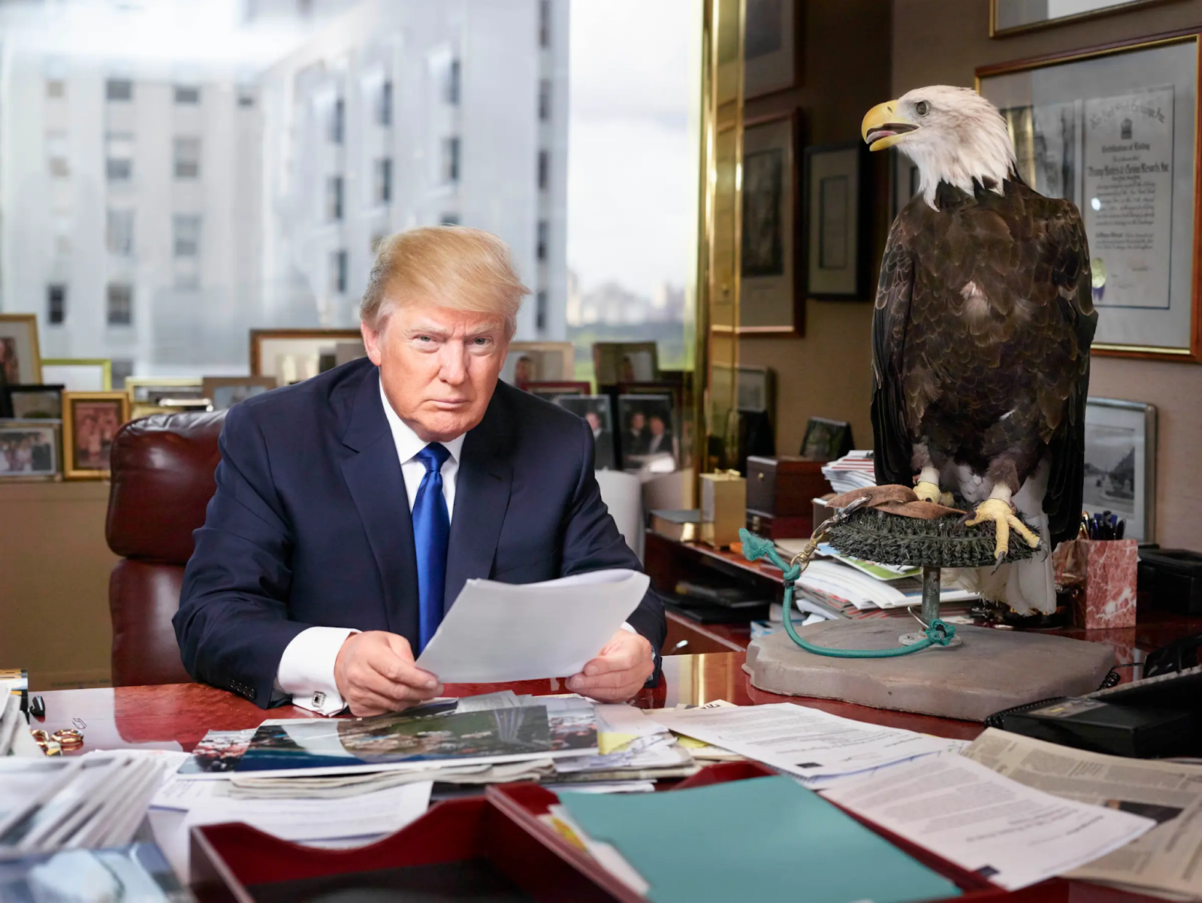
In addition, Trump listed about 515 organizations in which he holds some sort of position: member, partner, director, or president. The report also lists nearly 400 organizations that bear Trump's name or his initials. He made at least $9.5 million more by licensing his brand for luxury hotels or products like energy drinks, bottled water, vodka, and mattresses.
Finally, Trump reported having $25 million dollars in current and savings accounts, as well as invested in stocks of large corporations like Apple, Boeing, and Facebook.
In summary, Donald Trump is a big and wealthy businessman. He is reminiscent of a depiction of a capitalist from Soviet propaganda posters: the owner of factories, newspapers, and steamships. But there is more to Trump's personality than that. Trump wouldn't be Trump if he was just another rich American.
In 1989, Trump was featured on the cover of Time magazine with a playing card in his hand; the caption on the cover read:
"This Man May Turn You Green With Envy – or Just Turn You Off. Flaunting it is His Game, and Trump is his Name."
It's true. The former president's appetite for eccentric and offbeat public behavior, and even more so for attention and fame, was evident even before he ran for president.
In the same 2015 financial report, Trump listed the following income, among others: a $110,000 annual pension as a member of the Screen Actors Guild. Trump is an actor. He has had cameo roles in more than 10 movies. Trump's first movie appearance was in "Ghosts Can't Do It" (1989), and his most famous appearance was in an episode of "Home Alone 2", where the main character, Kevin McCallister, asks him for directions to a hotel. Trump got a role in the movie in exchange for permission to shoot a scene at the Plaza Hotel, where the movie was filmed and which he owned at the time. In all of the movies where he had a cameo, it was usually as himself.
Most of all, Trump's fame brought his own project. In 2004, he launched a reality show “The Apprentice”, in which he held the position of executive producer and main host. The show's contestants competed for the right to become an executive in one of his many companies. Trump hosted the first 14 seasons of the project. In his income tax return, he said he received a total of $213 million from the network for the show.
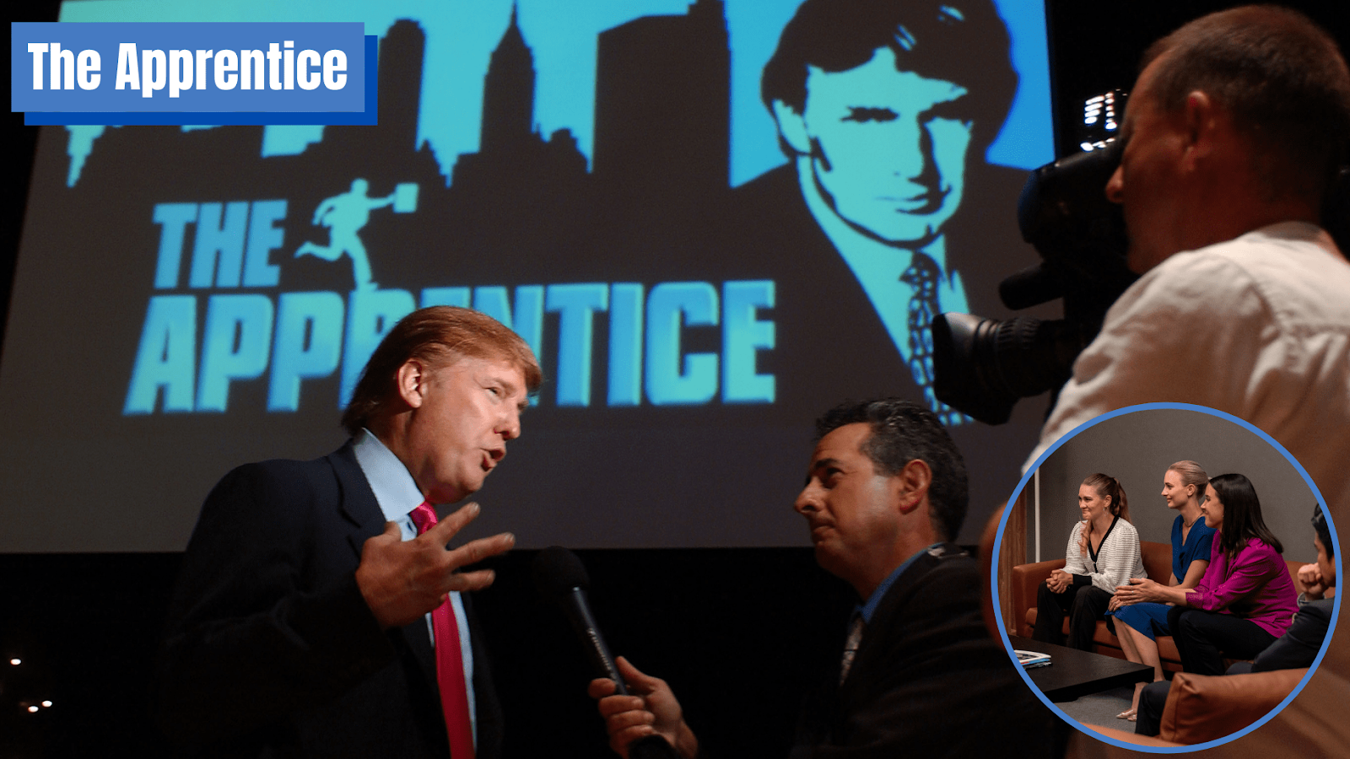
The calling card of the show was the famous phrase "You're fired," which Trump used to say to every failed candidate. It became so iconic that he continued to use it during the 2016 election.
Even outside of movies, Trump never stopped being an actor. He willingly played to the public, using all the techniques and tools of political PR. Just look at Trump's campaign promises: to bring back manufacturing and jobs, to build a wall on the border with Mexico, and to chase away migrants. And, of course, “Make America Great Again.” These are all sharp, provocative, and populist promises.
But populism is ineffective without the right pitch. In this regard, Trump has mastered the art of political presentation. The right pose, a certain pitch, a ringing slogan, and a sharp word can multiply the impact on the public. All of this was used to create the image of Trump as a candidate and president – a man who used every available opportunity for PR purposes.
Recall the assassination attempt in Pennsylvania. As soon as the former president's guards told him that the threat had been eliminated, Trump ordered the guards to wait, raised his fist in the air and shouted “Fight!” several times. It only took a well-timed reporter — and Trump got a shot that would overwhelm the Democratic Party's agenda for weeks and make history.
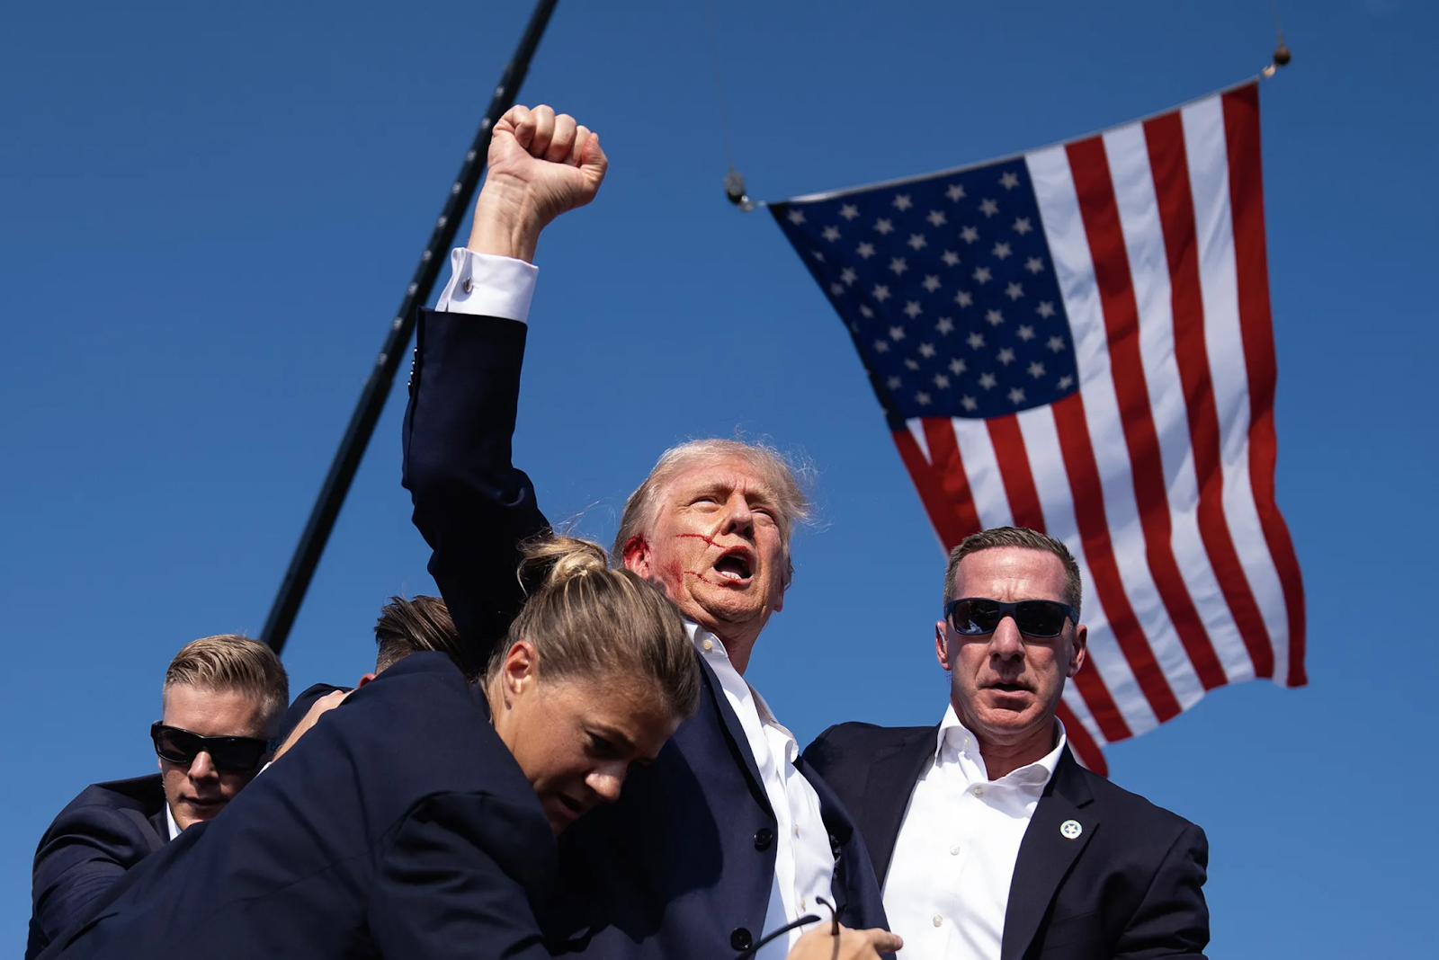
Donald Trump immediately after an assassination attempt on July 13, 2024, during a campaign rally in Pennsylvania. Source: Bloomberg
Trump also built his reputation in lesser-known areas. For example, the businessman became known for his penchant for writing books about his wealth. In his works “The Art of the Deal”, “How to Get Rich”, “Think Like a Billionaire”, “The America We Deserve” and others, Trump teaches Americans how to manage their money in order to get rich.
The books brought no appreciable recognition to Trump and apparently could not satisfy the ambition that lives in him. From 1996 to 2015. Trump was co-owner of the Miss Universe Organization, which owned such famous pageants as Miss Universe, Miss USA, and Miss Teen USA. But even that was not enough for him: in 1999, he founded his own modeling agency, Trump Model Management, which lasted until 2017.
Donald Trump is the kind of ruling class representative who not only has the business acumen but also the instincts of a political adept. For Trump, personal involvement in power and politics, as well as media fame and recognition, were not just tools to increase profits. He saw it as an opportunity to participate directly in the processes that affected his position as a capital owner. Thus, by lowering the corporate tax rate or imposing tariffs on China, he helped his business and satisfied his personal political ambitions, of which he had plenty.

3.3 Trump The President
Trump has repeatedly considered running for president, but it wasn't until 2015 that he announced his intention to run. In 2016, Trump became the candidate of the Republican Party. He was opposed in the election by Democratic Party candidate Hillary Clinton, who served as Secretary of State under the Barack Obama administration from 2009 until 2013. Trump's main campaign slogan was his promise to “Make America Great Again,” which then formed the basis of the MAGA movement.
Throughout the rally, he carefully constructed the image of a right-wing populist and a fighter against the elites. His threats to “drain the swamp in Washington, D.C.”, his promises to bring manufacturing back to America and create jobs, and to build a wall on the border with Mexico are well known. This tapped into the sentiments of Americans tired of social problems and elite domination of politics; they bought into Trump and his image as a "social conservative”. After winning key states, Trump won a majority of votes in the Electoral College and won the election, becoming the 45th president of the United States.
In domestic politics, Trump focused on realizing his rally promises. First of all, he started to fight migrants: he signed laws on immigration and border security and started building a wall on the border with Mexico. Under Trump, a mass expulsion of illegal migrants from the country began. If local authorities resisted and refused to extradite immigrants, Trump withdrew federal funds from them. In addition, he reduced quotas for refugee admissions and limited the conditions for the granting of green cards in the United States.
One of the biggest reforms was the tax reform we already mentioned. Trump cut the corporate tax rate from 35 per cent to 21 per cent, earning him immense love and loyal support from the heads of major corporations.
While implementing reforms, he encountered resistance from Democrats and the legislature. A series of crises significantly undermined his ratings: first, the escalation of racism and the rise of the far right, as well as the BLM protests in the summer of 2019, and then the outbreak of the coronavirus pandemic that collapsed the American healthcare system and killed millions.
Trump's foreign policy has also been aggressive. In 2017, while visiting Saudi Arabia for a summit in Riyadh, the US and Saudi Arabia signed a US arms sales deal worth about $110 billion.
In parallel, Trump made all sorts of gestures toward Israel: in March 2018, he signed a declaration with Netanyahu recognizing US sovereignty over the Golan Heights, and in May of the same year, he moved the US Embassy from Tel Aviv to Jerusalem.
All of these visits and friendly gestures were not coincidental and fit into the overall policy of creating an “Arab NATO.” The Trump administration managed to reconcile Israel and Arab countries, which included the United Arab Emirates, Bahrain, Sudan, and Morocco. The two sides entered into an agreement between them to establish diplomatic relations, which became known as the “Abraham Accords.”
Trump also tried to bring Egypt and Jordan into a possible future alliance. This was done in order to strengthen opposition to Iran in the region.
In addition to supporting Israel, Trump's Middle East policy has focused on fighting the regime of Syrian President Bashar al-Assad. In April 2018, Trump ordered the US Armed Forces to strike Damascus, the Syrian capital. The strikes were prompted by accusations of Assad using chemical weapons against the opposition in Idlib.
Another important episode in the foreign policy of the 45th president's administration was the worsening of relations with North Korea and the negotiations that followed. In April 2017, against the backdrop of the DPRK's successful ballistic missile tests capable of reaching the US coast, Trump sent the US aircraft carrier Carl Vinson to the South Korean port of Busan. And already on May 29 of the same year, the US and South Korean navies conducted demonstrative exercises in the Sea of Japan, after which a group of warships stood off the coast of Korea for another month.
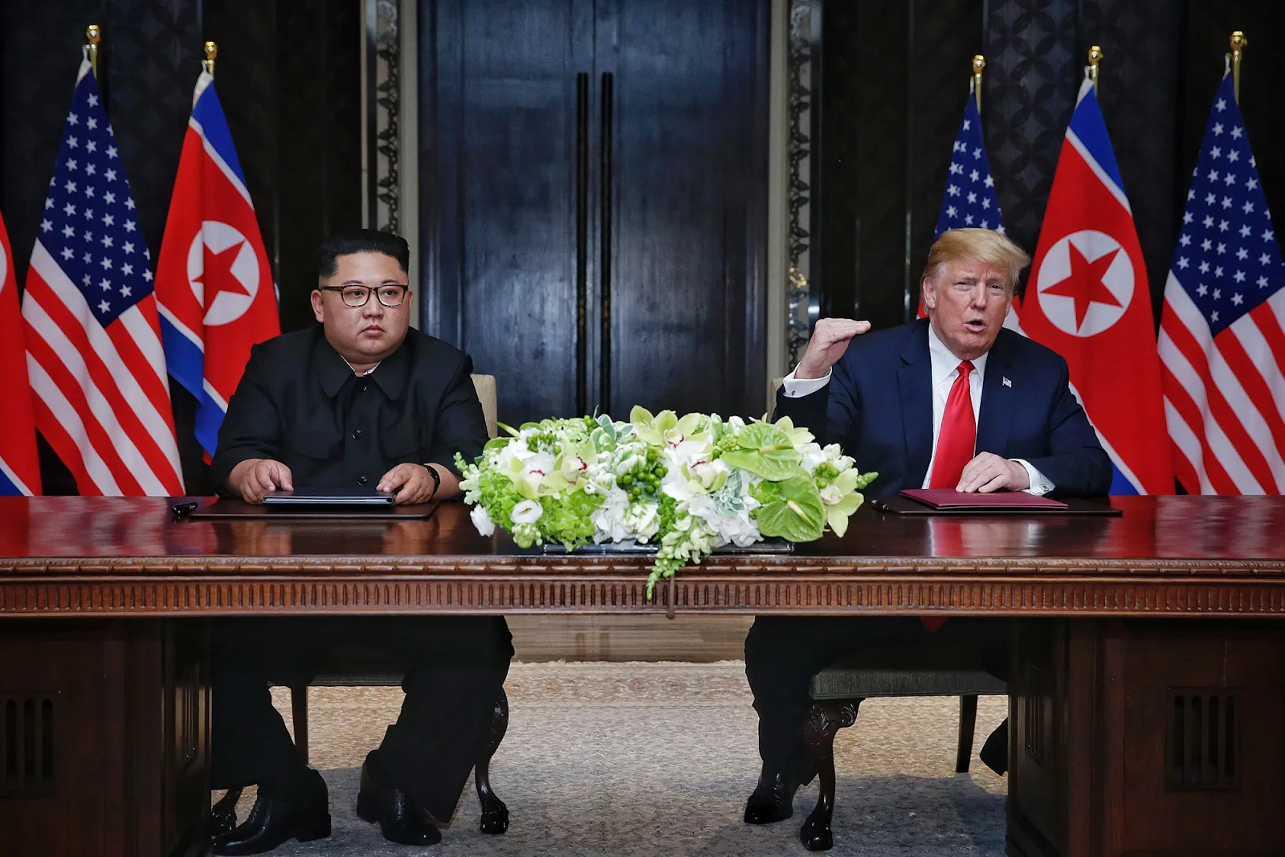
Kim Jong Un and Donald Trump
Trump deliberately sought the worsening of the situation on the Korean Peninsula in order to use a show of military force to induce Kim Jong-un to negotiate.
His strategy worked, and already in the summer of 2018, the two leaders met in Singapore. Thus, the summit in Singapore became the first-ever meeting between a sitting US president and the leader of North Korea. The main topic of the summit was the issue of denuclearization of the Korean peninsula.
At the end of the summit, the US and North Korea signed a joint statement, which stated the desire to establish new relations and build a peaceful regime on the peninsula. The DPRK reaffirmed the Panmunjom Declaration of April 27, 2018, under which it commits to work towards the complete denuclearization of Korea in exchange for security guarantees from the US. In addition, Trump was able to get North Korea to stop its nuclear tests. After the summit, Trump announced the end of joint military exercises with South Korea.
A year later, in the summer of 2019, a second meeting was held, but this time in the demilitarized zone – on the border of North and South Korea. The purpose of the second summit was to continue the dialogue on denuclearization. However, no concrete agreements or treaties were adopted at the end of it. Despite Trump's attempts to present his meetings with Kim Jong-un as an undoubted diplomatic achievement, the “honeymoon” in US-DPRK relations did not last long. In May 2019, the North Koreans resumed missile tests, and Pyongyang demanded that the US ease sanctions, to which it received a firm refusal. In January 2020. Kim Jong-un said he was ready to resume nuclear tests and missile launches. After Trump's defeat in the 2020 election, all the achievements of the summit were effectively nullified.
In his attempt to resolve relations with North Korea, Trump has shown himself to be a typical dealmaker. By threatening North Korea with military force, to which it had nothing to respond, he brought Kim Jong-un to the negotiating table. By making outwardly significant concessions, among which Trump's critics called the international legitimization of the Kim regime, he tried to give his opponent the impression of the possibility of a favorable deal in order to achieve the main thing – giving up nuclear weapons.
However, the interests of both countries in the region were antagonistic, and the United States was not going to make serious concessions, in particular, in the area of easing the sanctions regime against North Korea. The DPRK leadership quickly realized this, and all diplomatic statements and agreements remained only episodes of diplomatic history.
That said, the most important areas in the Trump administration's international policy were China and Russia.
Before Trump took office, the U.S. and China had an extensive trade relationship that began during Deng Xiaoping's reforms. While China was industrially weak and had yet to become the factory of the world, the US market only benefited from its relationship with China. US corporations actively exported capital and production to China, greatly increasing profits by exploiting cheap Chinese labor and exporting goods.
However, as China's industry and national capital grew and its mass-produced goods entered the global marketplace, China's goods began to threaten the US domestic market. Increasingly, US politicians and businessmen raised the issue of the US trade deficit with China, pointing to “unfair” trade by the PRC and theft of intellectual property.
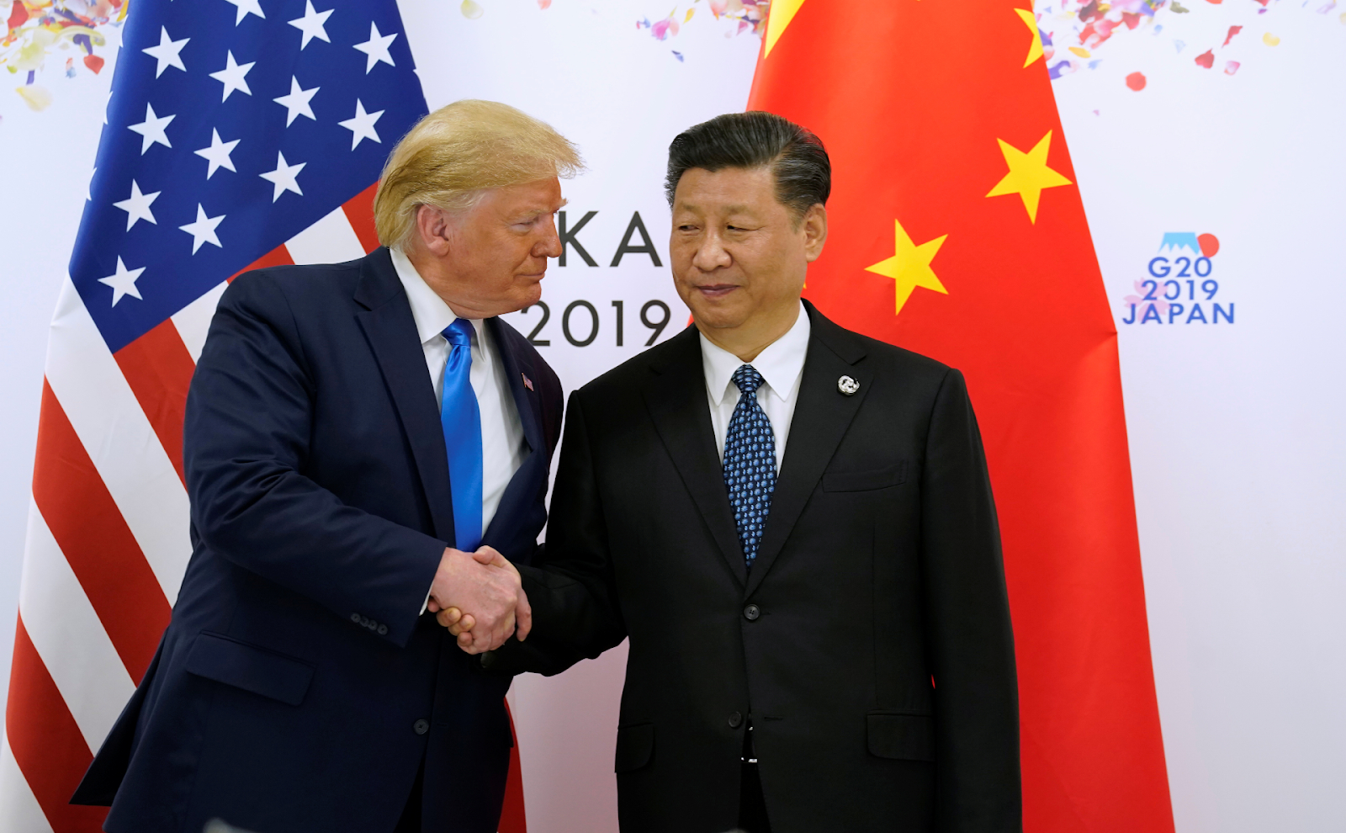
Donald Trump and Xi Jinping
The interests of US capital were reflected in Trump's rally promises to protect the US labor market and manufacturing. He claimed that China was “raping” the US with unfair trade. At the time, the main goods China exported to the US were electrical equipment, machinery, furniture, appliances, and a number of other products. China's total exports to the US as of 2017 were $522 billion, while imports totaled $187 billion. Thus, the US trade deficit was equal to $335 billion.
Since January 2018, the Trump administration has been systematically imposing tariffs on goods imported into the country, a significant part of which concerned Chinese products. American lists contained more than a thousand items subject to duties. China responded to American tariffs and duties with counter-restrictions.
In the period that followed, trade relations between the countries became increasingly restricted. Soon the trade war was accompanied by hostile political rhetoric on both sides. Eventually, U.S. analysts declared that the trade war had become a full-blown Cold War.
Trump's restrictions have not fixed the trade deficit. In 2022, it amounted to 367 billion. However, what is important is that with the beginning of the tariff war, the competition between the two imperialist powers intensified and took a hostile form. Donald Trump, defending the will and interests of the American capital, initiated the transition of the American strategy towards China to the stage of open confrontation. With Biden coming to power in 2020, the new administration maintained all the previous tariffs and even introduced new ones.
In relations with Russia, Trump also chose a tougher course compared to his predecessor Barack Obama. Trump's support for Ukraine has become an indirect leverage for Russia.
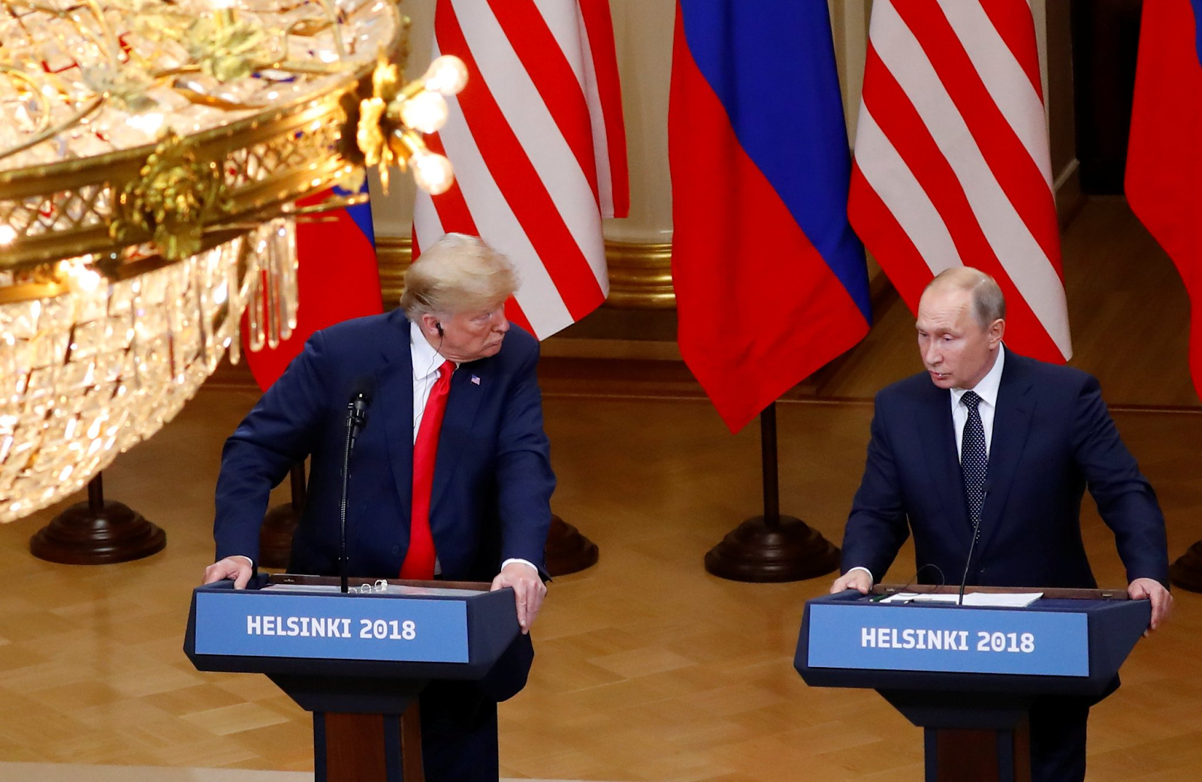
For example, in 2018, his administration for the first time began supplying Ukraine with lethal weapons, including Javelin anti-tank missile systems. Despite the freezing of a $400 million tranche of military aid to Ukraine in 2019, caused by Trump's behind-the-scenes pressure on Ukrainian President Zelensky, military aid has increased significantly under the Trump administration. In total, the Trump administration has allocated up to $800 million in military aid to Ukraine. Later, in the spring of 2023, he took credit for sending weapons to Ukraine.
A direct pressure on Russia was Trump's imposition of sanctions against the Nord Stream-2 gas pipeline in 2019. Construction of the pipeline at the bottom of the Baltic Sea began in 2018 and was almost completed by the time the sanctions were adopted. The new Russian gas supply route was supposed to be an important part of Russia's energy and political expansion into the European market, which in turn threatened the interests of the United States.
Thanks to the sanctions, construction was halted until 2021 and frozen after the start of the Special Military Operation in Ukraine. The destruction of the pipeline in September 2022 and the sanctions against Russia eventually led to the almost complete expulsion of Russian capital from Europe, freeing up the market for the United States.
At the same time, the defense budget, which provided for sanctions against the Russian gas pipeline, included a special section on measures to "deter aggression" by Russia. Thus, as in the case of China, Trump once again pursued a policy of protecting the economic interests of American corporations in the global market.
The aggressive foreign policy of the Trump administration was also expressed in the pressure on the European allies in the NATO bloc. First of all, Trump constantly scolded the allies for spending too little on military budgets. During the London summit in 2019, he said that spending should be 4 per cent of the budget. America's allies responded to Trump with "reciprocity": feelings of "NATO skepticism" spread among European officials. At the same time, rumors began to circulate that Trump might withdraw the US from the alliance in response to European opposition.
But after the start of the conflict in Ukraine, "NATO skepticism" was washed away by a wave of Russophobia, militarism, and a sharp rise in right-wing sentiment. Most European countries significantly increased their defense spending, up to the 4 per cent mark demanded by Trump.
What can we say in the end? US foreign policy under Donald Trump's administration has differed from that of his predecessors in its aggressive and decisive measures aimed at strengthening the US position in the world. Combining serious economic pressure, sanctions, and military aid with aggressive foreign rhetoric, Trump has openly labeled China and Russia as the main threats to the interests of the United States.
Trump's policies were not the personal will of an “eccentric politician”. His actions reflected the mood of the US ruling class, which, with the loss of its former world leadership and increased competition from China and Russia, shifted to a more aggressive strategy. As a result, the Trump administration's foreign policy line was a response of the US financial and political circles to the new environment: a significant loss of its former influence and position in the world. Starting with Donald Trump, US capital has adopted a course oriented towards restoring global influence through coercion and show of force.

3.4 Which Capitalists Support Trump?
Trump enjoys widespread support from big capital. In this year's election, as in past elections, he is receiving substantial support from America's big businessmen, who are generously paying for his rallies. Certain political events around Trump reinforce this support. For example, after the announcement of a guilty verdict in one of his cases in early June, Trump's campaign announced that it had raised $53 million in 24 hours. This is despite the fact that he had managed to raise 58 in the previous 6 months.
We've already pointed out that Trump has about 25 big billionaires backing him in this election. But who are these billionaires and why do they support the Republican? This is well illustrated by the largest donors.
According to open sources, we have the following data:
In first place is the heir of the big banker and billionaire Andrew Mellon, Timothy Mellon: he donated 90 million dollars to Trump. In June 2024, Forbes estimated the net worth of the Mellon family at $14 billion. It is one of the largest financial contributors to the Republican Party throughout Trump's political rise after the last election.
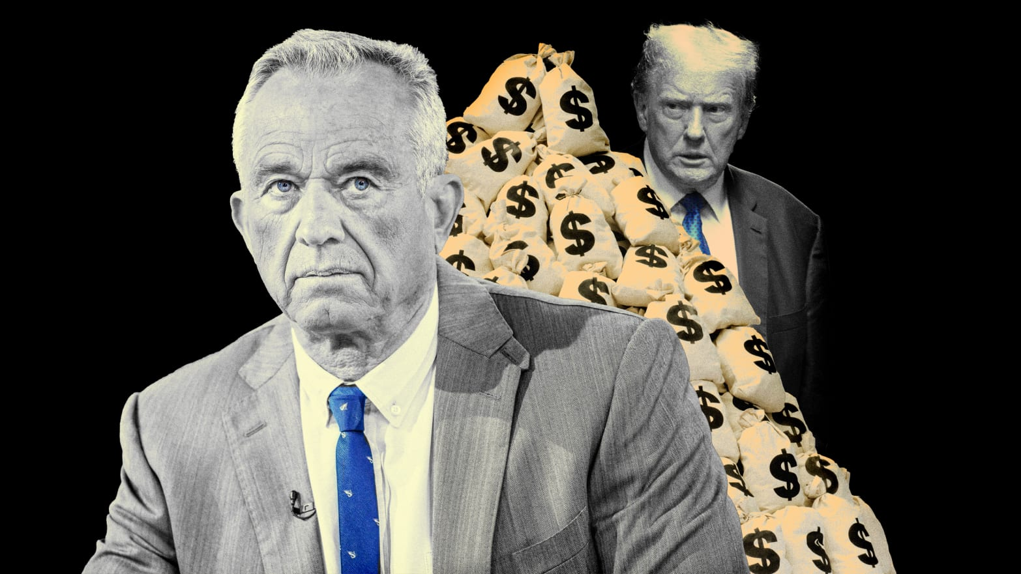
Back in 2020, Mellon donated 10 million to American First Action, a super political committee advocating for Trump's re-election. The billionaire emphasized Trump's work “in trade and righting the balance between our country and the rest of the world, especially China.”
In 2020, the Wall Street Journal examined Mellon's 2015 autobiography. In it, the businessman described welfare programs as a "return to slavery" and wrote that blacks became "even more militant" after the expansion of welfare in the 1960s and 1970s.
In second place is Kenneth Griffin – a billionaire investor, founder of the Citadel LCC mutual fund, and the richest man in the state of Illinois. Griffin gave Trump 75 million dollars. Griffin`s "Citadel" has repeatedly been in the media spotlight due to various scandals related to market manipulation. In particular, in 2021, the fund was accused of putting pressure on another financial market participant to restrict trading in certain stocks.
In third place, Richard and Elizabeth Youline: the couple donated 71 million dollars. They own a packaging materials company. In 2021, Elizabeth Youline spoke favorably of Trump's trade policies.
Fourth on the list of top Republican donors is Pennsylvania's richest man, Jeff Yass, with $70 million. Yass is the co-founder and chief executive of the trade technology company Susquehanna International Group (SIG). But Yass is also a major investor in Tik-Tok: he owns a $21 billion stake in the app's parent company, ByteDance.
There's a problem for the investor here because as we know, TikTok is being prosecuted and attempted to be banned in the US. However, Yass has spent millions of dollars sponsoring a Senate campaign against the decision. But far more interestingly, in 2016, Yass was considered one of the so-called "Never Trumpers" - that is, people who strongly opposed Trump becoming president of the United States. Despite this and the fact that it was Trump who signed an executive order banning the app in 2020, Yass was one of the former president's biggest donors.
Apparently, the large checks to Trump's account are directly related to the fact that Trump has noticeably softened his rhetoric against the app and has repositioned himself as an opponent of the TikTok ban.
Then there are such big donors as the founder and president of Elliott Management, Paul Singer: 39 million. The owner of the hotel chain Budget Suites of America and founder of the private space company Bigelow Aerospace, Bob Bigelow: 39 million. The widow of casino magnate and longtime Republican megadonor Sheldon Adelson, Miriam Adelson: 22 million. In 2020, the Adelsons gave 220 million to Republican initiatives.
In addition to the already-named capitalists, Trump is also supported by the owner of one of the largest private oil companies, Timothy Dunney (8.5 million), PayPal co-founder Peter Thiel, who promised to vote for Trump, the founder of the investment company Blackstone Group, Stephen Schwartzman with a fortune of 41 billion dollars, Jamie Diamond, head of a large bank JPMorgan Chase & Co. Among other things, Elon Musk has announced his intention to give about $45 million to a political committee supporting Trump's rally, America PAC.
In addition to those listed, Trump is also backed by a dozen other donors and smaller organizations.
As we can clearly see, Trump is sponsored by some of the richest people in America and the world. Political autonomy or independence is out of the question. Donald Trump is acting as a very real representative of big business. Obviously, it is their will and not the will of the American voters that he will carry out if he becomes president again.

3.5 What policies will Trump pursue?
Since Trump announced his intention to return to the White House, there has been an ongoing debate about what policies he will pursue. Based on the experience of his first term, we can guess what they will be.
In domestic policy, Trump is likely to continue to cut corporate taxes and begin to roll back the reforms enacted under Joe Biden. At the same time, Trump will clearly intensify his crackdown on illegal immigration, building on the rise of right-wing and far-right sentiment in American society. The return of the Trump administration will thus mark a new turn to conservative rhetoric by the official authorities of the United States.
In foreign policy, Trump will definitely increase the pressure on Russia and China. The international situation created by the beginning of Russia's ‘Special Military Operation’ in Ukraine and the further aggravation of US-China relations requires decisive action by the US leader. He may do the same with both countries as he did with North Korea: force them to negotiate.
Regarding China, Trump could provoke an escalation in the South China Sea by sending the US Navy there and supporting Taiwan with new arms shipments. This would lead to a sharp escalation of the entire international situation, which Trump could intensify with new sanctions or other restrictions against China. By confronting him with the heightened threat of direct confrontation, Trump could try to force Xi Jinping to negotiate on a wide range of issues where the interests of the two imperialist powers collide. Such a scenario becomes more likely the more futile the more restrained attempts at US-China talks, such as those that have taken place recently, prove to be.
A similar scenario is possible in the case of Russia. Trump could threaten the Russian leadership with the lifting of all restrictions on the supply of a full range of weapons to Ukraine in order to force it to start negotiations. At the same time, he could also pressure Kyiv to start negotiations by threatening to cut off all military and financial support. At the same time, Trump is likely to increase pressure on NATO allies in a parallel effort to shift the burden of supporting Ukraine in its confrontation with Russia onto the allies.
Such a scenario is in line with Trump's way of dealing with international issues. Moreover, it is not an unfounded assumption. In June this year, Reuters published a report claiming that Trump's key advisors had presented him with a plan for a peaceful resolution of the conflict.
The former chiefs of staff of the National Security Council under the Trump administration, Kellogg and Fleitz, have developed a peace plan that involves supplying Ukraine with more US weapons only if it agrees to enter into negotiations with Russia. At the same time, the advisors suggest warning Moscow that refusal to negotiate would lead to increased support for Ukraine.
According to them, Trump has responded "favorably" to the plan. Elements of the plan were outlined in a special research paper published in April this year by the America First Policy Institute, a pro-Trump think tank where Kellogg and Fleitz hold senior positions.
Among other things, the Institute's researchers suggest that Russia be promised a long-term postponement of Ukraine's admission to NATO and a limited lifting of sanctions. All this, in their opinion, should lead to the observance of a ceasefire during the peace talks.
Time will tell how likely such a development is in the event of Trump's re-election. But such tactics are very much in keeping with the style of the 45th president's first administration.

3.6 What is Kamala Harris known for?
Since the summer, there has been increasing talk in the Democratic Party that Joe Biden should withdraw from the race. The actively deteriorating health and behavior of the incumbent president, against the backdrop of an active and aggressive Republican opponent, has severely shaken the Democratic Party's position.
As Joe Biden's health problems became more apparent, the risk of losing the wavering electorate that had not yet decided for whom to vote increased. Meanwhile, winning this middle ground between Republicans and Democrats has often determined the outcome of many American elections.
Despite mounting criticism, Biden was in no hurry to withdraw from the race. The turning point was the assassination attempt on Trump, which gave his campaign a noticeable boost. After that, the criticism of Biden only grew.
On July 17, ABC News reported that Democratic leaders in Congress were worried about the prospect of losing seats amid the party's declining ratings. On July 19, more than 30 senior Democrats called on Biden to drop out of the race. Finally, on July 21, Biden announced his withdrawal from the presidential race by releasing a letter to that effect. As his party's successor, Biden endorsed the candidacy of Vice President Kamala Harris.
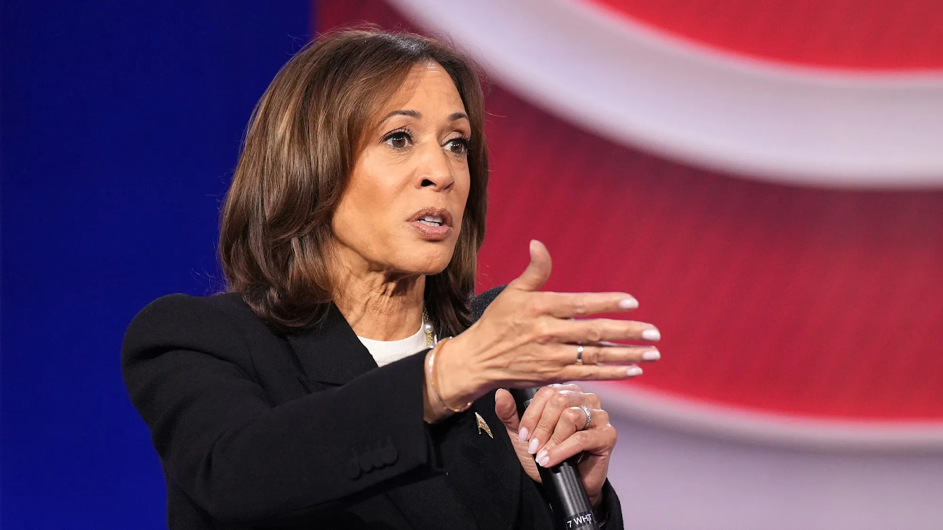
Kamala Harris
At the Democratic National Convention in Chicago, August 19 to 22, Harris was officially nominated as the party's presidential candidate. The convention selected Minnesota Governor Tim Walz as the vice presidential nominee. Following her victory at the Democratic National Convention, Harris was able to quickly consolidate the major forces of the Democratic Party, restore the Democratic Party's standing, and move ahead of Trump in voter ratings.
Before becoming Vice President, Kamala Harris built a successful legal career. She was educated at California State University and had a long tenure in the local district attorney's office. In 2003, her career accelerated when Harris accepted the position of San Francisco district attorney.
In this position, she actively built an image of a "fair" and "democratic" official. One of California's key problems is drug abuse and youth involvement in drug-related crime. Harris proposed that first-time drug offenders be given the opportunity to finish school and get a job. Her success in this area led to her election as California's attorney general in 2011, making her the first African-American woman to hold the office.
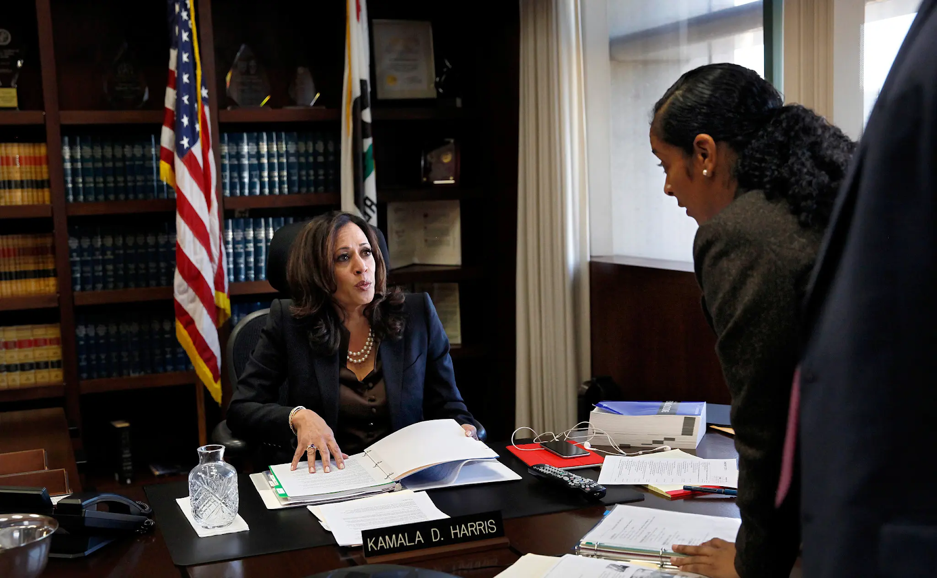
One of the most notable episodes in Attorney General Kamala Harris' career was her fight to help Californians affected by the 2007-2010 housing crisis. In February 2012, after lengthy negotiations with California's major banks, Harris announced an $18 billion settlement to help homeowners who lost their homes or faced eviction because of delinquent mortgage payments.
Harris's other focus was environmental protection. She pursued polluters and handled several environmental cases, including suits against large corporations for violating environmental regulations.
She also actively supported another major trend in American politics at the time: the legalization of same-sex marriage. As California's attorney general, Harris refused to defend the state's same-sex marriage ban and created a special unit to protect sexual minorities from violent crimes.
In 2017, Kamala became a senator from California as a Democratic representative. In the Senate, she proposed raising the minimum wage, supported expanding Americans' rights to health care, and advocated for restricting access to guns and tightening gun control. On everything from immigrant rights to a moratorium on the death penalty, Harris has run as a Democrat.
Throughout her political career in the judiciary and in the Senate, Kamala Harris has been aligned with the Democratic Party, sharing its main trends and ideological orientations. In this, she was the obvious opposite of Donald Trump.
In March 2020. Joe Biden, the Democratic presidential nominee, promised to choose a woman as his vice presidential running mate. Harris, who had already earned a reputation as a strong advocate for protecting Americans' social rights, quickly became one of the Democratic Party's favorites. Another advantage Harris had for the Biden campaign was her African-American background. This allowed her to attract more attention from wavering black voters who were deterred by Trump's white conservative rhetoric. Finally, Harris was helped by the fact that if Biden won, she would become the first female vice president, which is exactly what happened.
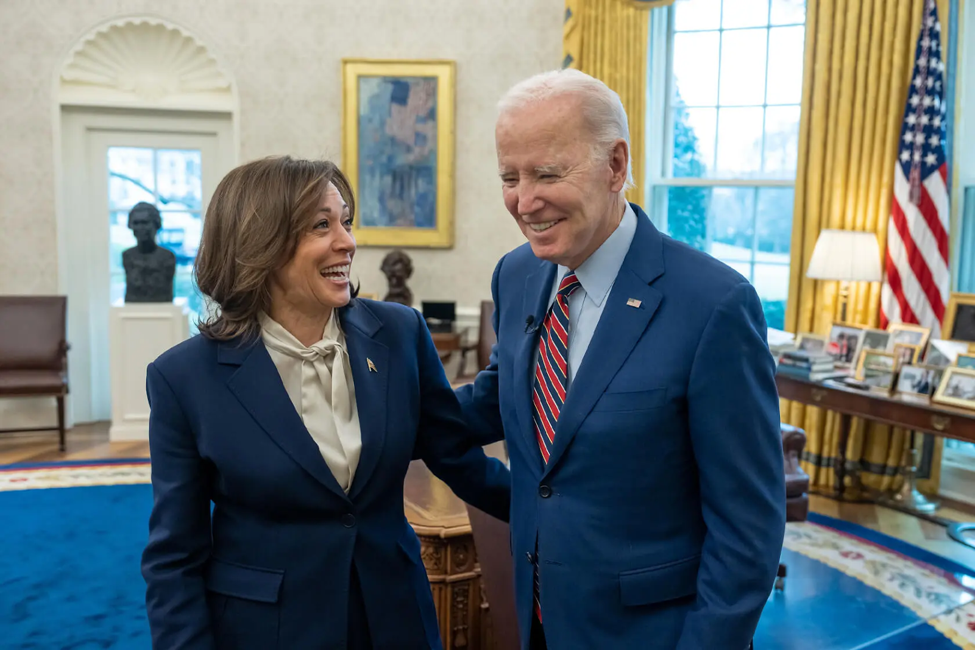
In August 2020, Biden announced his choice of Harris, calling her "a fearless fighter for ordinary people." On the campaign trail, Harris fulfilled her role by attracting significant numbers of women, black people, and more “progressive” voters to the Democratic side. On January 20, 2021, Kamala Harris was sworn in as Vice President.
The official website of the White House describes the activities of the first black vice president in a detailed and very flattering way. In this position, she generally continued the previous line of Democratic policies: she influenced the passage of some important laws for the Biden administration, including the 2022 law to reduce inflation, and continued to fight for social rights. For ordinary Americans, however, the vice president's activities were not so visible.
Much more visible was her presence on the international stage. Throughout her time in the Biden administration, Harris made dozens of foreign trips and repeatedly replaced Biden at events of importance to the United States. She replaced Biden at the Association of Southeast Asian Nations summit in 2023 and was his deputy at the Munich Security Conferences in '22 and '23.
On all such occasions, she acted as an avatar of the President, which is the function of the Vice Presidency.

3.7 Who is supporting Harris?
Like Trump and the Republican Party, Harris and the Democrats in this election are backed by big capitalists and powerful organizations. Democratic Party donors take more moderate positions on a number of issues, which doesn't make them any more "holy" or "benign" than Republican donors.
Among the top Democratic donors is billionaire Reid Hoffman, a venture capitalist and co-founder of Linkedin, a job search and networking platform. He also sits on Microsoft's board of directors. Hoffman has donated $28 million to Harris' campaign and is a key contributor to the Democratic Party.
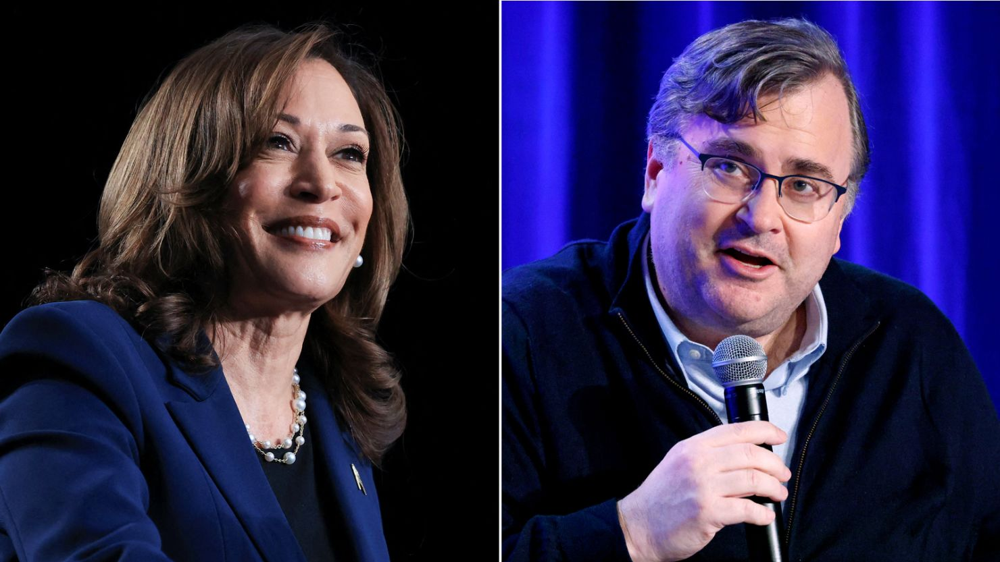
Reid Hoffman (right) is a venture capitalist, co-founder of the Linkedin platform and one of Kamala Harris' biggest backers.
In 2018, Hoffman had to apologize for funding a disinformation campaign during the 2017 special US Senate election in Alabama, after which he was repeatedly suspected of directly influencing politics. But a much bigger shadow has been cast over the billionaire by his ties to Jeffrey Epstein, a financier who has been accused of child trafficking and sex crimes in the US. The media reported on Hoffman's repeated visits in 2014 to Epstein's private island, where he ran a prostitution ring.
Another notable donor is Michael Bloomberg — former mayor of New York City, owner of the eponymous Bloomberg news agency, and one of the world's richest men. He has donated $27 million. During the 2020 election, Bloomberg endorsed Biden for president and spent $100 million to support his candidacy in the swing state of Florida. Bloomberg claimed he was spending all this money to stop Trump.
The billionaire is considered close to the ideological views of the Democratic Party. In particular, he actively supports the Democrats' social reforms in the field of health care and education, as well as the fight against climate change. In this area, the billionaire also took a personal part: from 2014 to 2019, he served as the UN special envoy on climate change.
He was repeatedly accused of sexism and racism, as well as stop-and-search policies that were widespread during his leadership of New York City. The former mayor was rebuked for policies that mostly affected people of color in the city.
Another supporter, Freud Eichener is the owner of Newsweb Corporation, a publishing company that prints newspapers and also owns several radio and television stations. In particular, the publishing company owns WCPT, a radio station that positions itself as "progressive. Eichener himself and his company claim to be "progressive" and "liberal" and a friendly environment for sexual minorities. He donated $26 million to Democrats.
Another major Democratic donor is Simons' spouse, James and Marlene Simons. James Simons is a well-known mathematician and investor in the United States who founded the Renaissance Technologies hedge fund. His fund provides market analysis services based on "mathematical models and algorithms". Simons himself has been described as a consistent supporter of the Democratic Party and the "liberal values" it represents. In 2016, he donated $26 million to support Hillary Clinton. This time around, he gave about $24 million to Democrats.
The Democrats are supported by many other billionaires and representatives of big business in America. It is also important to note that Harris has managed to gain the support of influential politicians and elites. Her candidacy is supported by the Clinton clan and Barack Obama, as well as such well-known financiers as George and Alex Soros. In August, Harris announced that she had raised more than $540 million.

3.8 What policies will Harris pursue?
In an interview with CNN, Harris stated that she intends to continue Joe Biden's policies. Unlike Trump, she has no original policy program. On the contrary, both before the vice presidency and during the Biden administration, Harris' line and the initiatives she supported were completely within the Democratic Party's course. Therefore, if elected, we should expect her to continue the policies of the current administration.
Regarding domestic policy, we should expect a continuation of the previous course of socially oriented reforms. This includes attempts to reform the healthcare system to make it more accessible and to reduce the tax and credit burden on working families. In addition, we can expect a continuation of the Democratic Party's previous line on climate change, racism, and so on.
The only area where the policies of the Harris administration may differ from those of its predecessors is immigration. The crisis that erupted in Texas in the spring between the state and federal authorities over the acute migration crisis has obviously affected the Democratic Party. As a result, Harris promised to step up the fight against illegal immigration, bringing her positions on the issue closer to those of Trump.
In general, the Democratic Party strongly believes in continuing to try to reform the American capitalist system in a way that the Joe Biden administration tried to do. As in his case, it will face strong opposition from conservative-minded elements of the ruling class and, above all, from the Republican Party. But beyond that, the reform course will be hampered by any serious economic crisis that may erupt in the world market in the coming years.
Regarding foreign policy, we should likewise not expect significant differences from the current administration's policy.
With China, Harris will continue to wage a trade war, which could further strain relations and increase sanctions. At the same time, we should expect renewed attempts to reach an agreement through the channels of both countries' intelligence services. The Harris administration is unlikely to embark on escalatory adventures like Trump's unless there are compelling reasons to do so.
With Russia, she will also continue the Joe Biden administration's line of "slow strangle" tactics. Under Harris, the U.S. will likely continue to support Ukraine by gradually expanding the range of weapons supplied, lifting more and more restrictions on fighting the Russian Federation, and crossing more and more "red lines" with pauses for behind-the-scenes negotiations with the Kremlin.

IV. Interests of Capital
This election is not just about two candidates with different political platforms and promises. Two wings of the American ruling class are vying for the right to run American politics.
Trump represents the more radical, reactionary wing, which in domestic politics wants to tighten the regime at all costs and roll back the concessions made to workers since the late 90s. The corporations and businessmen behind Trump believe that the working class does not yet pose a serious threat to them, and therefore funds can be freed up for international affairs.
This group of elites intends to act more decisively and boldly in foreign policy. They believe that through active and aggressive actions they can restore the former unconditional domination of America and American capital. To force the Russian Federation to make peace, to free up forces and means for a possible clash with China.
Harris, on the other hand, represents a more moderate wing that realizes that without concessions to the workers and reforms, a major crisis could erupt that would threaten the very position of the financial conglomerates and monopolies. This elite group plans to expand the social sphere and make concessions as far as the American system itself will allow.
This wing of the U.S. ruling class, while striving to restore the status quo in the international arena, is afraid of a sharp escalation and aggravation of the situation in foreign policy. Although it probably does not rule out such a possibility and is actively preparing for it, it still wants to take a safer path in the struggle against its rivals.
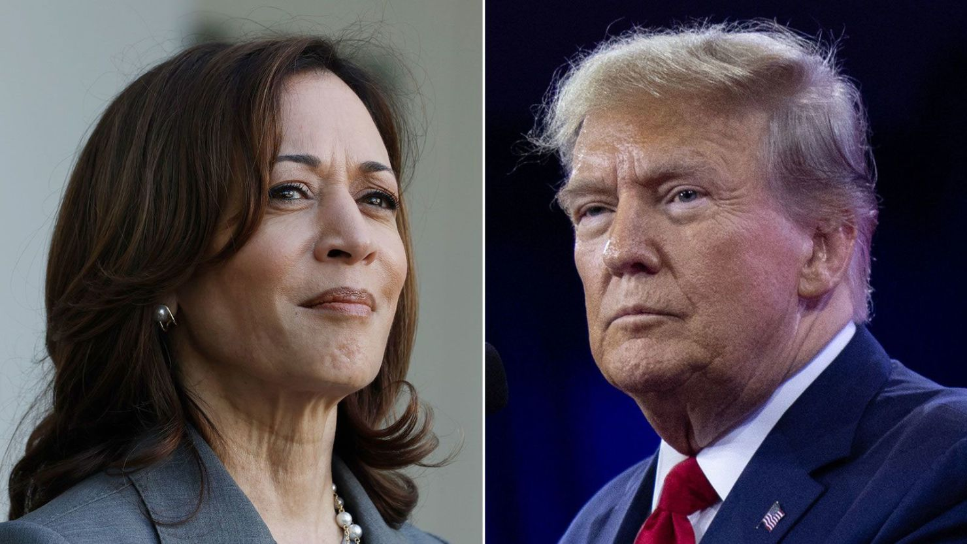
It is impossible to say for sure who will win the election — Trump or Harris, "conservatives" or "left-liberals". We can only see what a fierce form the pre-election struggle of various oligarchic clans is taking. It is impossible to predict exactly which side will prevail, and which side will be able to convince the voters.
Judging by the polls and the attitudes of Americans themselves, the Democratic Party candidate has a slightly better chance of winning. But given the intensity of the struggle, the big question is how the election itself will go. What tricks the politicians will use, how big the fraud will be, and how will the “unscrupulous voters” will show themselves this time?
But it doesn't matter. Both Trump and Harris, both the radical wing of the ruling class and the moderate wing, have the same goal: to strengthen the position of the United States in the modern imperialist system, and to neutralize the growing threat to it from China and Russia. So they have the same goal, only the tactics outlined to achieve it are different.
Whoever wins, the American president will in any case promote the interests of American capital. The only difference between the candidates is in their domestic narratives and the tactics they intend to pursue in the international arena.
Different presidents with different positions — but one consistent policy. This has happened time and again in American history. It was John F. Kennedy, for example, who sent regular American troops to Vietnam, despite his image as a "kind man" and peace advocate. The same was true of Bill Clinton: an exemplary family man and good Christian in America, he bombed Belgrade and other cities in Yugoslavia.
The party affiliation of the president does not matter much either. No matter what party a president comes to power under, they will always pursue policies favorable to the sponsors who put them in power. There is no difference between the "left" and the "right" of official American politics. There are the economic interests of American financial circles and the military plans of the Pentagon that serve them. The president, on the other hand, is the enforcer of policies in the interests of the corporations. The differences between presidents are reduced to tactical elements and some aspects of domestic policy.
By dividing American workers, by pitting them against each other in the struggle between the "progressive" and "conservative" agendas, American capital neutralizes its rear for foreign expansion.
American workers, through whose hands corporations make profits and wage wars around the world, need to understand this. They cannot find relief from the crushing realities of the capitalist system in the Democratic Party, much less the Republican Party. The only way they can get rid of the exploitation of labor and solve the pressing problems of American society in the form of unemployment, total debt, inaccessible health care, and corporate power, is to do it on their own.
Only by recognizing themselves as a united class whose interests are opposed to the interests and views of the party bosses on the payrolls of the bourgeois tycoons, and by uniting together, will they be able to wage a real struggle for their interests. Only the theory of Marxism-Leninism can help them get rid of the illusions of American politics and understand the reasons for their situation.
Having correctly understood the reality around them, they need to develop their own political organization, which will be the "third force" that truly represents their interests — the Communist Party.
No less important is the conduct of purposeful and careful agitation and propaganda among the entire working class. Only through mass educational work can false illusions be overcome and workers be shown that their real interest lies not in supporting the official parties but in uniting and fighting against capitalism.
An equally important labor must be the organization of independent workers' unions, free from the influence of capital. These unions should be the basis for solidarity among workers and their political and economic struggles.
By putting aside previous misconceptions and organizing themselves into a united force, American workers will be able to join the international struggle of the workers of all countries against capitalism. Only through unity and solidarity with the international proletariat can the working class effectively oppose capitalism and fight for a society in which power belongs to the workers and not to the capitalists and their many agents.

Sources

[1] Senate — The Constitution 1787.
[2] UMBC — Franklin Roosevelt’s Proposal for Reforming the Supreme Court.
[3] Cambridge University Press — Unlikely Heroes of Progressive Taxation: CEOs' Support for Bill Clinton's Tax Increase Package in 1993 — March 1, 2023.
[4] RBC — Trump has signed the US tax reform bill into law — December 22, 2017.
[5] Congress.gov — House Joint Resolution 542, 93rd Congress.
[6] Institute for Scientific Information on Social Sciences — The 2016 U.S. presidential election: outcomes and prospects.
[7] Cambridge University Press — The Enduring Legacy of the Imperial Presidency — August 7, 2023.
[8] Statista — Total Disbursements for US Presidential Campaign Financing Since 1979.
[9] Forbes — Trump's donors: who is sponsoring the billionaire's campaign in the presidential race — August 19, 2024.
[10] OpenSecrets — Cost of Election Overview.
[11] Forbes — Sanders and Rubio Support Costly Sugar Subsidies — August 25, 2015.
[12] Reform and Revolution — Homepage.
[13] The New York Times — Mike Pence’s Journey: Catholic Democrat to Evangelical Republican — July 20, 2016.
[14] Encyclopædia Britannica — Proud Boys. History and Overview — September 27, 2022.
[15] Anti-Defamation League — Patriot Front: Backgrounder.
[16] Reuters — U.S. Capitol Attack and Trump Extremists — January 15, 2021.
[17] The Washington Post — Oath Keepers Jan. 6 Trial — 2022.
[18] NBC News — QAnon Supporters Join Thousands to Protest Election Results — November 10, 2020.
[19] Associated Press — Trump Speech to NRA Members — May 19, 2024.
[20] Deutsche Welle — The U.S. Supreme Court has allowed states to fine misguided electors — July 6, 2020.
[21] FairVote — Resources on Presidential Elections.
[22] Constitution Center — The One Election Where Faithless Electors Made a Difference — December 19, 2016.
[23] CyberLeninka — The 2016 U.S. Presidential Election: Outcomes and Prospects — December 6, 2016.
[24] YouTube — David Rem Speech at Trump Rally — October 24, 2024.
[25] Los Angeles Times — Why Trump's "Wild Punches" Against Kamala Harris Aren’t Landing — September 2, 2024.
[26] RBC — A Trump supporter accused Harris of being "anti-Christian" at a Madison Square Garden rally. — July 15, 2024.
[27] RBC — Trump makes campaign stops to respond to accusations — August 28, 2024.
[28] Deutsche Welle — Democrats have frozen campaign contributions to Biden's campaign — July 2, 2024.
[29] Kommersant — Biden unveils updated campaign platform for green economy — August 21, 2024.
[30] Lenta.ru — Trump's campaign: the story of the billionaire's fight for the Oval Office — May 28, 2024.
[31] CNBC — 7 Revelations from Donald Trump's Financial Disclosure — July 24 2015.
[32] Web Archive — Read This: Never Forget Trump’s Razzie-Winning Role — September 5, 2016.
[33] RBC — Trump's election program amid global crises — July 14, 2024.
[34] TV Guide — Timeline of Donald Trump's Presidential Campaign — August 28, 2015.
[35] BBC Russian — The U.S. and Saudi Arabia have struck a $110 billion arms deal — May 20, 2017.
[36] TASS — США и Саудовская Аравия заключили контракт на поставку оружия — May 20, 2017.
[37] Kommersant — Израиль и арабские страны подписали соглашение об установлении дипломатических отношений — March 28, 2022.
[38] State Department — The Abraham Accords.
[39] RIA News — US accused Assad of using chemical weapons — April 12, 2017.
[40] BBC — US-North Korea Summit: What We Know — July 10, 2018.
[41] Trump White House Archive — Joint Statement from Trump and Kim at Singapore Summit.
[42] BBC Russian — Kim Jong-un: We will resume nuclear tests if US sanctions are not lifted — January 1, 2020.
[43] Brookings Institution — What Kim Jong-un and Trump Achieved in Singapore — July 12, 2018.
[44] BBC — How the US-China Trade War Evolved — May 2, 2016.
[45] U.S. Trade Representative — China Trade and Investment Policy.
[46] CNBC — China Announces New Tariffs on U.S. Meat and Fruit Amid Trade War Fears — April 1, 2018.
[47] Carnegie Endowment for International Peace — The U.S.-China Trade War Has Become a Cold War — September 16, 2021.
[48] U.S. Trade Representative — China Trade and Investment Policy.
[49] BBC Russian — The start of a trade war between the U.S. and China — April 30, 2018.
[50] Congressional Research Service — IF12040: Key Issues in U.S.-China Trade — May 22, 2024.
[51] RIA Novosti — Trump credited with starting arms shipments to Ukraine — March 26, 2023.
[52] Forbes — Trump signs defense budget with sanctions against two Russian gas pipelines — December 21, 2019.
[53] Politsturm — How Western Corporations Kicked Russia Out of the European Energy Market — September 2, 2023.
[54] DW —Trump demands NATO countries increase contributions to 4 percent of GDP — December 3, 2019.
[55] Politsturm — Ukraine, China and Militarization of Europe: NATO Summit Retrospective — July 16, 2023.
[56] RBC — Trump strengthens his position in the presidential race — June 1, 2024.
[57] OpenSecrets — Biggest Donors in the 2024 Election Cycle.
[58] Forbes — Who is Timothy Mellon, Trump's Biggest Donor? — June 21, 2024.
[59] The Washington Post — Top Donor to Trump Used Racial Stereotypes in Autobiography — June 18, 2020.
[60] HedgeFollow — Citadel Advisors.
[61] Reuters — Citadel Securities and Robinhood Executives Face Off Over Meme Stock Saga — 2021.
[62] Courier Journal — Why Rand Paul is Billionaire Jeff Yass' Favorite National Politician — 2022.
[63] Trump White House Archive — Executive Order Addressing Threat Posed by TikTok — August 6, 2020.
[64] Quartz — Jeff Yass, Trump, TikTok, and Truth Social — March 26, 2024.
[65] Forbes — Trump's donors: who is sponsoring the billionaire's campaign in the presidential race — August 19, 2024.
[66] CNBC — Peter Thiel Says "If You Hold a Gun to My Head, I’ll Vote for Trump" — June 27, 2024.
[67] RBC — Timothy Mellon and support for Trump's campaign — June 1, 2024.
[68] The Wall Street Journal — Elon Musk to Commit $45 Million a Month to Pro-Trump Super PAC — July 16, 2024.
[69] Kommersant — Trump considers plan to cut off military aid to Ukraine — August 27, 2024.
[70] Reuters — Trump to Halt Military Aid to Ukraine Without Peace Negotiations — June 25, 2024.
[71] America First Policy Institute — America First: Russia and Ukraine — April 11, 2024.
[72] The New York Times — Biden’s Withdrawal Timeline — July 21, 2024.
[73] America First Policy — America First: Russia-Ukraine.
[74] The New York Times — Biden Withdrawal Timeline — July 21, 2024.
[75] AP News — Biden Drops Out of 2024 Election — July 23, 2024.
[76] Democratic National Convention — Democratic National Convention.
[77] USA Today — Kamala Harris vs. Donald Trump: Suffolk/USA Today Poll Results — August 29, 2024.
[78] Forbes — "A historic event has taken place": who is Kamala Harris, who will become the first female vice president of the United States — July 22, 2024.
[79] The Atlantic — The Battle That Changed Kamala Harris — August 20, 2020.
[80] California Attorney General's Office — Attorney General Kamala D. Harris Secures $18 Billion California Commitment — February 9, 2012.
[81] The New York Times — Kamala Harris: Climate and Environment — July 22, 2024.
[82] The American Prospect — Kamala Harris and the Justice Department vs. Polluters — August 26, 2024.
[83] Business Insider — Who is Kamala Harris? Bio, Age, Family, Key Positions — August 12, 2020.
[84] The New York Times — Kamala Harris as Biden’s VP — August 11, 2020.
[85] The White House — Administration of Vice President Harris.
[86] OpenSecrets — Biggest Donors of the 2024 Cycle.
[87] The New York Times — Reid Hoffman and Alabama Election Disinformation — December 26, 2018.
[88] Forbes — New Documents Reveal Meetings with Jeffrey Epstein — May 3, 2023.
[89] NPR — Mike Bloomberg Commits $100 Million to Help Joe Biden Win Florida — September 13, 2020.
[90] Reuters — I'm Spending All My Money to Get Rid of Trump: Michael Bloomberg — January 12, 2020.
[91] The Washington Post — Michael Bloomberg and Women — February 15, 2020.
[92] LinkedIn — NewsWeb Corporation.
[93] ReadTrung — Jim Simons and the Making of Renaissance.
[94] InfluenceWatch — James Simons.
[95] BBC Russian — Kamala Harris has begun the race for the nomination. She has already been endorsed by the Clinton family and the governor of California — July 21, 2024.
[96] TASS — Soros endorsed Harris' candidacy for U.S. president — July 21, 2024.
[97] DW — Harris has raised over half a billion dollars for the campaign — August 26, 2024.
[98] Reuters — Harris and Walz Hold First Joint Network TV Interview — August 29, 2024.

Original article

