2021
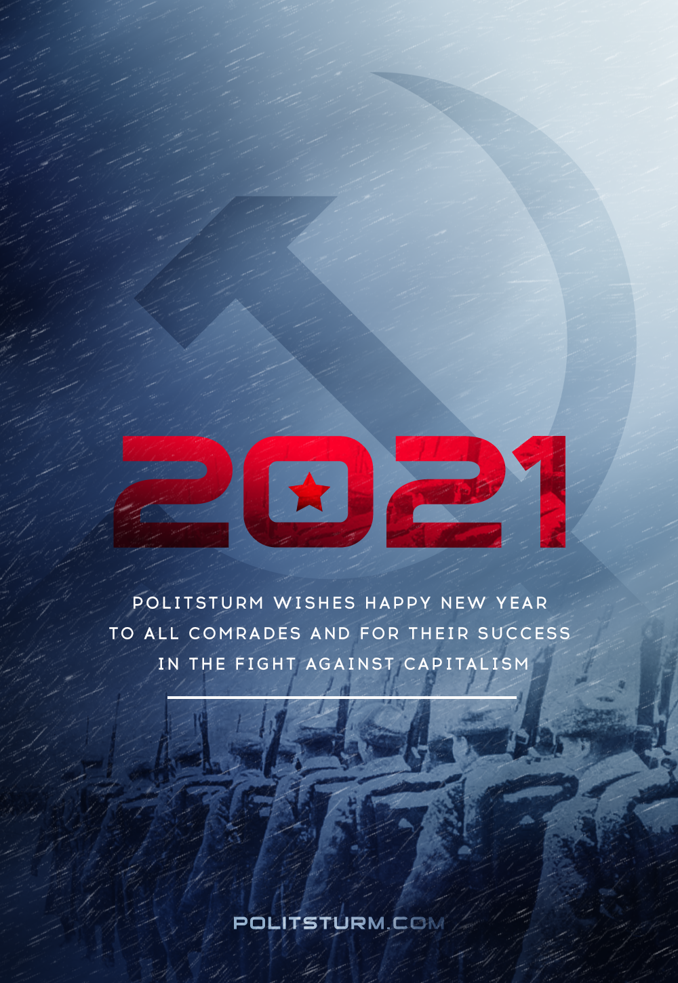

Original article
2020-12-31
1 min read

Comrades!
We meet year 2021 in the unfolding economic crisis and intensification of capitalist contradictions, with a simultaneous worsening of the working people’s life and an increasingly tougher reaction.
In ‘the’ upcoming year, our project will increase the work on all fronts, bringing up the literacy of the communists and preparing for the revitalization of the labor movement.
Moving along the path of Marxist-Leninist theory, we will do everything in 2021 to come closer to the rebirth of the world communist movement.
We wish all comrades strength, endurance and success on our way.
Happy New Year!

Original article

