17 American veterans commit suicide every day
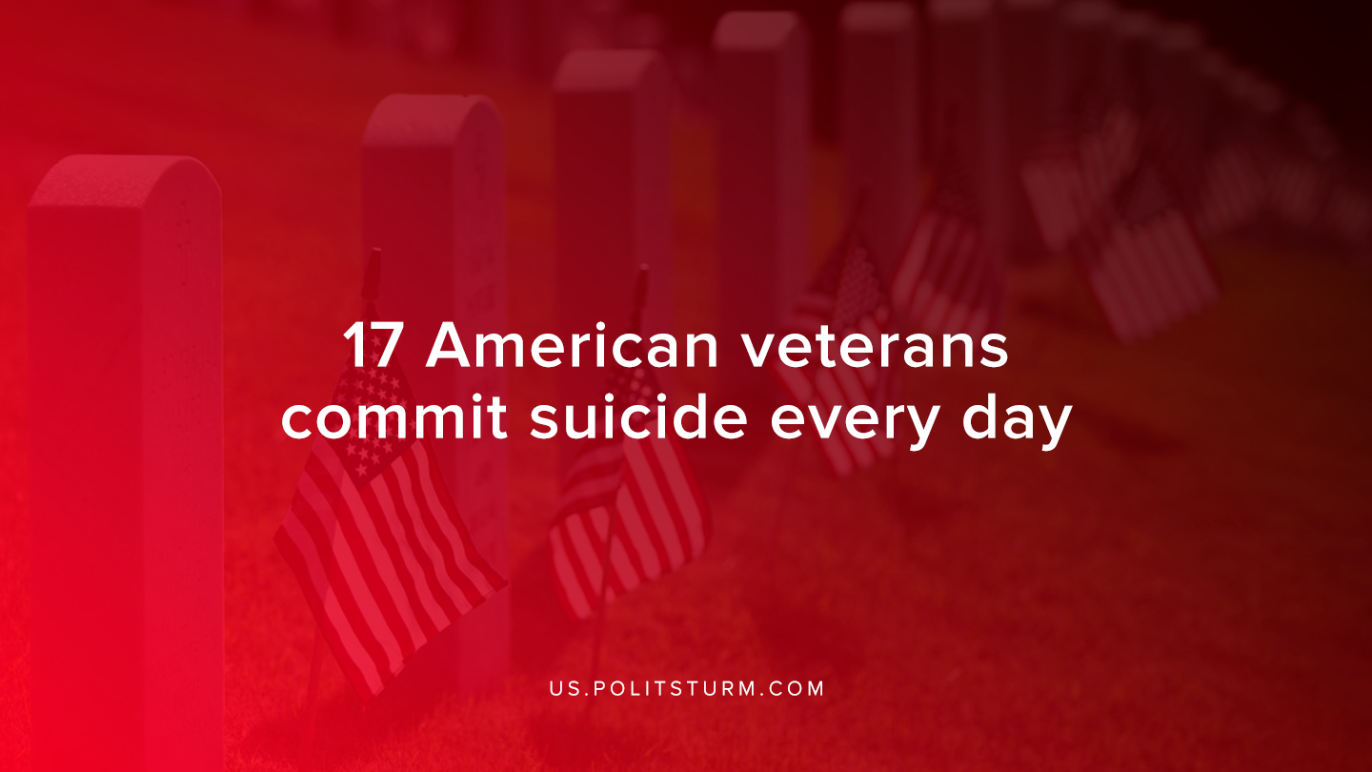

Original article
2020-01-31
1 min read

A new report shows the great betrayal of American veterans, that were left to be feasted upon by the free market. In the most recent statistics released by the Department of Veterans Affairs, it was shown that former military members are committing suicide at a rate of 17 a day.
Day by day we see more and more veterans take their lives from the horrors witnessed from US imperialism. Many are invited into the military after either noble ideas or simply saying that they will provide the basic necessities to the soldiers.
For the major imperialist nations to further exist, they need troops to send to their doom in order to maintain that empire. Similar to the proletariat, once they are used, they will be thrown off to the streets receiving little to no aid for their trauma, not compensate the family of the fallen or damaged soldier, not provide full rehabilitation programs, and not providing a good job to reintegrate into civilian society.
All of these supports are instead constantly being cut, in order for the capitalists to maintain their surplus value. Soldiers in a capitalist society will only exist as cannon fodder to further fulfill the interests of the ruling class. As we are coming closer and closer to the next global war of imperialist nations, the capitalists will once again use all of the resources available to manipulate the proletariat to think that the proletariat of another country is the enemy.
Once more people will be placed into a pointless war for them, and through mass bloodshed we will have revolts emerge. In order to limit the suffering of our time we must continue to agitate, we must educate and then recruit more and more into the ranks of Marxism-Leninism, and lead us into a world of eternal peace.
Only under socialism we will no longer see veterans take their lives as they will have the service to properly seek medical attention, no longer will they zone out from society as they will have a guarantee of a job and reintegration into society.
Source

Original article

