150,000 COVID-19 Deaths in the US
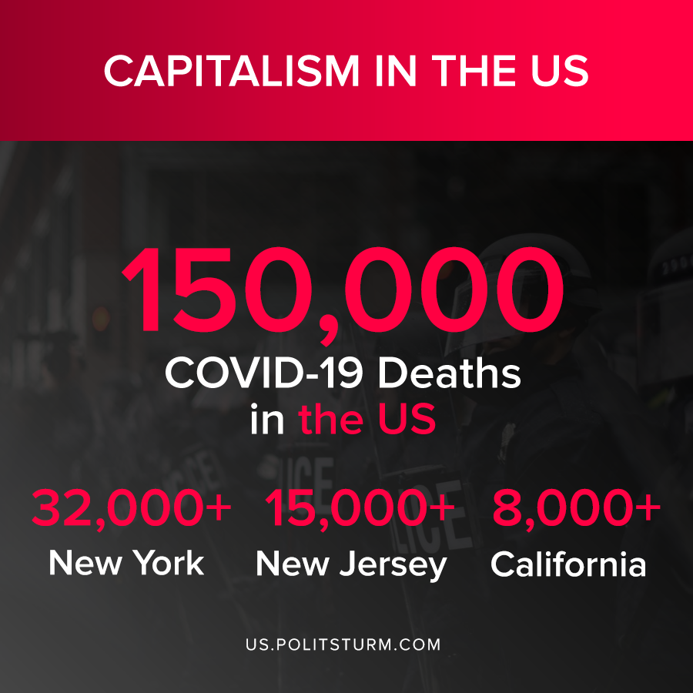

Original article
2020-07-30

150,000 COVID-19 Deaths in the US

Source: 1

Original article

