14.4 million U.S Workers Exposed to COVID-19 Every Week
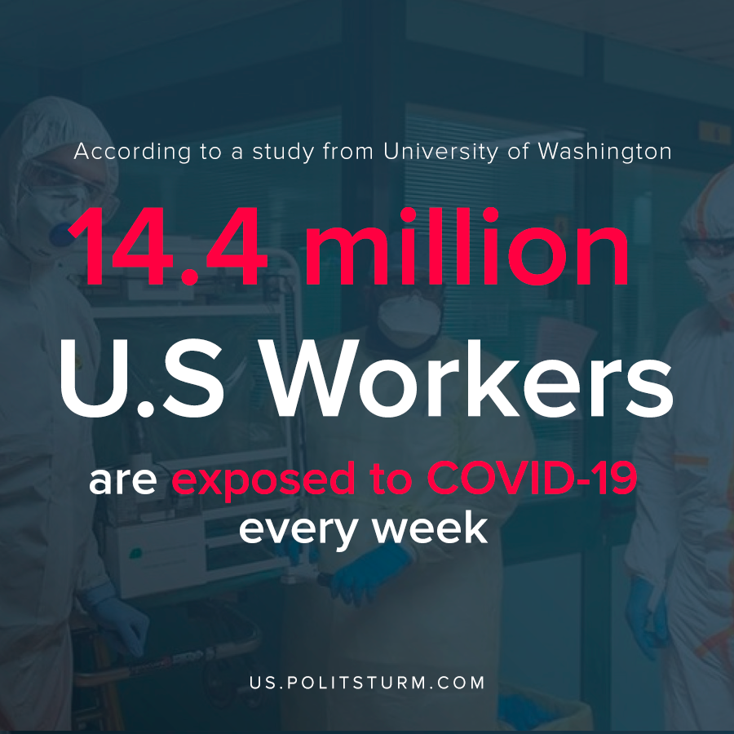

Original article
2020-05-07
1 min read

A new study from the University of Washington found that 14.4 million workers face exposure to infection such as COVID-19 once a week, and 26.7 million face exposure risk once a month at the workplace. Health care workers represent the bulk of the workers who are exposed to infection.
The study also found that there were discrepancies in terms of which workers were exposed to infections. Workers with higher-paying jobs could more likely afford taking time off work or have options to work remotely. Other workers, such as contractors, often do not have the same benefits such as sick leave, putting them at increased risk of infection.
One of the authors of the study Marissa Baker concludes that “workplaces need to make sure that they are not only protecting their workers at work, but also coming up with contingency plans to make sure that sick workers are not coming to work…”
However, the capitalist class is concerned with the maximum generation f profit, and not the wellbeing of the workers. With the death toll of the coronavirus in the United States mounting, some states are moving to reopen their economies and further expose the workforce to COVID-19. Only under a socialist organization of production would be possible to put the wellbeing and safety of the workers ahead of private profit.
Source

Original article

