12,500 Retail Workers Made Redundant in Great Britain
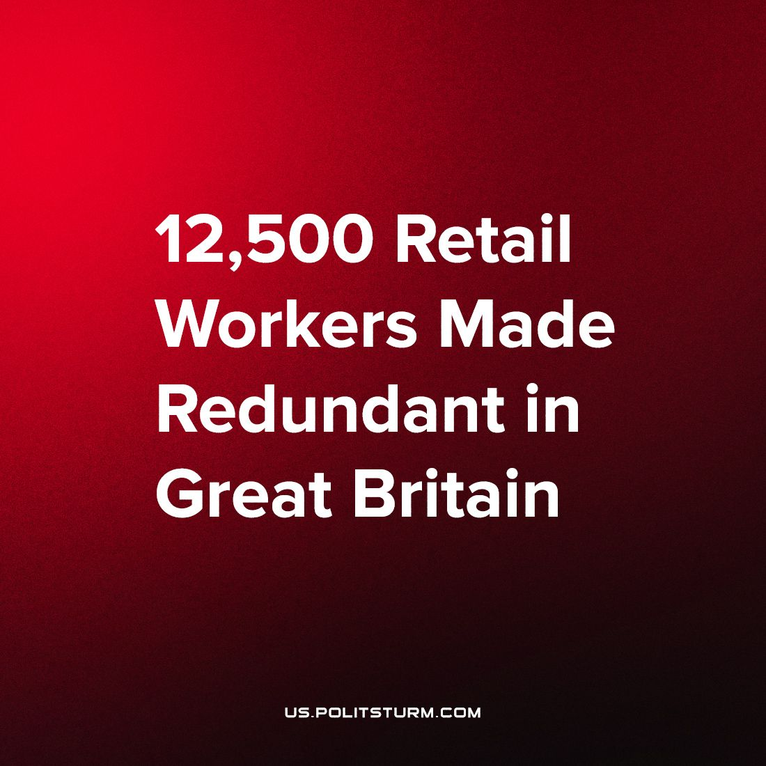

Original article
2023-10-11
1 min read

In Great Britain, the long-standing retail chain Wilko has made a crucial announcement – the closure of all its last remaining high street stores. This 90-year-old retail giant once had a sprawling presence, however now its remaining 400 stores scattered across the country are closing on Sunday the 8th of September. The unforgiving forces of market competition have pushed Wilko to its grave.
This move is poised to displace 12,500 workers, underscoring the unforgiving nature of market relations. The closure emphasises the disparity within capitalism - while the owners face financial losses, the real burden falls upon the workers who must grapple with unemployment and the evaporation of their pensions – through no fault of their own. This stark dichotomy illustrates the class antagonisms endemic to capitalism, perpetuating a system that demands a pool of unemployed workers, in order to depress the price of labour, in its current form as a commodity. It reveals a harsh reality where the profits of the capitalists outweigh the fate of working people.
In contrast, socialism offers an alternative path, where the means of production are collectively owned and operated, eradicating these issues. Economic decisions are no longer dictated by profit margins and the whims of the world market but guided by a rational, conscious and human-centred plan drawn up by and for all working people, catering to the well-being of all.
By freeing the productive forces from the shackles of market anarchy and ridding ourselves of the few that claim the bulk of society’s wealth as their own, socialism will not only ensure a right to work for all, but facilitate the transition of labour from an alienating drudgery and a means to an end, to life’s prime want.
Socialism can be established only when the working masses are organized as a class and guided by a communist party, armed by Marxist-Leninist theory.
Sources:
https://news.sky.com/story/wilko-to-close-last-remaining-high-street-stores-12979076

Original article

