100,000 Demonstrate in Rome Against Sending Arms to Ukraine
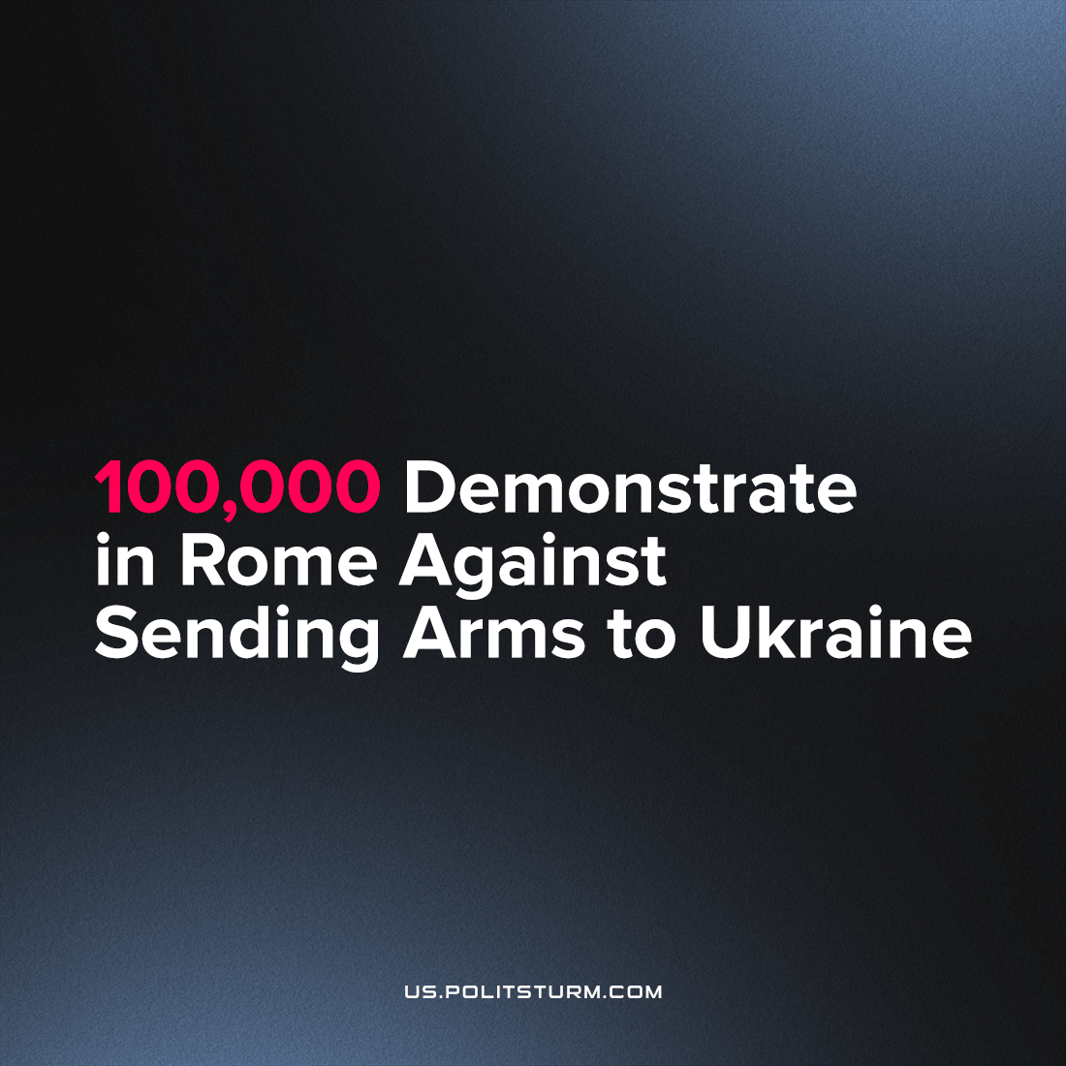

Original article
2022-11-26
1 min read

On November 5, a mass demonstration for peace in Ukraine took place in Rome. According to the authorities, about 100 thousand people went to the streets of the Italian capital to call on the Italian government and the world community for peace. Similar actions took place in more than 100 other Italian cities.
The demonstrators called on their government to stop military aid to Ukraine and immediately start peace talks. Some also called for the cancellation of anti-Russian sanctions and Italy’s exit from NATO. Under the slogans “Yes, to negotiations, no to deliveries!” the protesters demonstrated an understanding that an armed clash between the Russian and Western capital in Ukraine is not in the interests of either the Russian, Ukrainian, or European peoples.
However, the demonstrators showed neither class consciousness nor political unity. Various groups were represented in the actions, from trade unions and environmental associations to religious communities and LGBT activists, each of which put forward its own symbols and agenda. At the same time, there was a noticeable absence of large political forces that could direct the masses’ discontent in the right direction.
Later, it turned out that the demonstrations were initially planned as apolitical. In the organizers’ opinion, this way, they could attract as many people of different political views as possible by refusing to cater to any political agenda.
In reality, the absence of a political agenda only deprives the protests of direction and ultimately, the ability to influence the world’s political environment. People may oppose a particular war, but without a common theory, they cannot oppose the system that causes these wars. This is a task for a revolutionary party to unite the working class and direct it on the path of consistent struggle against capitalism by arming it with Marxist-Leninist theory.
Sources: 1, 2

Original article

