10.9% of U.S. Counties Experience Persistent Poverty
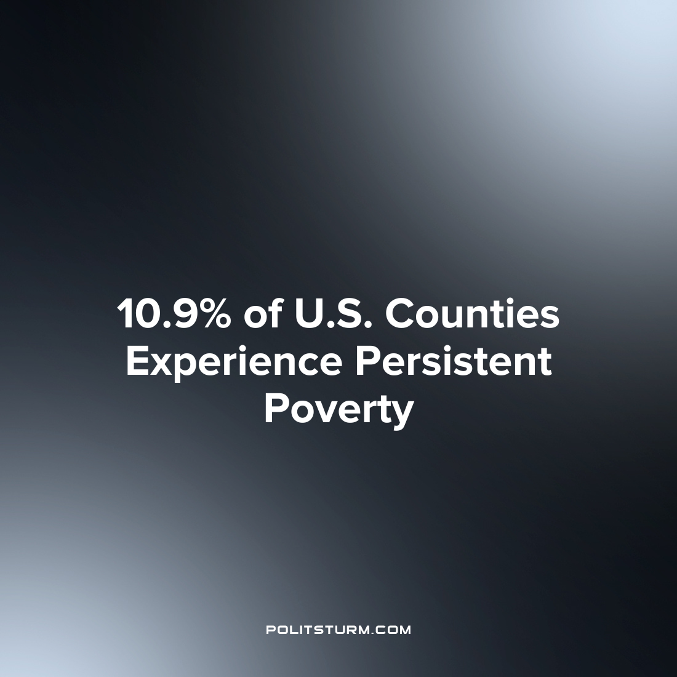

Original article
2023-07-02
1 min read

The U.S. Census Bureau published a report outlining counties across the country which experienced persistent poverty, defined as having a poverty rate of 20% or higher over three decades spanning from 1989 to 2015-2019. Of the 3,142 counties, 10.9% experienced persistent poverty which was correlated to such areas lacking sufficient infrastructure and community services.
Such areas are not equally distributed across the country. As a matter of fact, 80% of counties experiencing persistent poverty were located in the Southern region of the U.S. These areas were also heavily clustered in specific regions such as along the Southern border, Appalachia, the Mississippi delta, and across Native American and Alaskan tribal lands.
In addition to the South, the Northeast also had a disproportionate amount of persistent poverty with 28.4% of its population living in persistent poverty despite making up only 17% of the population. However, the entire population of the northeast experiencing persistent poverty lived in just three densely populated counties, Bronx and King counties in New York and Philadelphia county in Pennsylvania.
The Census data gives a consistent description of the uneven development that occurs both within and between capitalist countries. Particular areas of the country, largely rural and specific urban regions, remain relatively underdeveloped and lack infrastructure and public services while being mired in poverty that persists for decades. The division between town and country and the uneven development of countries under capitalism is well-known, however, it continues to this day. As long as the capitalist system continues to exist, bourgeois society will continue to reproduce the uneven and unequal division of society in which a small class of oligarchs enrich themselves at the expense of the mass of workers.
Sources: 1 2

Original article

