1 in 7 American Children in Poverty
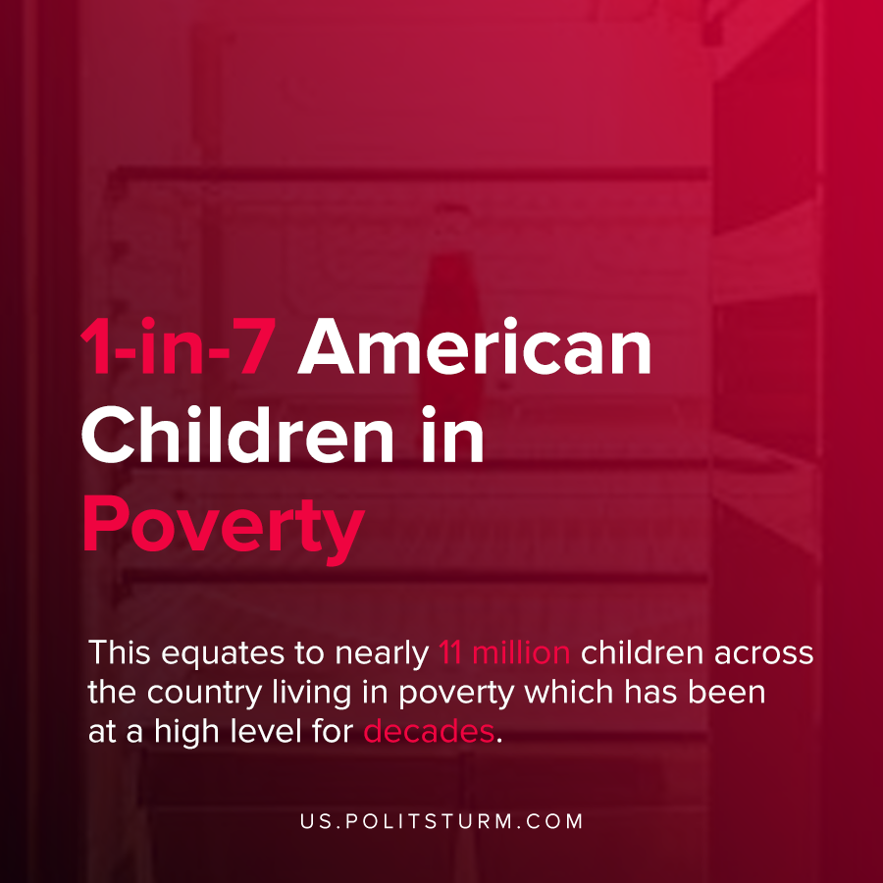

Original article
2021-03-11
1 min read

Nearly one in seven American children are living in poverty, according to the Center for American Progress. This equates to nearly 11 million children across the country living in poverty and which has been at a high level for decades.
The coronavirus and economic crisis exacerbated the problem of child poverty with job loss making it difficult for families to meet basic expenses or buy enough food.
The report indicated that the problem of structural poverty is under-reported in the official statistics, and disproportionately affects black, Hispanic, and native American children.

“Because America’s current policies do not guarantee a reasonable standard of living, a child’s economic security is deeply intertwined with their caregivers’ experience in the labor market”, said the report.
American policies do not guarantee a reasonable standard of living or stability because they serve the interests of the capitalist class.
A worker who sells their labor power to the capitalist is structurally in a precarious state because there is no guarantee of employment. The loss or reduction of labor income by working families by extension affects American children as well. This affects dependent children of the most vulnerable in the working class who suffer in poverty while the oligarchs enrich themselves. To eliminate child poverty it is necessary to guarantee employment, which is simply not a possibility under the capitalist mode of production.
Source: 1 , 2

Original article

