1.4 Million Health Care Jobs Lost During Pandemic
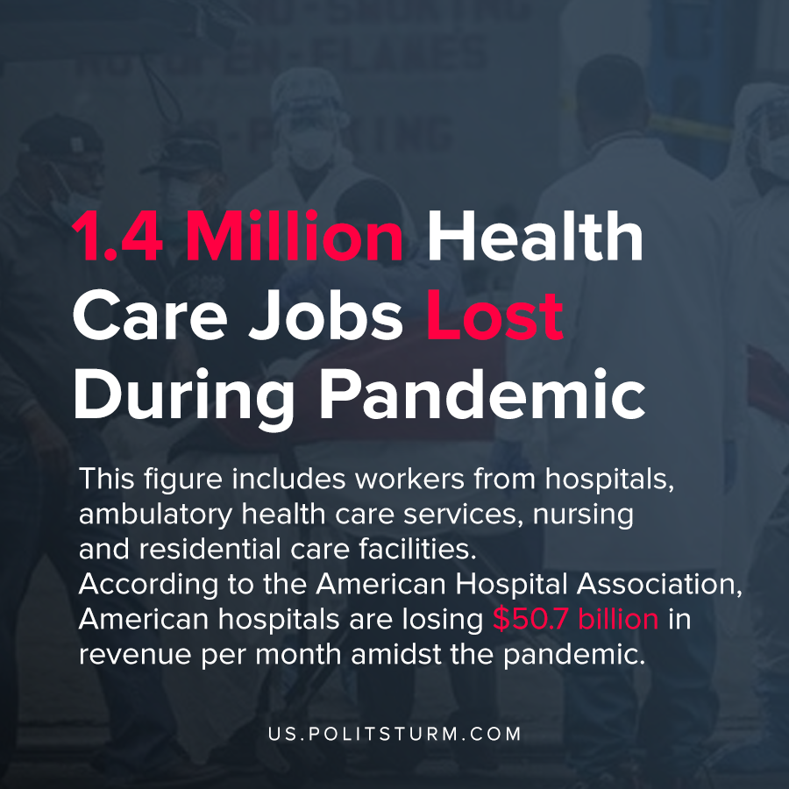

Original article
2020-05-13
1 min read

As of April 2020, 1.4 million American health care workers have lost their jobs from the preceding month according to figures released by the Bureau of Labor statistics. This figure includes workers from hospitals, ambulatory health care services, and nursing and residential care facilities.
Hospitals are losing revenue in the crisis for a myriad of reasons ranging from the cancellation of elective procedures to Americans postponing care as they shelter in place. According to the American Hospital Association, American hospitals are losing $50.7 billion in revenue per month amidst the pandemic.
In response to the declining revenue, hospital administrations have engaged in cutting costs. As a result, there has been a precipitous decline in the number of health care workers in the midst of a deadly pandemic when they are needed most.
The capitalist economic system based on private ownership of the means of production means that many hospitals are organized solely for the purpose of maximizing profits. Health care workers who sell their labor power to the capitalist are not immune from the negative effects of the crisis of overproduction and the coronavirus epidemic.
The aim of the capitalist system is to produce profit and a pandemic will not change this fundamental fact. Hospitals will shutter operations and lay off their staff if the current market conditions demand it. Only a planned, scoialist economic system is freed from the anarchy of the market and its negative consequences such as unemployment.
https://www.bls.gov/web/empsit/ceseeb1a.htm#ce_ee_table1a.f.4
https://www.aha.org/guidesreports/2020-05-05-hospitals-and-health-systems-face-unprecedented-financial-pressures-due

Original article

